ENPS Bucket Hat Fundraiser – cost $30 each

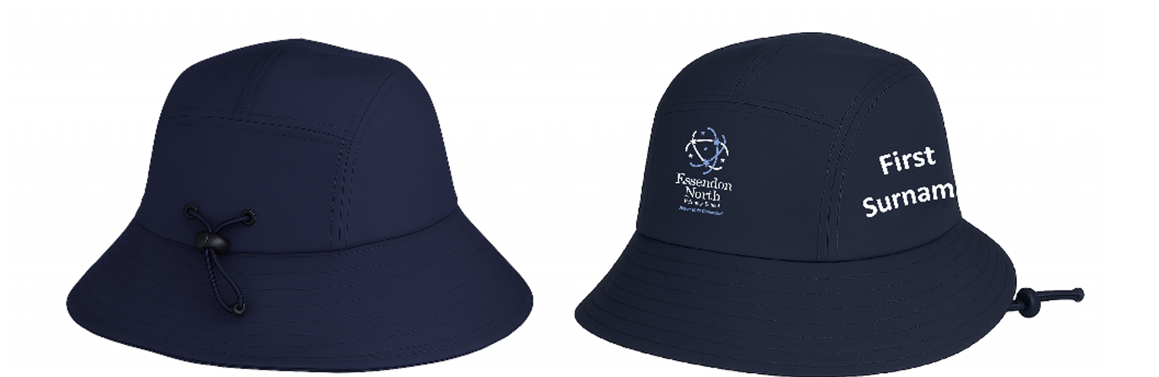

Dear Parents and Carers,

As part of our ENPS Sun Protection Policy, all students must wear a sun protective hat each day from mid-August to 30th April.
If you would like to purchase a personalised Bucket Hat as a part of our fundraising program, please see the form below. All hats are personalised with your child’s FIRST and SURNAME printed on the side of the hat. (See attached digital image) We ask that no nicknames are used, however shortened first names can be used as appropriate.

Complete the following [please print clearly] and email to Teresa.Heale@education.vic.gov.au
Please visit the office for sample sizes.

First Child’s First Name and Surname (no nicknames):
Hat size (circumference): Youth (54cm) Adults (58cm) Total Cost: $30

Second Child’s First Name and Surname (no nicknames):
Hat size (circumference): Youth (54cm) Adults (58cm) Total Cost:$60

Third Child’s First Name and Surname (no nicknames):
Hat size (circumference): Youth (54cm) Adults (58cm) Total Cost:$90

NO orders will be taken after Monday 19th October 2026. Delivery will be in early December.

Payment options:
Cash (please provide in a sealed, clearly marked envelope or bag to Teresa)
Credit card Please enter your card details below:

Cardholders Name: ________________________ Visa Mastercard

Card number:

Expiry Date: / CVV:

Cardholder’s signature: ___________________________ Amount $________

