Initial PAM Setup

Step 1. Receive your PAM account email from the school.
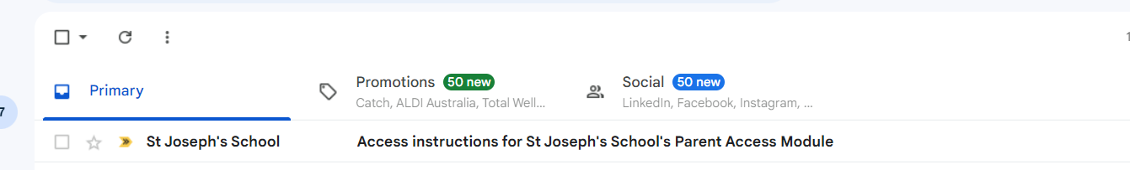
Step 2. Click on the link inside the email to launch a web browser to the school’s PAM portal.
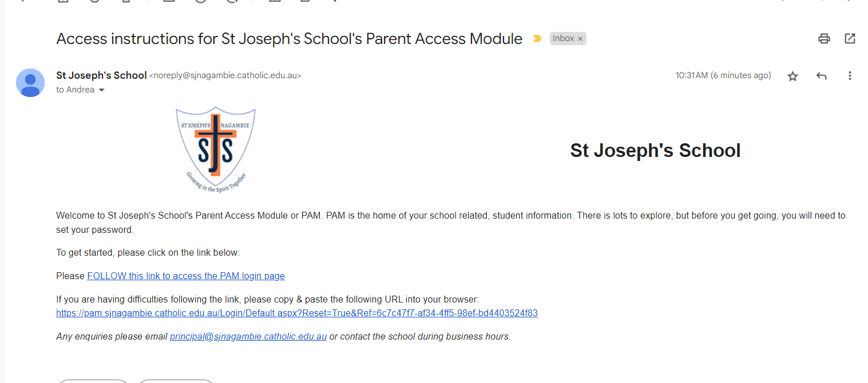

Step 3. Update your password. This and your email login will be needed for the setup of the SIMON Everywhere mobile app.
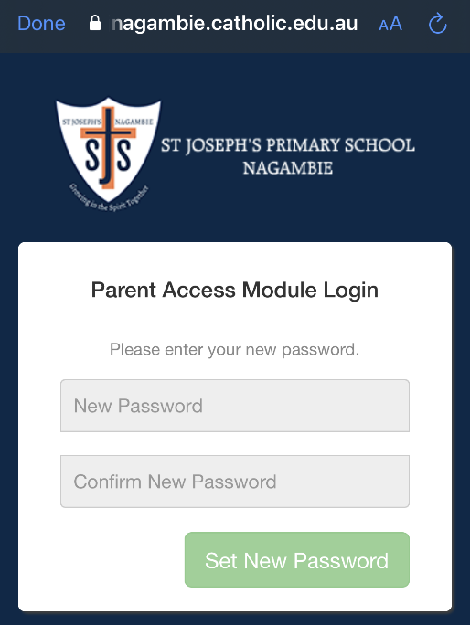

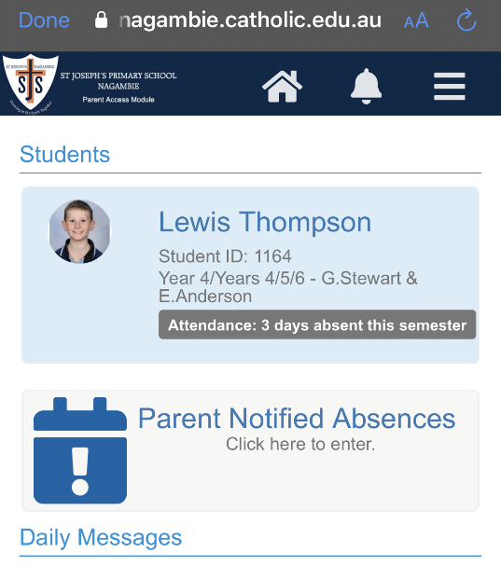
Step 4. You can view your child’s assessment records from last year and this year. You will also be able to inform the school of any on day or future planned absences.

