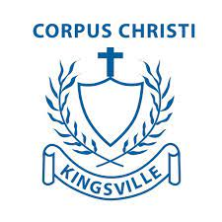

Multicultural Day Recipe Book Template

Name of recipe: Johnny’s vegetarian pizza
Child/ren’s name and class: Johnny 1/2C

Where is your recipe from: We used to make this recipe with my Nonna who is from Napies in Italy.

Ingredients
- flour
- water
- etc

Method

Step 1. Place ‘x’ grams of flour in a bowl…

Step 2.

Step 3.

Image (if you have one of your recipe or the children enjoying the meal or helping to make it)

