Dear Families and Friends of
The Ark - Salisbury Lutheran Kindergarten
We are running a Kytons Bakery fundraising event to raise money for the kindy. Please turn over to see the products available.
Kytons Bakery have been helping groups to fundraise in Adelaide for over 30 years, and are best known for their delicious, fluffy lamingtons which have won numerous local and national awards.
Please contact Jennifer Pfeiffer (treasurer) with your orders by email at
treasurer@salisburylk.sa.edu.au;
Payment can be made by direct banking to our Westpac account.
Please ensure your order is clearly identified with your name.
Final date for orders will be Monday March 28th.
Orders will be available for collection on Tuesday 4th April from the kindy, Golden Grove Lutheran School, St Paul Lutheran School or Endeavour College.
Thank you in anticipation of your support for our Kytons Drive.
Sincerely,
Salisbury Lutheran Kindergarten Council

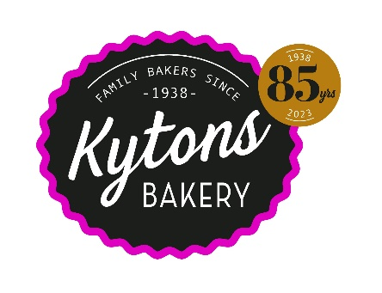
HOT CROSS BUNS
The Ark
Salisbury Lutheran Kindergarten
Kytons Bakery Easter Fundraiser 2023
Traditional x 12 snack size $11.30
Fruitless x 12 snack size $11.30
Please make payment to:
Salisbury Lutheran Kindergarten
BSB 735-047
Account number 070804
Please be sure to use your name and KYTONS to identify your payment
Fruchoc x 6 large $9.50
Gluten free x 3 $7.00

LAMINGTONS
Traditional x 12 $13.50
Mini x 24 $16.50
Choc-raspberry x 6 $7.90
Choc-coffee x 6 $7.90
Native lemon myrtle $8.50
& coconut x 6 fingers
Please email your orders to:
treasurer@salisburylk.sa.edu.au
& include your preferred pick up location & receipt number from Bank Transfer
Jen Pfeiffer mobile 0402058129
Final date for orders: Monday 28th March
Pick up Tuesday 4th April from following locations:
Salisbury Lutheran Kindergarten, Waterloo Corner Road, Salisbury
Endeavour College, Mawson Lakes
Golden Grove Lutheran Primary school
Good Shepherd Lutheran Primary School

For more information about Kytons Bakery’s products, including nutritional information, ingredients list, or serving suggestions, visit www.kytonsbakery.com.au

