**The market**

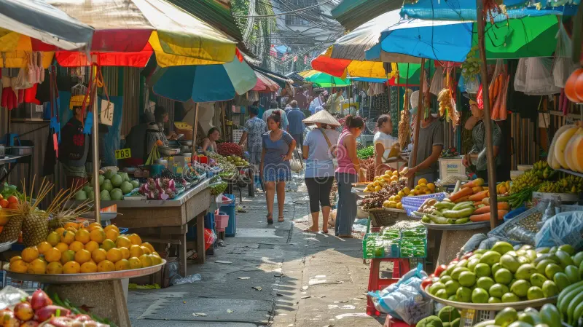As I entered the crowded market the smells of fruit, vegetables, fish and meat all rushed up to assault my nose as I trotted across the stalls of the market. Flowers filled my lungs with the scent of their sweet nectar because I had now entered the nursery. The nursery didn’t only just have flowers it also had elegant tall cacti as well as different succulent plants. I decided to by some cacti and then look at the other stalls. I went to go to the food stalls and buy some food. On my way there I saw a bunch of toy shops and all the children crowding around it when I got to the food section I realised that there weren’t multiple stalls but that instead it was only one store. Oh, they had to pack up I realised oh well I guess I got a go next time by 😊