Supercharged Career Outreach Events for Families
Sunday | Monday | Tuesday | Wednesday | Thursday | Friday | Saturday
30 April  May Day Celebrations Fremantle | 1 May | 2 May  Career conversations Broome | 3 May | 4 May | 5 May | 6 May  Data Science & AI Week
7 May  Curtin Maths enrichment program enrolments | 8 May  Department of Education Career Conversation for Parents Albany | 9 May | 10 May | 11 May | 12 May | 13 May
14 May | 15 May  Department of Education Career Conversation for Parents | 16 May | 17 May | 18 May | 19 May | 20 May  Careers Expo  Innovators’ Tea Party for Careers in STEM for girls
21 May  Careers Expo | 22 May  Career conversations Geraldton | 23 May | 24 May | 25 May  Department of Education Career Conversation for Parents Northam | 26 May | 27 May
28 May | 29 May  Department Education Career Conversation for Parents | 30 May | 31 May  Department Education Career Conversation for Parents Narrogin | 1 June | 2 June | 3 June
4 June | 5 June  West Australia Day | 6 June | 7June | 8 June  Department of Ed Career Conversation Esperance | 9 June | 10 June

Career Outreach Opportunities for Families

18– 21 May Careers Expo
This is the biggest career event of the year in WA. People from industry, education and training providers will be there to give information about their business.

Check out Get tips on how to get the most from your visit HERE.

TIP: I have tried going at about 2pm, during the week when the school groups have left but I’ve found that many of the exhibitors are exhausted and ready to go home.
I now go early on Saturday.
You can download a career expo planner. Download the career expo planner (PDF – 1.5MB)
Find more about the Expo exhibitors HERE.

Read: It’s Career Expo Time – Don’t sign anything! 3 tips for the Career Expo.

15 – 21 May National Careers Week
Start Careers Week by going to the Careers Expo and the Convention Centre. Then look for career events at your school or local library.

Find events HERE.

May – June Department of Education Career Conversations

The Department of Education gives advice on how to talk about careers with your student.
The Department of Education is providing free, easily accessible support that helps families to work through career ideas with their students. You can register for one or more of the events HERE.
Hear about:
- exploring university and training pathways
- career pathway information for young people with disabilities
- where to find accurate, up-to-date career pathway information
- where the jobs are
- what employers and industry are looking for.
Online  Monday 26 June  5:30 pm to 6:30 pm  Register in Eventbrite | North Metropolitan  Joondalup  Monday 29 May  6:30 pm to 8:00 pm  Register in Eventbrite  Morley  Tuesday 20 June  6:30 pm to 8:00 pm  Register in Eventbrite | South metropolitan  Mandurah  Monday 15 May  6:30 pm to 8:00 pm  Register in Eventbrite

How to get Professional Help if you Don’t Have Much Money
This isn’t strictly career education, but if students are not coping with their current life, they won’t have the ability to move forward into a successful future.

Towards the end of Term 1 teachers were talking about how disruptive students were being.

We discussed if COVID had a bigger, long term impact than we anticipated.

We don’t have time to analyse why kids are disturbed, we need to be providing a safety net now.

I found this site that gives links to different mental health resources that students can tap into. I hope it helps.

MyFuture website – simply the best
I still think MyFuture is the best career information site in Australia.
All Australian State and Territory governments contribute career information to it.

It is more focused on providing information targeted at you than other sites. You need to get an account and have a very secure password as it is a government site, and they collect the information you provide when setting up your profile.
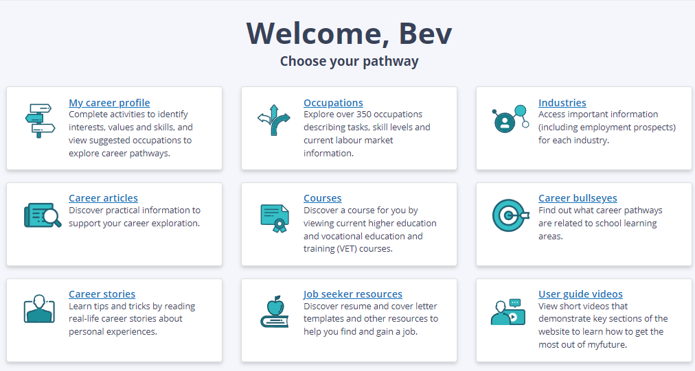
You can set up your account HERE.

University Events

1 May Early Offers for 2024
Year 12s will be able to apply for a place at a university in WA for 2024 from Monday 1 May. You will NOT have an advantage over other applicants who do not apply early.

University Early Offers for 2024 Open 1 May
University | Information | Key Contact
Curtin | If your final ATAR score is 3 points above your predicted ATAR, you’ll receive a $3000 scholarship.  Apply through TISC from 1 May and choose Curtin as your first preference.  How to Apply to Curtin | Book an appointment with a student counsellor
UWA | Apply directly to UWA or through TISC  Ealy Offers Information  Early offers based on end of Year 11 and mid-Year 12 results or STAT results. | Phone  131 UWA (131 892)  8.30am–5.00pm (AWST), Monday to Friday  Online consultation  Book a virtual consultation
Notre Dame | You can start to fill out your Notre Dame application now by going HERE.  How to apply to Notre Dame | Email: online.admissions@nd.edu.au  Phone 9433 0533  For a personalised campus tour go here
ECU | Year 11 results are used to calculate a predicted ATAR.  If you're studying a Certificate IV or enabling course, or if your predicted ATAR doesn't quite meet the minimum entry requirements for your course, you'll still be eligible for an early offer. This offer will be conditional on you meeting all entry requirements for your course.  Applications through TISC  Get current information HERE. | Visit HERE for a full list of courses available.  Phone: 6304 0000  Enquire HERE.
Murdoch | Year 12 Early offer Program for 2024 enrolments | Phone: 1300 6873 624  Ask a question here.

3,10, 17, 31 May Curtin Pathway Support
Thinking about applying to uni but have a few questions about the various pathways on offer?
Come down to Curtin Connect to chat with one of our Future Student Advisors about your pathway options, including ATAR entry, Portfolio entry, enabling pathways, and more!
We’re here to run you through your options, give you tailored advice and discuss what your journey to Curtin could look like. Bring your questions along and we look forward to seeing you there.
Get details HERE.

Curtin Early Offer Application Advice

Every Thursday in May 8.30am – 4.30pm
Are you in year 12 and keen to lock in an early offer to Curtin? Let us take the pressure off and help you with your application.
We’ll be opening up Curtin Connect, our central hub of information on campus, for you to come down and talk to a Future Student Advisor on how to submit a successful early offers application.

Applications for early offers open through TISC from Monday 1 May 2023, so join us every Thursday in May from 8:30am to 4:30pm to sort out your application and secure an offer for Semester 1, 2024.

Read about it HERE.

7 May Term 2 WAAPA Junior Academy Short Courses for secondary school students

The WAAPA Junior Academy is designed specifically for young people who have a passion for performing.
This exciting program gives secondary students the opportunity to establish strong voice and movement skills and explore a range of acting techniques that will be applied to stage, screen or music theatre performances.
Junior Academy courses 2023
- Acting and Performance Making - School Years 7 to 12
- Music Theatre - School Years 7 to 12
- Tell Your Story - Ages 12 to 17 years

Contact Gabrielle Metcalf Phone: (+61 8) 6304 6775 Email: explore.waapa@ecu.edu.au

24 May ECU Year 10 Parent Information Evening
Joondalup Campus 6-7.30pm
If you don't know what subjects to pick next year or you just want to find out about uni and the courses we offer, this is a great opportunity to have a chat with our friendly Future Student Engagement Team! Find details and register HERE.

24 May Murdoch Year 9 & 10 Parent and supporters information Evening
Assist your child as they navigate senior secondary school and the journey to tertiary studies!
Join us for a Parent Information Evening where we'll cover:
- Course offerings
- How to help your child choose preferences
- Understanding university lingo
- Fees & Scholarships
For any queries about this event, please contact us on engage@murdoch.edu.au .
Rind more information HERE.

24 May Murdoch Year 11 & 12 Parent and supporters information Evening
Help your child take the leap from secondary school to university!
There are hundreds of study choices for school leavers. We’re here to help you through this exciting new chapter in your teen’s life by providing all the information you need to guide them through Years 11 and 12 and beyond.
Join us for a Parent Information Evening where we'll cover:
- Course options
- Understanding ATAR
- Application processes
- Key dates
- Fees & Scholarships
Find more information HERE.

Notre Dame Undergraduate Course Guide 2024
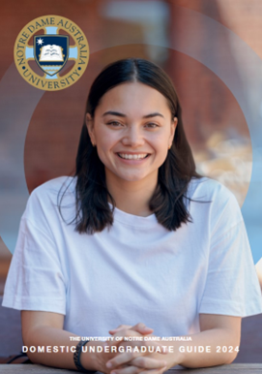
The 2024 Undergraduate Course Guide is out.
Demand for courses at Notre Dame seems to be increasing. They get good reviews from current students in COMPARED.

Check out the new Notre Dame Undergraduate Course Guide for 2024.

Curtin Undergraduate Course Guide 2024
The 2024 Undergraduate Course Guide is out.
Curtin is the biggest university in Western Australia and has strong industry links, international study opportunities and excellent student accommodation.
Check out the courses, then check COMPARED to see what Curtin students think of their student experience.

Check out the Curtin Undergraduate carouse guide 2024 HERE.

ECU Student Ambassador Recruits
These ECU students are available to speak to high school students about their courses and experiences at ECU.
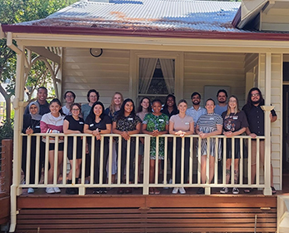
Because they are close in age to school students, and because they have had recent transition from school experience, they know the concerns and needs of school students.

Find more about how to engage with a student ambassador HERE.

ECU West Coast Eagles Partnership
ECU and the West Coast Eagles has formed a partnership designed to provide expertise to a new generation of people wanting to belong to Australia’s significant sports industry.
The partnership is designed to support students studying:
- Exercise and Sports Science
- Media and Communications
- Commerce (sport business)
- Sport, Recreation and Event Management
- Marketing, Advertising and Public Relations
To find out more go HERE.

ECU promotes non-ATAR Pathways
Students rate ECU as the top university in Western Australia for student experience. It is therefore well placed to support students to enrol and succeed through non ATAR entry pathways.
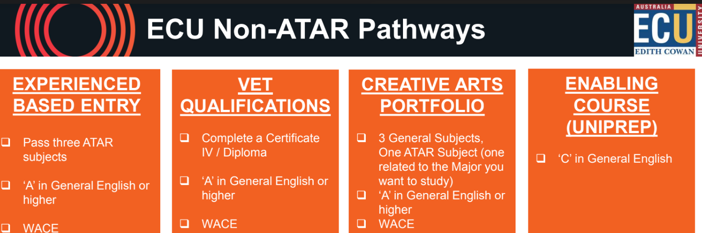

You can check out ECU Non-ATAR Pathways HERE.

ECU Uni Prep
ECU has three UniPrep Courses designed to support students to gain skills required to succeed at university:

- UniPrep (Accelerate) 4 weeks.
    - Available for students with near miss ATAR between 55 – 69
    - Intensive 3 unit version of UniPrep
    - 4 weeks on Joondalup campus

  - UniPrep (Summer) 8 weeks.
    - Available for students with an ATAR below 55 or no ATAR
    - 8 weeks from the end of November through till end January

  - UniPrep General
    - Available for students who achieve English competency.
    - Run for one full semester.

UniPrep Schools
ECU has several schools that participate in a UniPrep Schools program. It is for Year 11 and 12 students and students take the program while at school.

Alternative Pathways and Success Rates
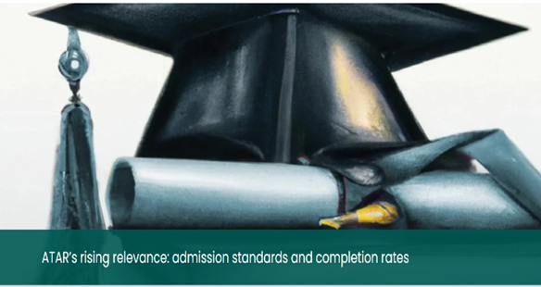
Last month the Centre for Independent Studies published a report saying that students who bypass the ATAR (or similar in other States) are almost twice as likely to drop out.

This was significantly due to the lack of support provided to those students.
At a recent event for Career Practitioners ECU proudly promoted that the students taking its non ATAR pathways were just as likely to succeed as those taking ATAR pathways.
ECU always scores well on national assessments for the support it provides to students. It must be this level of support that is resulting in outcomes that go against the trend.
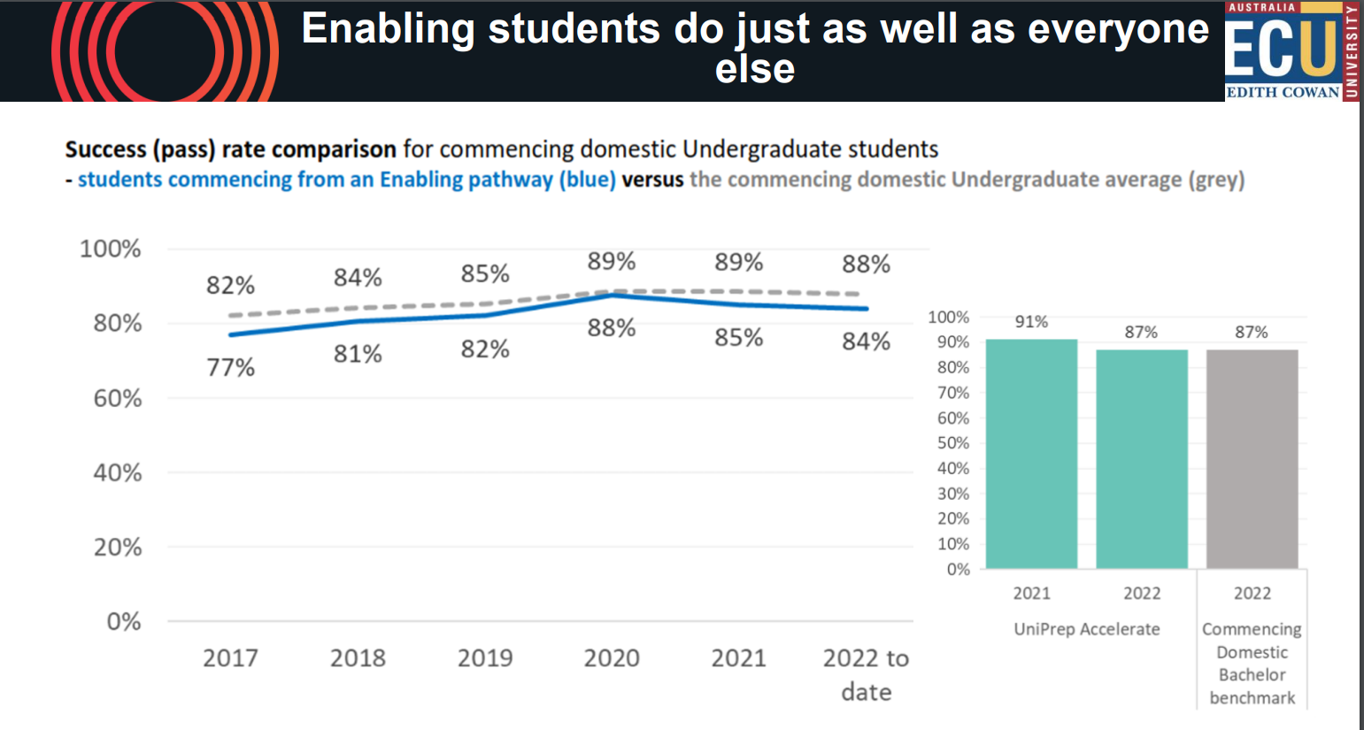

ECU ATAR High Achievement Scholarship
ATAR High Achievement Scholarship
- ATAR of 90 or higher (unadjusted)
- $3,000 scholarship in two payments in your first year

ATAR Outstanding Achievement Scholarship
- ATAR of 97 or higher (unadjusted)
- $5,000 for each full year of study for your chosen course

ECU Engineering Excellence Scholarship
- Valued at up to $20,000, $5,000 per year.
- Available to high performing Year 12 students who have achieved an ATAR of 94

ECU Science Excellence Scholarship
- Valued at up to $15,000, $5,000 per year.
- Available to high performing Year 12 ATAR students

ECU Equity Scholarship
- Up to $1,500 per semester for the duration of the course

ECU Aboriginal and/or Torres Strait Islander Scholarship
- Valued at $3,000 per year for each full-time year of study.

Students don’t know or don’t care what their degree costs

At a recent Curtin event a panel of students was asked if they knew how much their degrees were costing them. NOT ONE knew the answer.

Quick Calculation
Most subjects (units) cost just under $2000
You can choose your units on this great UWA Fee Calculator
Curtin has a fees calculator that you can find HERE.

Curtin has collated information about fees and financial assistance HERE.
They say:
When you study at university, you’ll be required to pay:
- tuition fees (paid per unit)
- an annual Student Services and Amenities Fee, which supports the provision of services and facilities at Curtin
- the costs of textbooks, laboratories supplies, art supplies or field trips.
If you are a domestic student, part of these fees will be covered through Commonwealth support. You can also access loans for the rest of your tuition fees and the student services and amenities fee.

It is organised under the headings:

Understanding your fees.

Calculating your fees

Paying your fees

Alternative Pathways to Uni in WA 2024
If you are interested in alternative pathways to university in WA for 2024, ask your career advisor for a copy of this booklet that collates information from each of our universities.

Or you can get a copy HERE.

Get career advice from universities
Year 11 and 12 students who are seeking career advice, are welcomed by university career services.

You can find general career advice, to explore a range of potential opportunities, and you can meet with specialists in a faculty, for example, Health. These advisors are specialists in their industry. They know about new courses, emerging employment trends, work opportunities and rates of pay.

Training Opportunities

Discounted Driving Lessions for Pre-Apprentices
This is part of a new Drivers Licence Support Program which is removing barriers for young people training in the building and construction industry as part of the Government's efforts to get more workers into construction.
The Construction Training Fund's $1.26 million Driver's Licence Training Support Program gives students the opportunity to obtain a driver's licence while ensuring apprentices entering the construction workforce are job ready.
For more details, please click Here

Strong employment outcomes for apprentices
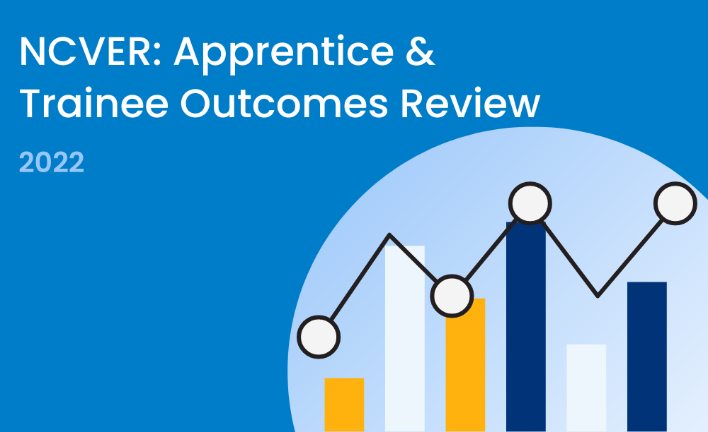
The proportion of apprentices and trainees employed after training remained high in 2022, according to the latest report from the National Centre for Vocational Education Research (NCVER).
- Apprentice and trainee outcomes 2022 shows that 94.9% of apprentices and trainees who completed their training in a trade occupation were employed after training, Of these, 67.7% were with the same employer as their apprenticeship or traineeship.
- For those who completed training in non-trade occupations, 89.3% were employed after training, up 1.7 percentage points from 2021, of which 70.9% were with the same employer as their apprenticeship or traineeship.
- 84% of non-completers, from both trade and non-trade occupations, were employed after leaving their training.
You can read the report HERE.

West Australia Defence Space Capability Training in Exmouth
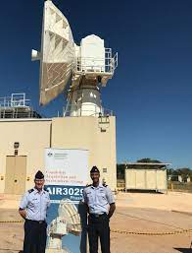
WA is about to start building its capacity to engage in strategic naval and space capabilities at the Harold E. Holt defence base in Exmouth.

South Metro is joining forces with defence space capability partner Raytheon Australia to train its Exmouth workforce.

If you think working in the space industry is where you belong, contact South Metro TAFE to find out more.
Senior School Opportunities

7 May applications close: Air force Careers Day
This is a day of experiences. Students need to register so that all get a chance to experience the activities.
An Aerial View: Air Force Careers Day (20 June 2023) Job Ref - WEP/01097/23
- 20th June 2023
- RAAF Base Pearce Great Northern Highway, Bullsbrook WA 6084
- Air Force
Information Pack Word Document Information Pack PDF Document
- Start New Application
- Access Existing Application
- Preview Application Form

20 May Innovators’ Tea Party – Rewarding careers for women in STEM
The women from industry who provide information to students at the Innovators’ Tea Party are volunteers who are keen to encourage more females to join STEM careers.
Students are encouraged to come along with a friend, as peer support is a great pathway to making good career decisions.
Session 1 - 10:00am - 12:00pm - limited tickets available
OR
Session 2 - 12:30pm - 2:30pm - limited tickets available

Each session will give students the opportunity to meet with 8 inspiring women working in a range of Science, Technology, Engineering and Maths fields.
Royal Park Hall 180 Charles Street West Perth, WA 6005 Register HERE.

Girls Focus on Mining Camp

The Girls Focus on Mining Camp is a five-day residential camp for high school girls to experience what it’s like to study and work in the mining industry in WA. You’ll get to tour mine sites, participate in hands-on workshops and tour Curtin’s Kalgoorlie School of Mines campus.
The program targets girls in Year 10, 11 or 12 who have an interest in science or engineering and would like an introduction to the mining and resources sector.
Do dates identified yet. Find details HERE.

Year 12 Opportunities

30 May UWA Fogarty Scholarship applications close

The UWA Fogarty Foundation Scholarship Program is one of Australia’s premier scholarship programs. It is a joint venture between the Fogarty Foundation and the University of Western Australia, investing in the future leaders of Western Australia.
There are 10 scholarships on offer for Year 12 high school students from WA.

Each scholarship is valued at $10,000 per annum. Applications close on 30 May 2023

Register for UCAT Now Medicine Application for 2024

You need to undertake the UCAT ANZ compulsory entry requirement if you are applying for medicine at:
- Curtin, or
- for an assured pathway into medicine at UWA
The test is conducted between 3 July and 11 August 2023

- You can register and find preparation tests HERE.

Applications close on 17 May.

Late bookings close on 31 May.
- Find our about reduced test fees HERE
- There are banks of practice tests HERE

All candidates need to prepare by understanding these test tools.

Applications to Medicine at Curtin
The application process for a Bachelor of Medicine, Surgery at Curtin has changed. You must now also undertake a Casper test.
So, the process is now:

Step 1: ATAR 95 with Chemistry
Applicants need a minimum ATAR of 95 and ATAR Chemistry is a pre-requisite subject.
Curtin also requires Mathematics: Methods ATAR, Mathematics Specialist ATAR OR Mathematics Applications ATAR as a desirable subject.

Step 2: UCAT ANZ Test

If you want to apply to get into medicine at Curtin, or the assured pathway into medicine at UWA, you must also do the UCAT test

Step 3 Casper Test
Applicants must now also sit the Casper test. This is an online test that asks what you would do in a tough situation and why. It is designed to determine behavioural tendencies of applicants who pursue people-centred professions.
Applicants can register for the test from early June. For more information go HERE.

Step 4 Multiple Mini Interviews
Applicants who do well will be shortlisted in steps 1 – 3 will be shortlisted for interviews.

For more information go HERE.

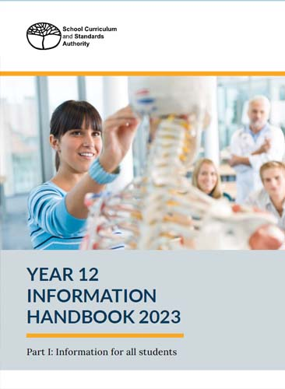
Year 12 Information Handbook 2023
Part 1 of the SCSA Information for all Students is out now.

This is the one with:
- important dates,
- how to use the student portal (you must complete the Student Declaration and Permission by 24 August)
- information about the WACEChecker
- special exam arrangements
- how to meet literacy and numeracy requirements
- school assessments
You need to be familiar with the Year 12 Information Handbook if you are in Year 12.
Download it HERE.

(Part II, “Examinations” will be out later in the year.)

Defence Force Gap Year

If you are not sure what you want to do next year, check out the Defence Force Gap Year program.
- You get paid.
- You have somewhere to live.
- You learn new skills.
- You travel and you meet new people.

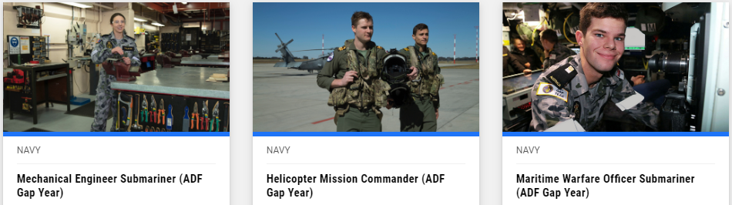

These are just 3 or the many careers that you can choose from.
Find out more HERE.

Gap Year Suggestions
Taking time out to explore your world before going on to further studies can help you to make a better decision about direction you want to take. 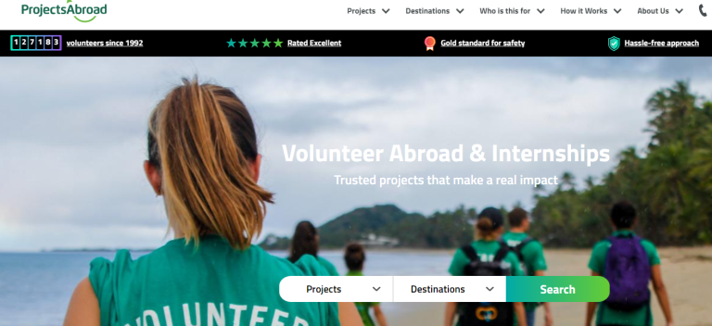
For ideas on how to unearth where you want to go, check this out.

AG CareerStart Gap Year
The AgCAREERSTART 10-month gap-year program helps kick-start the careers of young Aussies in agriculture through a paid job, training, development, and networking opportunities. 2024 applications open in August, so get ready. Learn more about the application process here.

Year 11 Opportunities

Watch for UWA Fairway Program
The Fairway Program supports students by providing academic, financial and personal support to students in Year 12 and during their university studies. You apply for Fairway while you are in Year 11.
Fairway places are open to all students from any school in the State who can demonstrate financial hardship. Check eligibility HERE.
Your future success can be made easier through this program.
At least check it out by going HERE.

RRR Opportunities

25 May ECU South West Teacher Education Info Session (Online)
Our online information sessions introduce you to our teacher education courses and the excellent support services you can expect as a student. We'll cover admission pathways, how to apply, fees and scholarships and flexible study options like online or part-time.

Find out more and register HERE.

29 May South West Information Evening
Find out everything you need to know about studying undergraduate or postgraduate courses at ECU South West. You will also find out information on entry pathways, scholarships and support services and have the chance to speak to our friendly Future Student Engagements team.

Find out more and register HERE.

Career Conversations – Advice on how to help your student to make career decisions

This series of Career Conversations is available online starting in April, before going to regional centres.

Online events
From 5:30 pm to 6:30 pm.
- 26 June 2023
Goldfields  - 8 June, Esperance  - 13 June, Kalgoorlie | Kimberley  - 8 August, Kununurra
Mid West  - 22 May, Geraldton  - 27 July, Carnarvon | Pilbara  - 21 June, Karratha  - 22 June, Hedland  - 25 July, Newman  - 10 August, Tom Price
South West | Wheatbelt  - 25 May, Northam  - 31 May, Narrogin

Aboriginal and Torres Strait Islander Opportunities

Indigenous Australian Engineering School 2023

The Indigenous Australian Engineering School (IAES) is a week-long residential camp introducing students to engineering studies and careers. Students will do site visits, meet industry representatives and participate in educational activities. The program targets Indigenous students in Year 9, 10, 11 and 12 with an interest and aptitude towards engineering, science and mathematics.
For more information go HERE.

Mining and the Lands for girls Year 9 -12

Mining and the Lands is a five-day residential camp for the girls to experience what it’s like to study and work in the mining industry in WA.
Students tour operational mine sites in the Southwest where they will meet mining industry leaders, and visit Curtin University to participate in hands-on workshops and meet lecturers and students. The program targets female students in Year 9, 10, 11 and 12.
For more information go HERE.

Students with Disability Opportunities

Good News: Workpower Inc. acquires Activ WA worksites

Last year families that include someone with a disability were rocked by the announcement that Activ Foundation was to close. There was no immediate plan to transition Activ workers to new positions.

The State, then Commonwealth governments stepped in with interim management strategies as they worked out what went wrong and how to fix it.
Workpower is a private NDIS provider.

It now has the Activ site in Bentley will ensure the ongoing employment of current workers.
You can read more HERE.

Australian Disability and Indigenous Peoples' Education Fund

The Australian Disability and Indigenous Peoples’ Education Fund is open for applications. This education fund is about helping people complete or undertake courses and programs through distributing small six monthly grants of up to $2,500 to assist people with disabilities to continue their learning.
Deadline for applications: 30 September each year. Find out more about the Australian Disability and Indigenous Peoples' Education Fund

Vision Australia: Digital Access Self Paced Training has arrived!
Vision Australia is now providing options for self paced training alongside their instructor led training. The first course on offer is 'Introduction to Digital Accessibility', a self-paced course that lays the foundations for understanding why digital accessibility is necessary today and into the future. The course's duration is approx. 60 minutes long and requires no pre-learning. Find out more about Vision Australia: Digital Access Self Paced Training has arrived!

International Student Opportunities

Build your own brochure
Select courses you are interested in and enter questions about course locations, scholarships, accommodation and anything else you would like to know about and this resource will create a course brochure designed to answer your questions.
Start designing your brochure HERE.

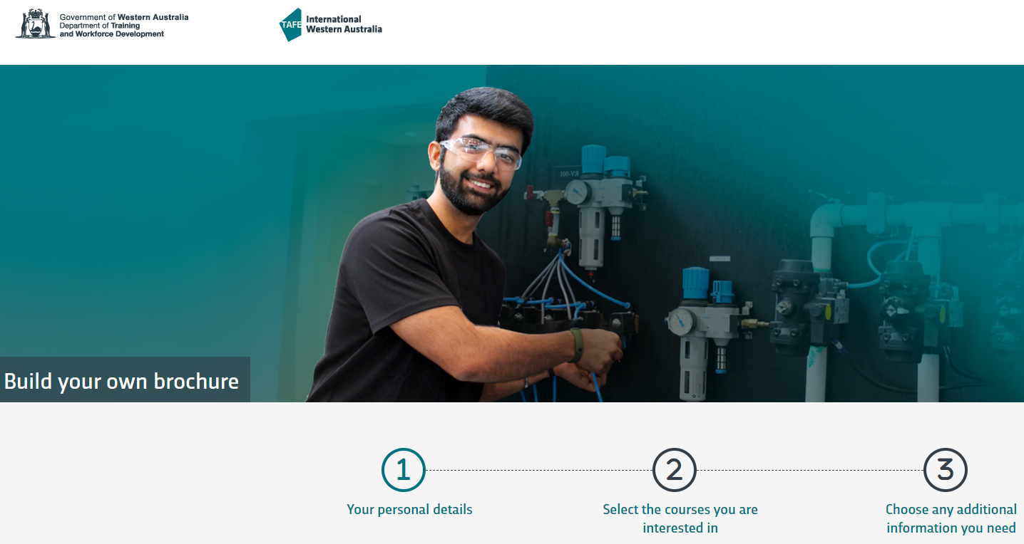

Destination Australia Scholarship

Scholarships are not available on a limited number of courses for international students who choose to study in regional WA. You can get up to $7,000 per semester and additional funding is available to support international students to find employment and accommodation in regional areas.
Check out details HERE.

