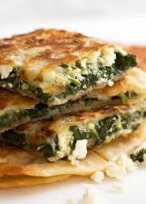

Skye Primary School

**Gozleme**

A delicious stuffed Turkish bread

**Fresh from the garden:** Spinach and lemon

|  |  |
| --- | --- |
| **Equipment:**  Wooden spoon  Knife  Chopping board  Rolling pins  Scales  Measuring spoons  Frypan  Spatula  Oven tray | **Ingredients:**  **Dough Ingredients**  600g greek yoghurt  750g self-raising flour  6 tablespoons of olive oil (for frying)  **Spinach Mix Ingredients**  300g Danish feta  150g chopped spinach |

**Method**

1. Combine yoghurt and flour. Mix with a wooden spoon until dough forms (be patient).
2. Knead dough for 2-3 minutes (add extra flour if sticky). Don’t let the dough stick to the bench or your hands.
3. Cut into portions (one for each person in the class).
4. Roll out into thin circles.
5. Mix the spinach and feta together with your hands (use gloves at school).
6. Add a tablespoon of spinach mix on top of the circles. Fold in half.
7. Heat pan until it is hot.
8. Add 1 tablespoon of oil to the pan and cook gozleme, 30 seconds each side.
9. Place in a moderate oven whilst others are cooking.
10. Serve with lemon.