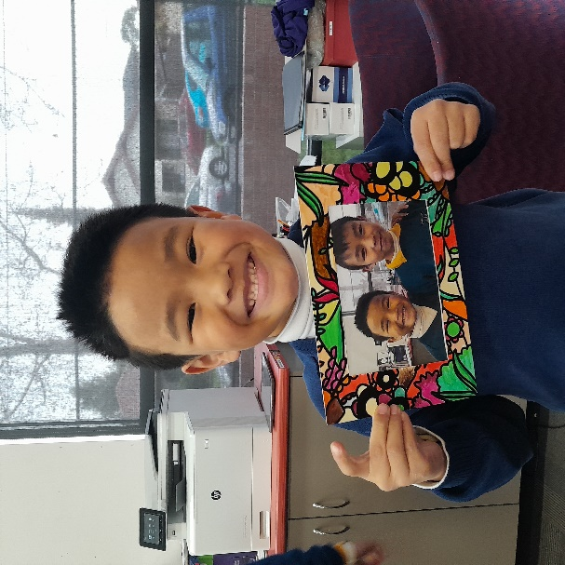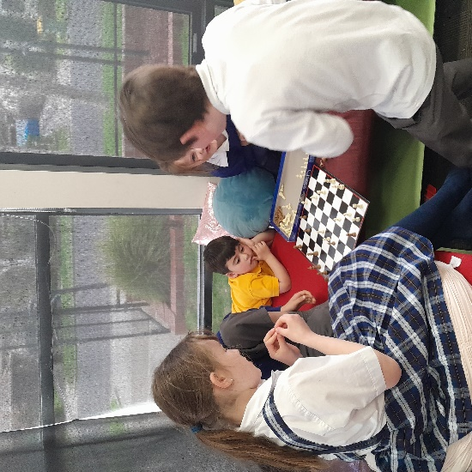

Over the last couple of weeks, we have been setting up our Class Dojo website. We have made it a goal for this term to provide a platform so families can share suggestions and feedback for our service. We will post photos, events, and observations to showcase the children’s learning.

I’ve sent out a text with the link to join our Class Dojo so you can see what the children have been participating in.

Please let me know if you would like me to send you the link again 😊

Thanks so much for the families who have already joined and are leaving comments and likes.

We would really appreciate any feedback

or ideas on what you would like to see us

post on our Class Dojo.

# What’s been happening…

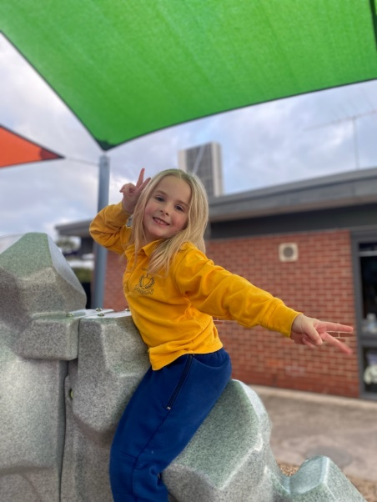

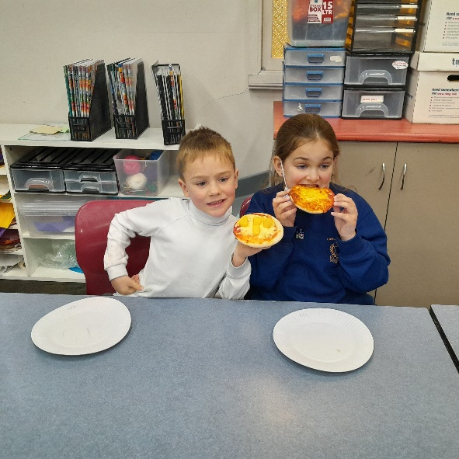

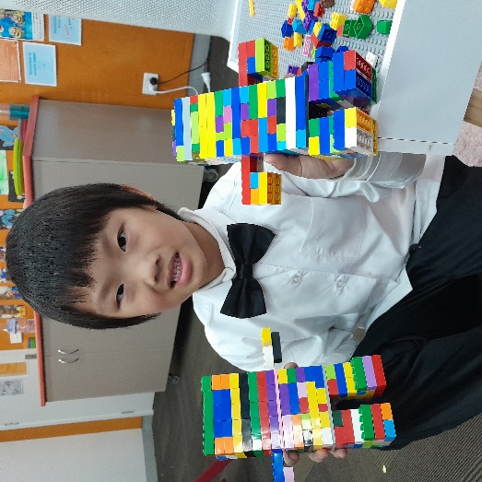

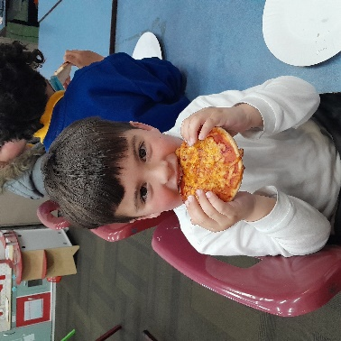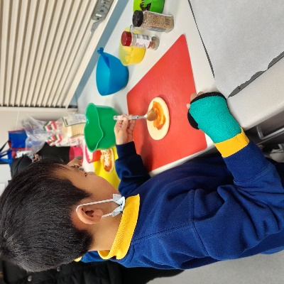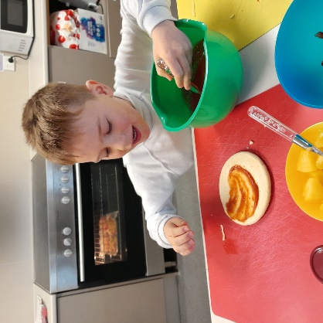

**Quality Area 6: Collaborative partnerships with families and communities**

Over the rest of the term, we will be focusing on families being supported to be involved in the service and contribute to service decisions.

We will be working on this by slowly implementing Class Dojo, which is an online platform to see photos of what the children have been up to.

Wear your footy colours day

If you have any queries or require further assistance, please contact us on 0401 501 661. Our contactable hours are between 7am and 9am and 3pm and 6pm; however, if you leave us a text message or voicemail outside of these hours, we will get back to you as soon as possible.

Furthermore, you can also call our Customer Service & Billing team on 1300 395 735

# Contact Us

First day of Term 4

School finishes at 1pm

# Quality Area Reflection

During discussions with the children at the start of the term, the children were regularly suggesting more cooking experiences and hot food for afternoon snack. Every Wednesday we now make all sorts of delicious meals with the children.

Here are some photos of the children making and eating their pizzas! We have also made fried rice, Mexican wraps and loaded wedges.

# Cooking Wednesdays!

# Important Dates

# Let’s Reflect

During our Sand Art activity on Monday, Izzy was finding it a little bit difficult to peel the paper off and stick on the coloured sand. The other children were happy to help and demonstrated to her how to do it. This built up her confidence and she was able to continue without assistance. She was so proud to show the educators when she was finished and was so happy that she learnt a new skill. Well done Izzy!

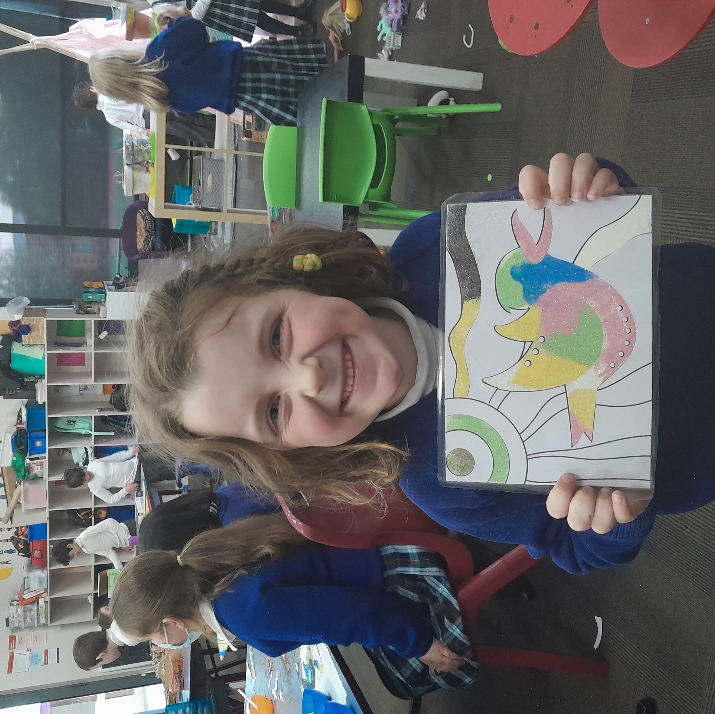

The children collaborated to create playdough from a recipe and then built a big volcano. They each had a turn to pour in the baking soda and the vinegar to see how the volcano erupts!

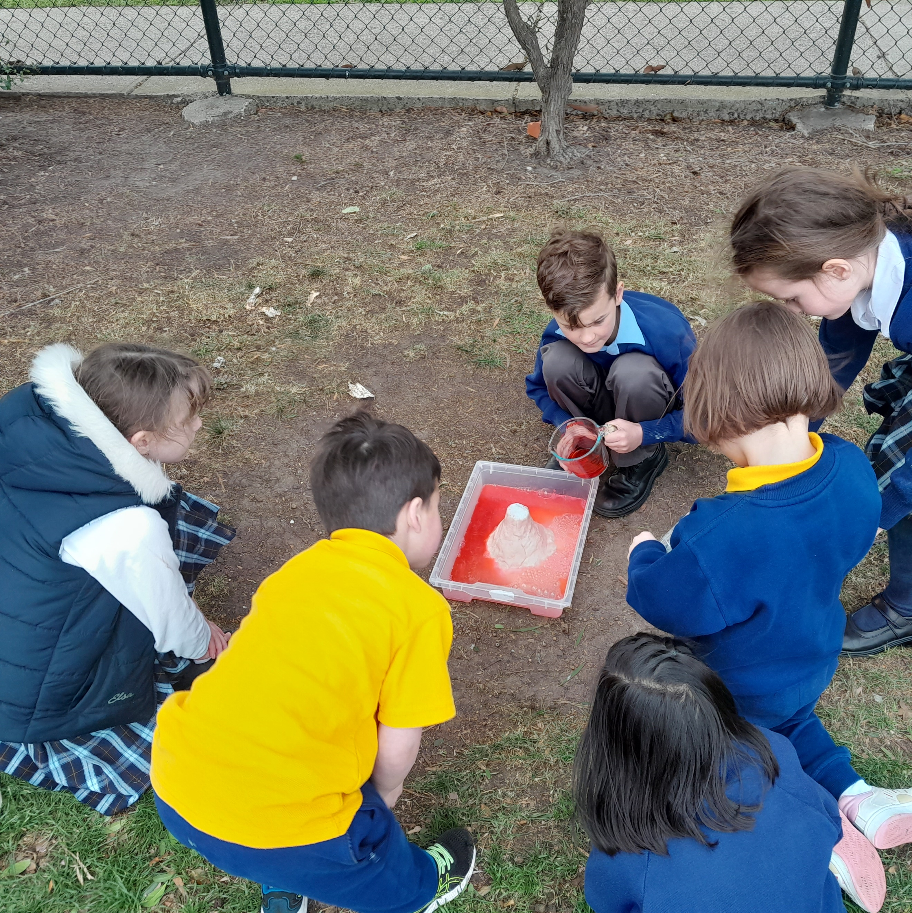

# OSHClub Stars

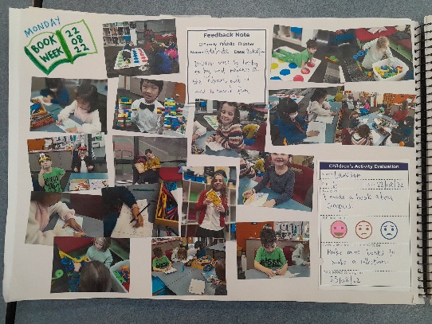

Come in and check our weekly reflection journal!

Inside you’ll find an overview of each day and all the fun activities the children have been enjoying.

Filled with pictures and the kid’s artwork, come in and have a look.

