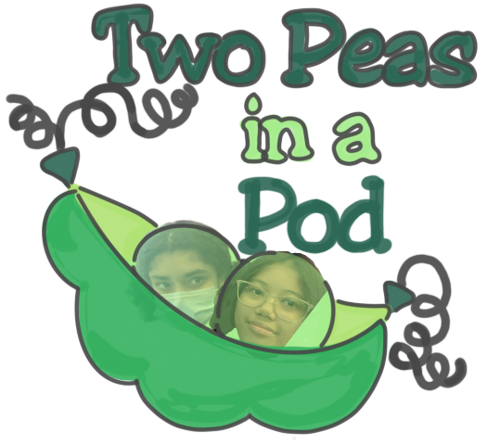
The Exile of a Cat
It was October 19th, the day of the trip, the trip that would change our lives. We arrived at Heathmont Station, in preparation for our journey to the city. We met with our companions and basked in their wonderful banter as well as their utter radiating glory. However, a shocking revelation was held, Kitty did not have permission to bask in the same discoveries that we were so fortunate to have obtained. Leaving our feline friend alone in a world full of hungry wolven beasts with no guidance to her name. Begrudgingly, we would have said goodbye to our friend, but we couldn’t, so we had to move forward on our own path.

The Train Ride of Destiny (Our Trip through Self-Discovery and Addiction)
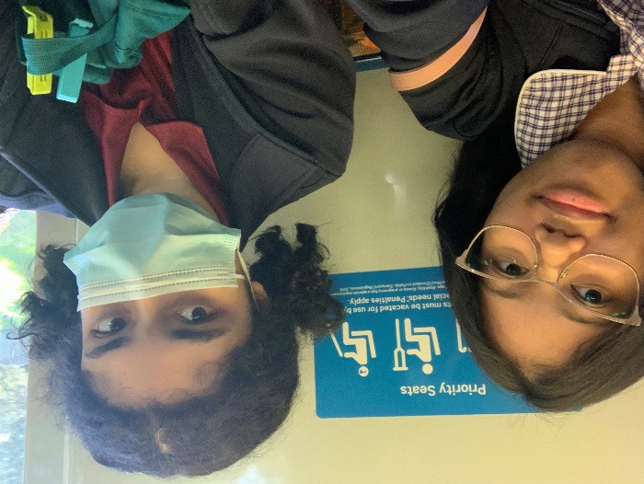
We boarded the train expecting to be bored out of our minds - But were promptly proven wrong, by the revelation of Patricia’s addiction(s). The first perpetrator being a deceivingly lovely little app called ‘Project Makeover’. A game in which you do your makeover projects on desperate recipients. Mind numbingly she opened the app and proceeded to play. This is where I- Daniela step in. I had to put a stop to this malevolent force, as Patricia was already on level 1205! See, Patricia had confided in me about this addiction in the past, and I thought she was getting better. She was not. Last I checked, she was on level 738 -and that was only a month ago!! That means she went up 467 levels in only a MONTH. Crazy right… Now moving, Patricia really did try to combat her addiction, an app she downloaded the day before the trip, ‘I Am Sober’. She in fact, was not sober. This is why the app was here to help! Slowly, the path to restoration was becoming clearer and clearer -until! The devilishly charming app named ‘Resortopia’ entered stage right… I remember it clearly, every time she would open the mysteriously named ‘insta’ group chat, she would type out these bone rattling words;
‘I am playing my hotel game.’
BAM. Already, she was drowning. After only three days she was already back at square one, liters deep in intoxication. She even gave me a tour! It was the most traumatizing, teeth-chattering experience I’d ever experienced! My friend who I’d tried so hard to save from the satanic grip of cutesy mobile games, was now back and settled into her roots. Like a tree. -But that wasn’t the you may ask? Well… It was a beast I wasn’t sure I was ready to tackle. It was only a phrase, yet it did so much- So much harm to my friend who I’d worked tirelessly to save. What was this phrase you may ask well I’ll tell you what, ‘Word Up.’

When Baby Birds Leave the Nest
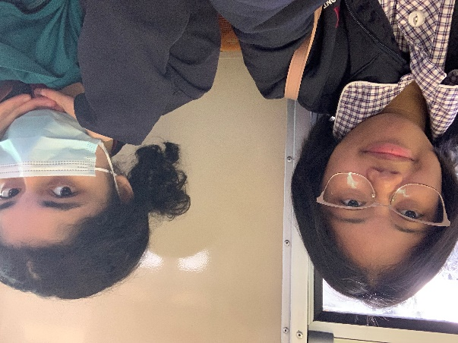
After the train ride full of new-found information about ourselves we were dropped of at Flinders St Station. As a class we all gathered around at Fed Square. We were given directions and boundaries by Mr. Yong. Then we left our fellow classmates and split off with another whimsical pair of girls by the names ‘Hsa Hay’ and ‘Aleisha’. They suggested we catch a tram to Melbourne Central and we happily agreed. The tram ride was squished as all the seats were taken, I (Patricia) was holding onto dear life to make sure I wouldn’t fall flat on my face. Fortunately, we were able to sit down before the end of the ride.
We arrived at our stop and skipped off of the tram.
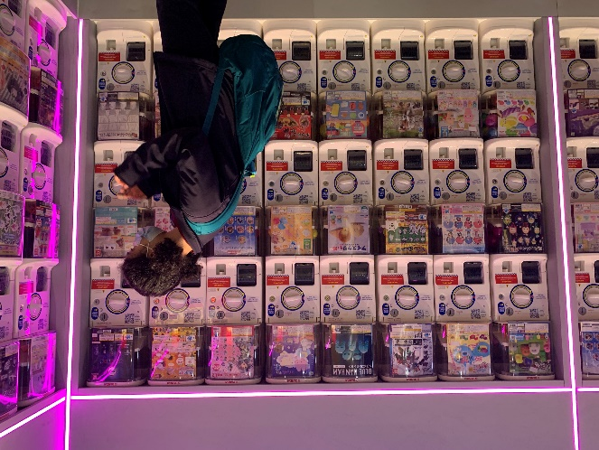
While we were walking through intending to go and get some sushi, we found ourselves astonished by the cacha machines. Upon closer inspection we even found some related to our own personal interests. Such as one of Patricia’s favourite mobile rhythm games, ‘Bandori’. We also saw ‘Attack on Titan’ which Hsa Hay was keen on.
After gawking at the different prizes, we departed and went over to the sushi place called ‘TAKO NORI · タコス’. Hsa Hay ordered her meal, which she said in her own words, was ‘delicious’.

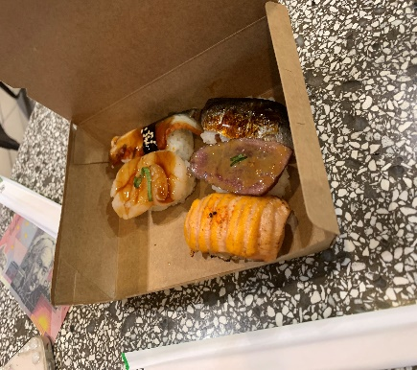
While she ate we discussed on our next move. We were seeking out for suitable candidates for our interviews. Around us there were another group of school students. After being promptly rejected by a young woman we made our way to them. They approved of our request for an interview of the four of them.

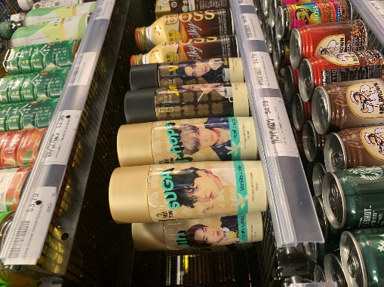
Once we had finished, we met back up with our two fellow Heathmont students and Hsa Hay took us to the Asian grocer, ‘Pantre’. We took a good long adventure throughout the store. Finding some intriguing snacks, Patricia’s personal favourite was the BTS drinks.
Keeping in mind of our next interviews, we talked about how we should buy something from the grocer to give to our interviewees. We decided on Kit Kats and Pocky. But, to our demise our long chat about what we should be giving out had gone on too long. We turned our heads around and then…
Boom! We were left alone!

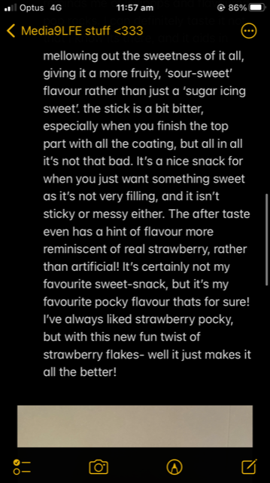
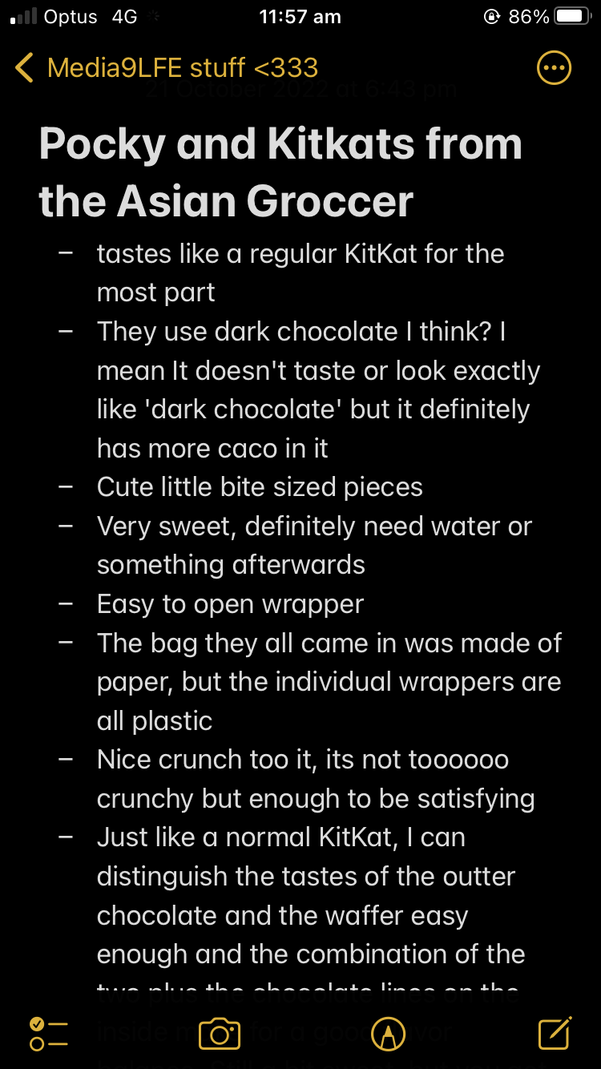
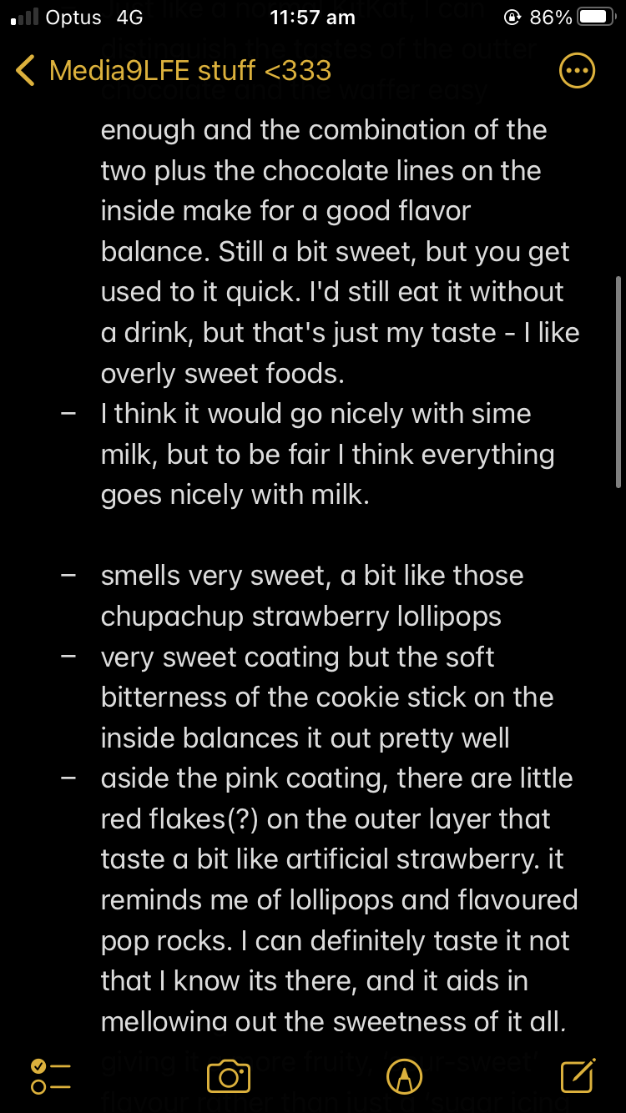
A Tale of Two Ugly Ducklings Left to Fend for themselves (In a World Full of Hungry Wolven Beasts)
Aleisha and Hsa Hay were gone. They left us, defenseless and alone in a dark world of poorly run trains, confusing google maps apps, and wild predators known only as… ‘people’. This was it. It was kill or be killed.
But then we saw the man!!
He was carrying an indecipherable sign and wore a full head cover skull mask. Paired with his baggy black clothes, we knew we had to interview this fine fellow. He was in the café now and we were losing sight of him, if we wanted an interview we’d need to be hot on his tail! But the café was crowded, full to the brim with people yearning for this dashing young mans attention. We were about to lose hope, when… He ended his conversation! Now having him all to ourselves, we dashed at the opportunity to (politely and classily) ask him for an interview.
It. Was. MAGICAL. This was our calling- We’d hadn’t felt this much of a rush of excitement and fulfillment since twenty minutes ago when we departed the group!
We knew what we had to do.
Steeling ourselves and casting a glance to the café behind us, we looked at each other with determination in our eyes. It was destiny- our time to shine! We had to…
Converse with the locals.

Cats Always Land on their Feet, Conversing with the Engrossing Locals (And an Action-Packed Woman from Perth)
Now out of the café, we needed to find people. But not just any people! No, no, no. We needed interesting people. Only the upmost exquisite, and eccentric specimen were worthy of our graces.
That’s what led us to the protests.
-See, we had been walking tirelessly for what seemed like miles. We were tired and hungry, yet our dedication to the cause left us walking past multiple fast food stands, tears in our eyes and stomachs hollow.
We were lost.
As Google maps had already been long abandoned, deemed too difficult to use, we were left to drag our feet- Searching, pleading, yearning for even a dreg of sustenance.
That’s when we saw them. Our climate fighting angels in white and blue. Dressed in handmade hoop dresses and funky hats, they were so awe-inspiring we even forgot to interview them or take a picture!
Suddenly gaining a burst of energy, we followed the dancing protesters through the streets,

Mum, Come and Pick us Up! – The City Ranger Interlude
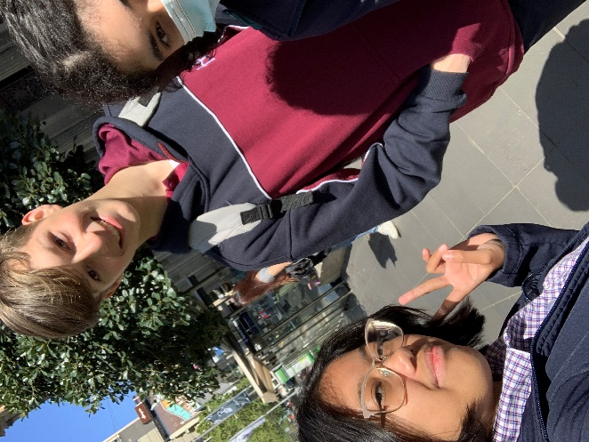
The end of our lovely little interview with the action-packed woman from Perth led us to the realisation that we were stranded. For we have no idea how to navigate our surroundings. In desperation Patricia turned on her phone and attempted to contact our closest, dearest friends. We first tried to call Hsa Hay only to no avail. Then we tried to ring up Aleisha, again to no avail. We thought as hard as we could and came up with a master plan. We would talk to our wonderful City-Life friends, Alina and Joud. We called Alina, once again we were silently rejected as she did not pick up either. But out of the corner of our eyes, we saw the rest of the City-Life class! We ran through the roads (respectably, we did wait for the traffic lights to go green). We yelled, pointed and waved at the other class. Thankfully, Noah noticed us and signaled for us to come to the other side where his class was gathered round. We followed suit. We came to the conclusion that he would be perfect for an interview and he agreed.
After that, Alina finally called us back. She gave us instructions to meet her and Joud at 7/11. In our search for Alina and Joud, we sadly lost Noah and his group. But sometimes in life you must sacrifice. We ran off to 7/11, yet when we arrived we did not see either Alina or Joud. Turns out…we went to the wrong 7/11. But, Alina and Joud being the angels they are, found us. Once we met back up with our beloveds they suggested we go get pizza. To which we happily obliged.

Learning Self Guidance through Found Family in the Shape of a Big Pizza Pie (That’s amore)
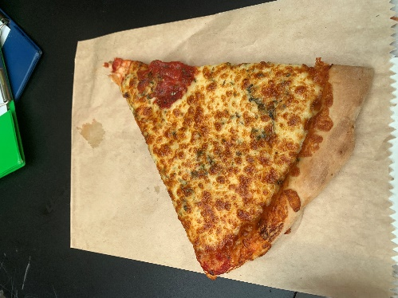
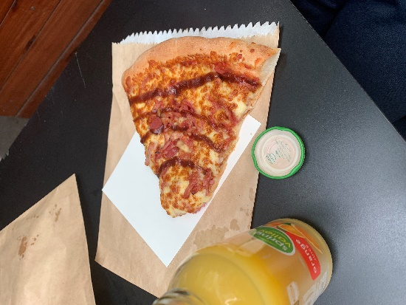
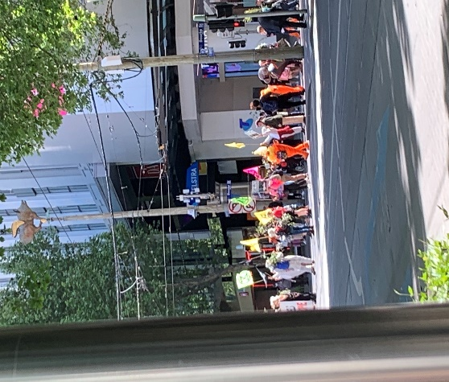
So as our group of two had multiplied and became a group of four, we were taken to a pizza place by the name of Rozzi’s. Patricia got a single slice of margherita, Alina bought cheesy garlic, Daniela got a meat lover’s and Joud had already gotten a huge Slurpee and wasn’t hungry. The slices were absolutely ginormous, and Patricia had to share her slice with both Joud and Daniela, even then not being able to finish it. Giving the rest to the lucky birds that could find it. As soon as Alina took the pizza out of the brown paper bag a bunch of oil came into contact with my fingers, reluctantly she still ate it as she was famished. She said, ‘All I could taste was bits of garlic (YUMMY) and cheese (delicious) and OIL (ew).’ Unfortunately, she could not taste the dough. She rated the pizza a 4/10 or 4.5/10. To which Patricia agrees, her margherita slice was overall…ok. Earning Rozzi’s another 5/10. Another interesting happened while we were eating that quite captured our attention, nearby right across from us were protesters rallied around. They were protesting against climate change, which is a good thing however they were in the way of the road. Not a good thing. Alina and Joud had to get back to their class soon, but before they went off, Alina was so kind enough to teach us how to use Google Maps. With this new-found information we were ready and raring to go. Near us at our tables were a mother and son on one end and two guys sitting down having some Rozzi’s pizza on another end. We offered an interview with the mum and her kid but were rejected. We kept our heads up and moved on and interviewed the two guys instead. Fun thing to note, they had a crazy huge height difference, really making them a contrasting dynamic duo.

After that, we now knew how to guide ourselves. So, after we checked the clock and noticed it was nearly time to head back we set off on our way to the square.
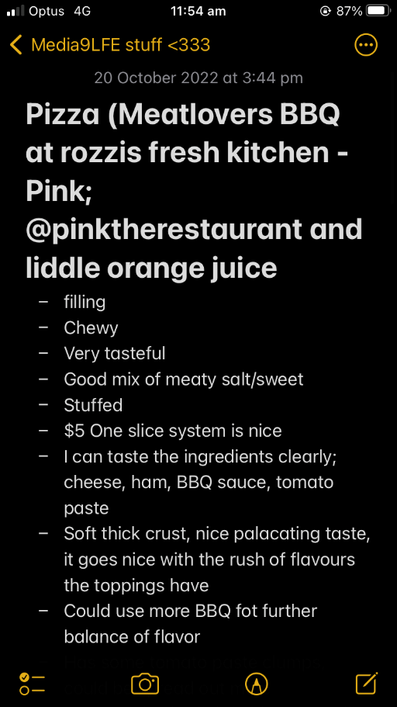
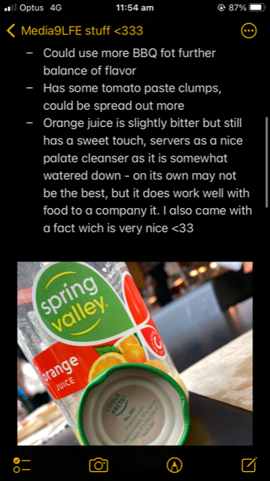

Reading two pages of the National Sunday Law (We became Nationally and Irrationally Devoted
Now having left the very-not-insta-worthy-Rozzi-PINK-Pizza-Pizza’s place, we needed to get back to Federation Square. Despite the fact Alina had taught us the downright trifling ways of Google Maps before leaving, that didn’t change that we had a time limit. -A time limit that was draining fast. With only half an hour to spare, we stampeded down the streets of Melbourne, taking every twist turn and tumble we could. -We even became professional Jaywalkers in the process!!
Our journey took what felt like years and we had to turn our backs on multiple potential-candidates-in-the-making on our way, but at long last, we saw it…
The beautifully geometric silvers of the ACMI building in the distance.
It was just standing there! Standing in all it’s geometric glory! Over-come by pure, all-enchanting, unadulterated, joyous bliss, we almost didn’t notice the man waving books in front of people’s faces.
-I say almost, because the people he happened to be waving books in front of, was us.
(Face full of book, the ACMI theater was no longer in view. So close, yet so far)
Having already turned down many opportunities for interviews, our attentions were now fully grasped by this man and his seemingly never-ending stack of books. We just knew we had to ask him about his adventures here. His book, his purpose, his ideals, his family, how much he weighed, what he had for breakfast this morning, his dream partners hair colour, his home address! His everything! He seemed like the perfect candidate! We needed to ask him all we could, such an all captivating man – who was still trying to get us to take the National Sunday Law books and be on our way mind you – couldn’t escape our grasps!
…
I should’ve listened to my fifth-grade math teacher more. I think he would have something very choice to say about this. Maybe something like; ‘Never go up against a business man!’ but with a lot more aggression and pizazz to it. …Yeah. That sounds about right.
At least it can’t be said we didn’t try! …I think.
REGARDLESS. In the midst of our harrowing tribulations, it felt like we’d wasted so much time, we’d be late! National Sunday Law books in tow, we jaywalked our way across the remaining streets to Federation Square. Only to find!
That we were the first ones there.
-And that we were ten minutes early.
Then I realized I was thirsty. Despite the fact I probably had time to go buy a drink. Despite the fact thirst was scratching its way up my throat, ploughing it’s claws through flesh. -Dry, papery claws tearing through my skin leaving it tattered and frayed, the feeling of someone pouring glass down my esophagus staining my insides, I decided to watch the bird eating Patricia’s left-over pizza instead.
[video]
It left as more people arrived which made me kinda sad, but ever quick to distract me from the pain of my new friend leaving, was a sharp object poking me from the inside of my pocket!
It was the National Sunday Law.
Turning to my dear companion Patricia in glee, I shook her vigorously. It was a sign!!! The Nation Sunday Law!! It really was Law! Immediately at me sharing my revelation, me and Patricia conceded that we must read this astounding work of art. Why shield ourselves from such divine knowledge and purity?
…
Two pages.
Only two pages and we had to stop.
-Because it was so great! The words spun and weaved, twisting into near incomprehensible lines of glory- Really! Neither of us had read a greater book! It was so confusing, that it just had to be written by the ancient hands of the seraphic.
Thirst now long forgotten, still wallowing in our freshly heightened livelihoods, we failed to realize it was now 1:09 – nine minutes since Mr. Yong was meant to find us at the meet up spot. Everyone from our class was here now, all gathered around a small grouping of circle chairs and glass tables. Mr. Yong was never one to be late, so for him to not be here was quite surprising. It was only an exclamation and point that direction our attention elsewhere.
I’m not sure who said it, but we all turned at the noise only to find-

The Bright Yellow Beacon of Light in the Distance
After a long tiring journey of trying to figure out where on earth we were going. We had finally got ourselves back to our original meeting place, Fed square. We looked around to see if any of our other classmates had already made it back. A couple of them were and had be promptly seated on the tables near the ACMI museum. We decided it would be best if we sat down near them as well. While waiting we took another peak at our wonderful newfound sanctity that we know as ‘National Sunday Law’. Eventually, the rest of our class had also found us. We all sat around for some minutes more, waiting for Mr. Yong to come and get us. Soon, it had already reached the time we were supposed to meet up. We looked around and Mr. Yong was nowhere in sight! We all used our collaborative efforts to find him. Lo and behold he had appeared, seemingly out of thin air. Thankfully, his bright yellow outfit made him easy to spot anywhere. We walked over to the corner where he was stood and now we could go to our actual destination. The ACMI Museum!
Finally, Reaching Our Actual Destination

The Tom & Casey Saga (+ Bethany) With A Main Course of Ice Cream
After we dispersed from our little trip at the ACMI museum, we were granted an hour of freedom to do as we please. The whole class spent some time mesmerized by the spinning chairs and we all sat and span for a while. Then we were satisfied with our spins and left to go out on our own. We walked around for a bit and Daniela tried to hop onto one of the scooters. But an old man that was smoking right above us intervened and stopped either of us from any scooter endeavors. Daniela wanted to go to a good ice cream place at Southgate called ‘Cups n Cones’, so we headed off to there. Funnily enough, a good chunk of our class had the exact same thought and we met them there. Daniela tried to order a single ice cream with two scoops, but the worker had a different idea and thought the both of us wanted an ice cream each. She asked us, ‘Are you paying separately or together?’ Leaving our minds boggled. Very confusing for all parties. So, Daniela was left with two separate ice creams, what a main course! We ate outside next to our other classmates and against the windows. This is where we met a very interesting pair of young kids. To which we dubbed, ‘Casey’ and ‘Tom’ respectively. While we ate patiently, they approached us by the windows, first it was just Casey, the younger one that wanted to talk to us. He smacked his hands against the glass, to which Daniela did the same and the two of them played a fun game of smacking hands for a few minutes. Then Tom, the older one approached, he was the more difficult one of the two. When he was given the opportunity to play the same hand game, he rejected and faked a punch. Rude. But, this was not the last of their mischievousness as Casey tried to run out the store! But, thankfully he was caught by his mum, Bethany. That wasn’t the only attempted escape, he tried again only for his efforts to be thwarted by Bethany again. However, this must’ve set off a switch in Tom’s mind as he did the exact same thing. What a naughty bunch. Casey and Tom got their own ice creams only for it to be smothered all over their shirts and the floor. Soon, we had to part ways with little Tom and Casey. Time passed us by and we had to head back. We followed the rest of our class and soon we were back at Fed Square.

Thanks for reading! That’s the end of our blog.

