Play a board game or game of cards | Make a paper boat and see if it floats on water | Bake a cake or cookies | Build a fort in the garden  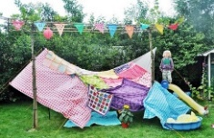 | Plant some veggie seeds (Reject shop sells seeds)
Go for a bike or scooter ride  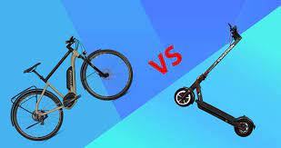 | Write a letter or draw a picture and send it to a friend or family | Draw a family portrait of your whole family | Have a picnic  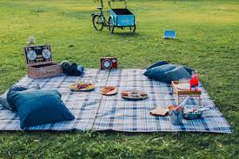 | Go on a nature walk and see how many birds you can see.
Take photos of your toys | Make some fruit jelly | Make a smoothie or milkshake | Do a star watch when it gets dark  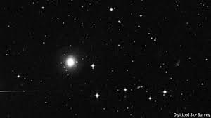 | Read a book  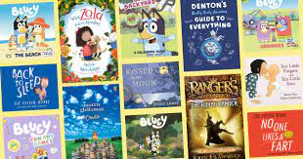
Holiday Activity Grid – How many can you do?

