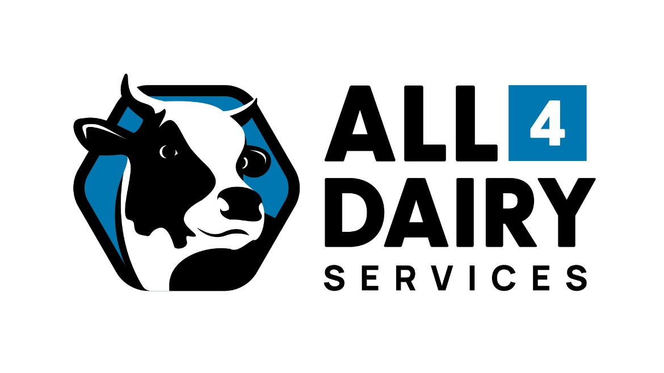

All 4 Dairy Services (an up-and-coming new local dairy business in Leongatha) is seeking an Apprentice to join the team. The desired applicant will be 16+ years, self-motivated, enthusiastic and punctual. Having a keen interest in the dairy industry and willing to work in a team environment. No experience necessary. The apprentice will attend trade school and complete a Certificate 3 in Metal Fabrication.
This diverse role will involve working closely with other technicians and customers on farms in the Gippsland region. You will be taught how to diagnose problems on equipment and effectively solve them in a timely manner. You will also learn construction elements for building, upgrading and repairing dairy systems.
Gippsland is a beautiful area and is one of 3 dairy regions in Victoria. Statistics from 2021 state Gippsland produces approximately 23% of Australia’s milk production.

If this role sounds perfect for you, please email your resume and cover letter to admin@all4dairy.com.au

