**CAREER NEWS** **Friday 16 September**

**Dates to Diarise in Term 4**



* **Year 12 VTAC late applications** – 29 September – 4 November
* **VTAC SEAS and Scholarship applications** – due October

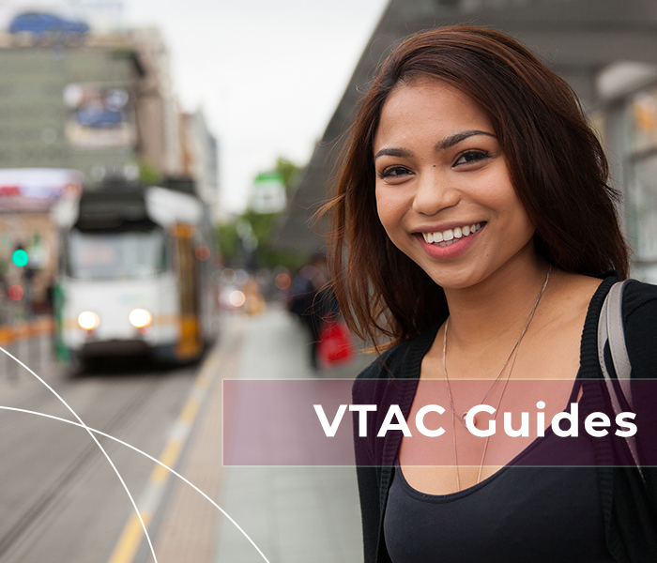 **Reminder: VTAC 2023 Upcoming Key Dates** 

|  |  |
| --- | --- |
| **Timely applications through VTAC** | Thursday 29 September 2022 |
| **SEAS applications close** | Friday 7 October 2022 |
| **Scholarships through VTAC close** | Friday 7 October 2022 |

Also, students applying for courses that have **essential requirements** (i.e., submitting a folio, a pre-selection kit, arranging an interview, etc.) are reminded that failure to meet the deadline date for these means students may no longer be eligible for selection into their desired course.

Students eligible to apply for **SEAS** are also encouraged to apply for **VTAC Scholarships**.

**The VTAC website is** [**www.vtac.edu.au**](http://www.vtac.edu.au)

 **Where can a Law Degree take you?**Graduates of a law degree can use their qualification in a far broader range of industries than is often believed.   
  
There is the **“traditional law”** involving roles as a barrister, corporate lawyer, an associate judge, etc.   
  
However, there are other areas where law expertise is required. These include **international law, cyber law, artificial intelligence**.

Another area where legal knowledge is required is in the areas of **health, aged care, voluntary assisted dying, human rights law,** and **workplace law**.

Finally, there is the need for legal expertise in **arbitration and mediation, government policy, consultancy, journalism,** and **human resources management**.

 **Get Set to Study at RMIT University**RMIT University will be hosting a ***Day at RMIT*** in the upcoming school holidays.  This will be an opportunity for students to begin to get prepared for life after high school.  This in-person event will help students prepare for the transition to tertiary life and eliminate any uncertainties they may have.  Current students will talk attendees through some of the tips and tricks that they wish they knew before transitioning into University, while giving students a chance to meet other students before your first day!

**Date:**Thursday 22 September 2022  
**Time:**1.00pm – 4.00pm  
**Location:**RMIT University - Building 80, 435-457 Swanston Street in Melbourne

**Register to attend this *free* event at**[**A Day at RMIT.**](https://www.eventbrite.com/e/get-set-to-study-a-day-at-rmit-tickets-396308458267?aff=odcleoeventsincollection&keep_tld=1)

 **Angliss School Holiday Events**

* **Angliss Talk & Tour**

Students who are interested in or looking at studying *Foods, Tourism, Hospitality or Events*, are invited to participate in an ***Angliss Talk & Tour***.  An Angliss course expert will take students on a tour of the Melbourne campus and facilities.  This one-on-one tour (parents and friends are also welcome) offers students a good chance to ask questions and seek clarification on Angliss courses.

**Date:**                Monday 19 September 2022

**Time:                V**arious times available

**Location:**555 LaTrobe Street in Melbourne

**Register at**[**Talk & Tour**](https://williamangliss.secure.force.com/dc/reg/Talk&TourSep2022)**.**

* **Travel, Tourism & Aviation Experience Day**

Year 9 to Year 12 students who have an interest in *Travel, Tourism & Aviation* might like to experience life as an Angliss student.  On this day, students will be able to talk with Angliss trainers, explore the Melbourne campus and experience fun and interactive activities at the Experience***Day***.

**Date:**Wednesday 28 September 2022  
**Time:**10.30am – 2.00pm  
**Location:**          555 La Trobe Street in Melbourne

**Cost:**                  $10/pp (includes a light lunch)

**Registrations are essential, and places are limited.  Register at**[**Travel, Tourism & Aviation Experience Day**](https://williamangliss.secure.force.com/dc/reg/TravTourAviExperienceDay)**.**

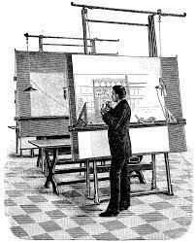 **Career as an Architect  
*Architects*** *use creativity and a practical understanding of structures and materials to develop concepts, plans, specifications and detailed drawings for buildings and other structures. They negotiate with builders and planning authorities, administer building contracts and inspect work that has been carried out. To become an architect, you usually have to complete an accredited degree in architecture. This usually consists of a degree in arts or design with a major in architecture, followed by a Master of Architecture.* Completion of a Master’s degree meets the academic requirements for registration as an architect in Australia. [Good Universities Guide - Architecture](https://www.gooduniversitiesguide.com.au/careers-guide/browse/architect)

The duties of an architect include –

* meeting with clients or builders to discuss their requirements and prepare a design brief
* prepare sketches, production drawings and detailed drawings by hand or using computer-aided design (CAD) software
* combine structural, mechanical, and artistic elements into a building's design, such as decks and atriums, lifts, air conditioning systems and decorative finishes
* discuss designs and cost estimates with clients and others involved in the project
* obtain necessary approvals from authorities
* prepare specifications and contract documents for builders, tradespeople and legal advisers

*Sometime students opt to become an* ***Architectural Draftsperson*** *and this role involves completing architects' and other designers' concepts by preparing documents (drawings or plans) and liaising with builders and contractors -* [*Good Universities Guide - Architectural Draftsperson*](https://www.gooduniversitiesguide.com.au/careers-guide/browse/architectural-draftsperson)*.* Most often, a TAFE qualification – ***Advanced Diploma of Building Design (Architectural)*** *–* is required to fulfil this role, and in Victoria this diploma is offered at a number of institutions including Box Hill Institute, Holmesglen Institute, Federation University, RMIT University, Swinburne University, and Victoria University.

Successful architectural drafts people need to -

* *be able to visualise ideas in three-dimensional form*
* *enjoy technical drawing and working with technology*
* *be able to draw neatly and accurately*
* *have good concentration and attention to detail*
* *have some artistic talent in freehand drawing*

In the case of either of these two roles, both include liaising with other designers and specialists throughout the building process, such as structural and civil engineers; electrical, mechanical, and hydraulic consultants; builders; surveyors; and landscapers.

 **Medical Imaging Courses in Victoria in 2022***Medical imaging technologists operate X-ray and other imaging equipment, such as MRI and Ultrasound, to produce radiographic images which are used in the diagnosis and subsequent management of disease or injury.* Below are links to the specialised medical imaging areas, some of which are detailed in the *Good Universities Guide*: [Nuclear Medicine Technologist](https://www.gooduniversitiesguide.com.au/careers-guide/browse/nuclear-medicine-technologist), [Medical Imaging Technology](https://www.gooduniversitiesguide.com.au/careers-guide/browse/medical-imaging-technologist), and a useful links - [So, you want to be a Sonographer?](http://www.sdms.org/learning/resources/educational/so-you-want-to-be-a-sonographer), and [Medical Imaging and Radiation Sciences at Monash](https://www.monash.edu/medicine/spahc/radiography/geninfo). **In Victoria students can study specific medical imaging courses (also known as medical radiography or medical radiations or sonography) at the following universities:**

|  |  |  |  |
| --- | --- | --- | --- |
| **INSTITUTION** | **COURSE** | **VCE PREREQUISITES** | **2022 ATAR** |
| **CQU**  M - Melbourne Campus | [Medical Sonography](https://www.cqu.edu.au/courses/study-areas/health/undergraduate/bachelor-of-medical-sonography-and-graduate-diploma-of-medical-sonography) | Recommended study in English, Maths, Biology, Physics, Science | 91.85 (M) |
| **Deakin University**  G - Geelong Waurn Ponds  Campus | [Medical Imaging](http://www.deakin.edu.au/course/bachelor-medical-imaging) | Units 3 and 4: a study score of at least 30 in English (EAL) or at least 25 in English other than EAL; Units 3 and 4: a study score of at least 25 in one of Biology, Chemistry or Physics; Units 3 and 4: a study score of at least 22 in one of Maths: Mathematical Methods or Maths: Specialist Mathematics or at least 30 in Maths: Further Mathematics. | 91.40 (G) |
| **Monash University**  C – Clayton Campus  **\***For the first year, you will study units at both the Caulfield and Clayton campuses. The units in years’ two and three are delivered at the Clayton campus. | [Radiation Sciences](https://www.monash.edu/study/courses/find-a-course/2021/radiation-sciences-m2017) | Units 3 and 4: a study score of at least 27 in English (EAL) or at least 25 in English other than EAL; Units 3 and 4: a study score of at least 25 in one of Maths: Mathematical Methods or Maths: Specialist Mathematics. | 82.35 (C) **\*** |
| [Radiation Sciences (Informatics)](https://www.monash.edu/study/courses/find-a-course/2020/radiation-sciences-m2017?domestic=true#overview-1,Radiation_sciences_informatics) | Units 3 and 4: a study score of at least 27 in English (EAL) or at least 25 in English other than EAL; Units 3 and 4: a study score of at least 25 in one of Maths: Mathematical Methods or Maths: Specialist Mathematics. | n/a (C) **\*** |
| [Radiography and Medical Imaging](https://www.monash.edu/study/courses/find-a-course/2019/radiography-and-medical-imaging-m3006) | Units 3 and 4: a study score of at least 35 in English (EAL) or at least 30 in English other than EAL; Units 3 and 4: a study score of at least 25 in one of Biology or Physics; Units 3 and 4: a study score of at least 25 in one of Maths: Mathematical Methods or Maths: Specialist Mathematics. | 98.00 (C) |
| **RMIT University**  B – Bundoora Campus | [Medical Radiations (Nuclear Medicine)](https://www.rmit.edu.au/study-with-us/levels-of-study/undergraduate-study/bachelor-degrees/bp321) | Units 1 and 2: satisfactory completion in one of Biology or Chemistry or Units 3 and 4: one of Biology or Chemistry; Units 3 and 4: a study score of at least 30 in English (EAL) or at least 25 in English other than EAL; Units 3 and 4: a study score of at least 20 in one of Maths: Mathematical Methods or Maths: Specialist Mathematics. | 80.65 (B) |
| [Medical Radiations (Radiation Therapy)](https://www.rmit.edu.au/study-with-us/levels-of-study/undergraduate-study/bachelor-degrees/bp321) | Units 1 and 2: satisfactory completion in one of Biology or Chemistry or Units 3 and 4: one of Biology or Chemistry; Units 3 and 4: a study score of at least 30 in English (EAL) or at least 25 in English other than EAL; Units 3 and 4: a study score of at least 20 in one of Maths: Mathematical Methods or Maths: Specialist Mathematics. | 77.55 (B) |
| [Medical Radiations (Radiography)](https://www.rmit.edu.au/study-with-us/levels-of-study/undergraduate-study/bachelor-degrees/bp321) | Units 1 and 2: satisfactory completion in one of Biology or Chemistry or Units 3 and 4: one of Biology or Chemistry; Units 3 and 4: a study score of at least 30 in English (EAL) or at least 25 in English other than EAL; Units 3 and 4: a study score of at least 20 in one of Maths: Mathematical Methods or Maths: Specialist Mathematics. | 90.30 (B) |

**Optometry Courses across Australia in 2022**The [Good Universities Guide - Optometrist](https://www.gooduniversitiesguide.com.au/careers-guide/browse/optometrist) states that *Optometrists perform eye examinations to determine the presence of vision problems and other eye conditions and disease. They treat or manage these problems by prescribing glasses, contact lenses, optical aids, vision therapy, medication (in the form of eye drops) or referral to an eye surgeon when required.   
Optometrists need to have a patient and caring manner; be able to carry out accurate and precise work, have good communication skills, and enjoy helping people.*

To become an optometrist a student usually has to study optometry at university. Alternatively, they can complete a degree in vision science or a relevant area at university, followed by a postgraduate qualification in optometry. Prerequisite subjects, or assumed knowledge, in one or more of English, mathematics, chemistry, biology and physics are normally required. Entry to postgraduate courses usually requires completion of an appropriate bachelor degree. A number of universities in Australia offer these degrees. Universities have different prerequisites, and some have flexible entry requirements.

**Optometry courses on offer in Australia include -**

|  |  |  |
| --- | --- | --- |
| **INSTITUTION** | **COURSE** | **ENTRY REQUIREMENTS IN 2022** |
| **DEAKIN  UNIVERSITY** | [Bachelor of Vision Science/Master of Optometry](https://www.deakin.edu.au/courses-search/course.php?course=D302&stutype=local&keywords=optometry) | Units 3 and 4: a study score of at least 30 in English (EAL) or at least 25 in English other than EAL An ATAR of 95+ |
| [Master of Optometry](https://www.deakin.edu.au/courses-search/course.php?course=H710&stutype=local&keywords=optometry#ADMISSION-REQ-GEN) | Completion of a Bachelor of Vision Science, or equivalent, with an emphasis on an adequate coverage of vision sciences |
| **FLINDERS  UNIVERSITY** | [Bachelor of Medical Science (Vision Science), Master of Optometry](https://www.flinders.edu.au/study/courses/bachelor-medical-science-vision-science-master-optometry) | Assumed knowledge of Maths Methods, Chemistry and Physics An ATAR of 95+ |
| **QUEENSLAND UNIVERSITY OF TECHNOLOGY** | [Bachelor of Vision Science/Master of Optometry](https://www.qut.edu.au/courses/bachelor-of-vision-science) | English/EAL, Maths Methods or Specialist Maths, Chemistry, Physics An ATAR of 99+ |
| **UNIVERSITY OF CANBERRA** | [Master of Optometry](https://www.canberra.edu.au/coursesandunits/course?course_cd=374JA&version_number=1&title=Master-of-Optometry&location=BRUCE&rank=CCC&faculty=Faculty-of-Health&year=2020) | Only open to students who have completed the [Bachelor of Vision Science](https://www.canberra.edu.au/coursesandunits/course?course_cd=372JA&version_number=2&title=Bachelor-of-Vision-Science&location=BRUCE&rank=AAA&faculty=Faculty-of-Health&year=2020) at the University of Canberra |
| **UNIVERSITY OF MELBOURNE** Note:Students who attain an ATAR of99.00 are eligible for the [Graduate Degree Package](https://study.unimelb.edu.au/study-with-us/guaranteed-undergraduate-to-graduate-study-pathways/graduate-degree-packages) through Biomedicine or Science | [Doctor of Optometry](https://study.unimelb.edu.au/find/courses/graduate/doctor-of-optometry/) | An undergraduate degree (or equivalent), and three subjects at second or third year level (or equivalent) in one or more relevant biological science disciplines plus the GAMSAT or MCAT |
| **UNIVERSITY OF NEW SOUTH WALES** | [Bachelor of Vision Science with a Master of Clinical Optometry](https://degrees.unsw.edu.au/vision-science-clinical-optometry/) | English/EAL, Maths Methods, Chemistry, Physics An ATAR of 99+ |

 **Courses offered by AIM – Melbourne Campus in 2022**The [Australian Institute of Music (AIM)](https://www.aim.edu.au/who-we-are) is a private music school totally dedicated to the pursuit of excellence in music – be it composition, performance, or even management.

AIM has campuses in Sydney and Melbourne, and courses offered in Melbourne include:

[Bachelor of Entertainment Management](https://www.aim.edu.au/programs/undergraduate/bachelor-of-entertainment-management) – a 3-year course for anyone with a passion for the inner workings of the music and entertainment industry.

[Bachelor of Music (Composition & Music Production)](https://www.aim.edu.au/programs/undergraduate/bachelor-of-music-composition-and-music-production) – a 3-year course providing a creative environment for composers, songwriters, electronic musicians, film and screen composers, game composers and music producers to gain their own unique blend of technical, musical, and professional skills.

[Bachelor of Music (Contemporary)](https://www.aim.edu.au/programs/undergraduate/bachelor-of-music-contemporary) – a 3-year course great for instrumentalists or vocalists looking to become a highly accomplished musician, both as a soloist and within an ensemble setting.

[Bachelor of Music (Music Theatre)](https://www.aim.edu.au/programs/undergraduate/bachelor-of-music-music-theatre) – a 3-year course developing skills in four core disciplines: Voice, Acting, Dance and Musicianship. Students will learn to develop the ear of a musician, the body awareness of a dancer, the imagination of an actor and a thorough understanding of the music language.

**Find out more about AIM and all its course offerings by browsing** [**Australian Institute of Music (AIM)**](https://www.aim.edu.au/)

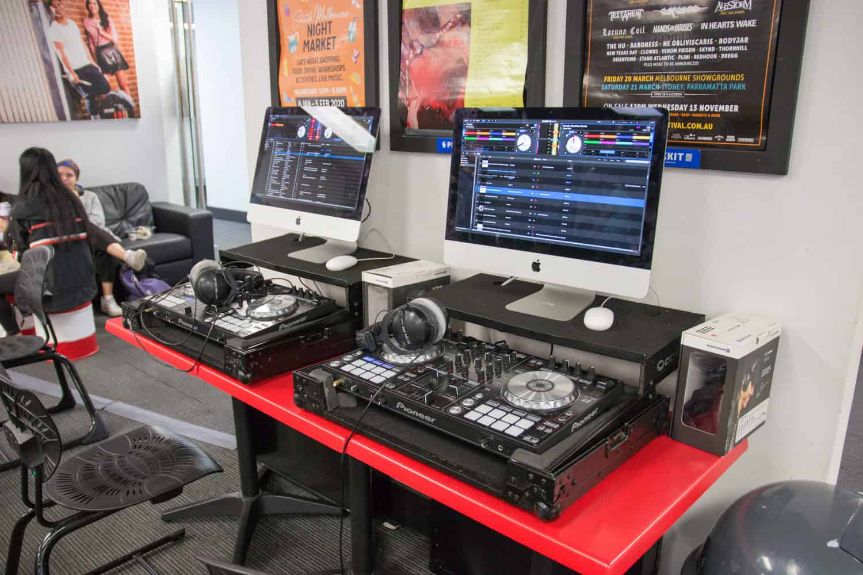

**Snapshot of Torrens University in 2022**

* Founded in 2013, Torrens University is Australia’s international university, partnering with prestigious schools and colleges, to develop a fresh, modern, global perspective for higher education.
* Torrens offers a range of [study options](https://www.torrens.edu.au/studying-with-us/study-options) - undergraduate, graduate, higher degree by research and specialised degree programs in a wide range of academic disciplines, delivering its programs online and at its campuses.
* Torrens has six [campuses](https://www.torrens.edu.au/campuses) – in Sydney, Melbourne, Adelaide, Brisbane, the Blue Mountains, and China.
* Torrens has very strong [industry connections](https://www.torrens.edu.au/our-impact/industry-engagement) and partnerships, and Work-Integrated Learning (WIL) is an essential part of its course offerings – with industry placement built into every one of its undergraduate degrees.
* [Student support and well-being](https://www.torrens.edu.au/studying-with-us/student-support-well-being) is taken very seriously, whether it in regard to requiring academic guidance or social support.
* Partner institutions to Torrens University include –

[Billy Blue College of Design](https://www.torrens.edu.au/billy-blue-college-of-design)

[Blue Mountains International Hotel School](https://www.torrens.edu.au/blue-mountains-hotel-management-school)

* Torrens offers [courses](https://www.torrens.edu.au/courses) in areas including –

[Business](https://www.torrens.edu.au/courses/business)

[Design](https://www.torrens.edu.au/courses/design)

[Education](https://www.torrens.edu.au/courses/education)

[Health](https://www.torrens.edu.au/courses/health)

[Hospitality](https://www.torrens.edu.au/courses/hospitality)

[Technology](https://www.torrens.edu.au/courses/technology)

