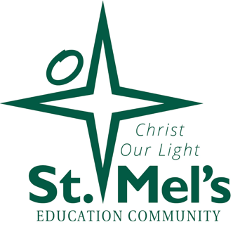

**Letter to St. Mel’s Families**

***ALERT: GET READY FOR THE BEST SCHOOL DAY EVER!***

Hi St Mel’s families,

We are excited to announce that we’ll be hosting *School Fun Run’s Crazy Colour Day* this year, and we need your help to make it a success! Our goal is to raise funds to build a GaGa Pit for the children, and we’re asking for your support as we gear up for this fun event.

What's a Ga Ga Pit?

Click here to find out: <https://www.gagagames.com.au/>

**Event Details:**

* **Date:** Friday, November 8th
* **Location:** St Mel’s School

**What is the School Fun Run?**

It’s an online fundraising program where each family creates their own unique online profile. You can choose target prizes and work toward reaching your fundraising goals! Your profile will include a cyber-safe link to share with family and friends who can donate to help you reach your target.

**What do we need you to do?**

This week, we ask that you create your online profile by visiting [funrun.com.au.](http://funrun.com.au/) The class with the most profiles created by Friday, October 11th will win a special treat – icy poles for everyone!

This is an inclusive event, and we’d love for all families to get involved! If you’d like to come along to watch the fun and cheer on the kids, we’d love to see you there!

**More information to come:**

Please watch the online video – linked to your registration for more information on how the event runs. We will send out further details very soon.

Thank you for your support in making this an amazing day!

Warm regards,

St Mel’s Social Club