
Sausage Rolls
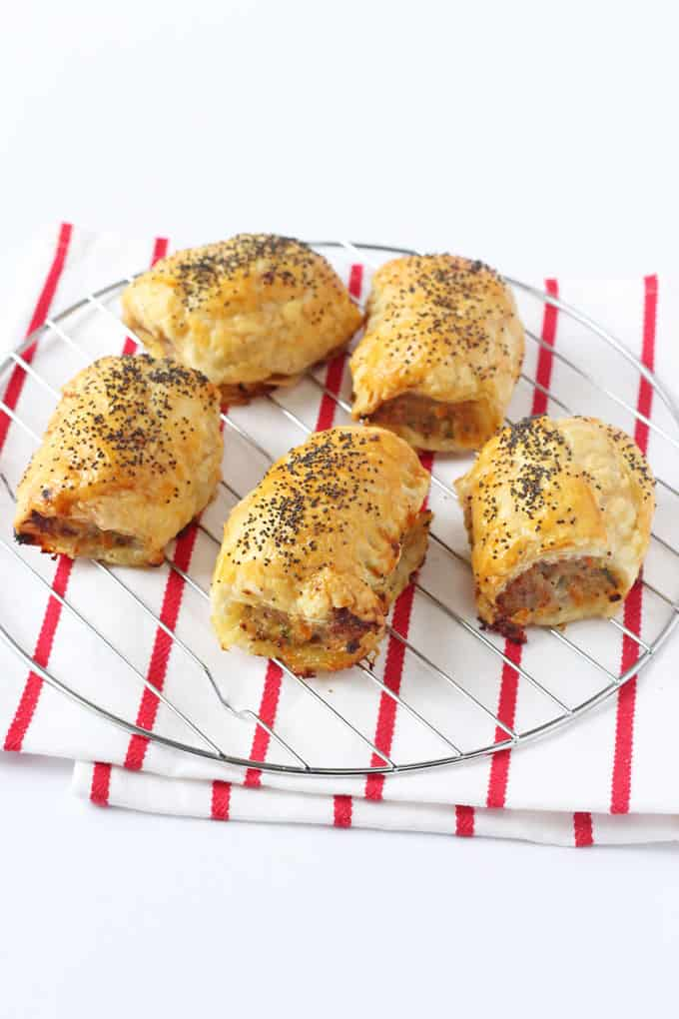

- Baking trays  - Baking paper  - Salad spinner  - Knives  - Chopping board  - Grater  - Pastry brush  - Teaspoon  - Bowl | Ingredients:  - 500g of sausage mince  - 1 medium carrot (grated)  - 1 large onion (peeled and chopped)  - 1 cup of chopped herbs (whatever is available in the garden e.g. parsley, rosemary, basil, oregano)  - 4 sheets of frozen puff pastry  - ¼ cup of milk (for brushing)
  Equipment:

What to do:

- Preheat oven to 220°C.
- Peel and chop the onion, grate the zucchini and carrot.
- Wash herbs and use a salad spinner to remove moisture.
- Finely chop herbs.
- Put the sausage mince into a bowl and onion, carrot and herbs.
- Mix all ingredients.
- Take one sheet of pastry (leave the plastic film on the back). Cut it in half so you have two long rectangles.
- Using a teaspoon, make a log of sausage filling along the long side of the rectangle closest to you.
- Lift the long edge of the puff pastry off the plastic film, and roll it over until the pastry overlaps. Discard the plastic backing.
- Cut the large sausage roll in half, and then into quarters. Cut each quarter into half again (you should have 8 small sausage rolls. Place them onto a baking tray lined with baking paper.
- Repeat step 8-10.
- Brush the sausage rolls with milk.
- Bake for approximately 30 minutes or until golden brown.

