CAREER NEWS Friday 14 August

 Dates to Diarise in Term 3
- University / TAFE Open Days 2026 – late July and throughout August
- Year 12 VTAC timely applications – early August until end September
- VTAC SEAS and Scholarship applications – throughout August and September

 Missing Prerequisites for Allied Health or Education?
ACU now offers free short courses in mathematics and human biology to help students build confidence and meet prerequisites for selected ACU courses.
Courses include 20 hours of flexible self-paced learning and enrolments open 28 September 2026. Students seeking entry for Semester 1, 2027 can complete a short course and sit an ACU entrance test on:
• 3 December 2026
Students applying through the TAC main rounds should sit the test on 3 December 2026. There will be a January test date, but the results will only be considered in later Offer Rounds if there are still places in courses. Completion of a short course and entrance test does not guarantee admission. Students must still meet all other course entry requirements.
Find out more at Short courses in mathematics and human biology at ACU.

 Academic Excellence Scheme
This admission pathway recognises high performance in English and mathematics by applying adjustment factors to boost your selection rank.
Students who demonstrate excellence in high-level English or mathematics in their Year 12 exams, you can attain up to five adjustment factors towards their ATAR to boost their selection rank.
To be eligible for the Academic Excellence Scheme, a student must:
- be a domestic student
- apply for an undergraduate course commencing in Semester 1 or 2
- be completing the VCE the year before university admission (this includes students completing their studies outside of Australia)
- achieve one of the following results in English or mathematics:
A study score 33 – 38+ in English/EAL/Literature or in Maths Methods and/or Specialist Maths

To be considered, students simply apply for their chosen course through UAC. If they are eligible for adjustment factors, these will automatically be added to their ATAR for all eligible courses on their preference list.

Find out more at University of Sydney Academic Excellence Scheme. To learn more about the participating courses and the adjustment factors on offer, browse Eligible courses and adjustment factors.

 Bachelor of Social Work
Are you passionate about improving the lives of children and families and helping to build strong communities for current and future generations?
The Bachelor of Social Work is available for study at Fed Uni’s Berwick, Gippsland, and Mt. Helen campuses. This course has been co-designed with local partners to address this specific skills shortage. Students will participate in 140 days of placement, during which they will be exposed to challenging real-life situations in social work settings.
Experienced professionals in the field will support students every step of the way. They will become confident working with children and families, people of diverse cultural backgrounds and gender diversity. Students will also learn to work effectively with people with substance use issues and mental health problems and in palliative care, child protection, youth services and much more.
Find out more at Bachelor of Social Work.

 News from Deakin University
- Deakin Uni Ready
Deakin is excited to introduce Deakin Uni Ready – a new fee-free government funded program designed to support prospective students into university study.
The program will assist students who do not meet entry requirements or have completed secondary school without receiving an ATAR. Deakin Uni Ready is a part-time yearlong program, delivered in 6-week intensive blocks fully online. It is part of the Australian Government’s Fee Free Uni Ready initiative. The program includes 3 core units and 1 elective that aligns to the student’s future chosen degree pathway. Current Year 12 students can plan to apply for Trimester 1, 2027.
After completing Deakin Uni Ready, students can apply for a range of Deakin undergraduate degrees, including:

• Bachelor of Arts
• Bachelor of Business
• Bachelor of Communication
• Bachelor of Creative Arts
• Bachelor of Criminology
• Bachelor of Design
• Bachelor of Early Childhood Education
• Bachelor of Health Sciences
• Bachelor of Information Technology
• Bachelor of Science
• Bachelor of Sport Development

Upon completion, students must apply through the Deakin applicant portal for their chosen bachelor degree. There is no guaranteed entry, and students will apply through the standard admissions process.
For more information, please visit our website – Deakin Uni Ready.
- Revised Business and Commerce Degrees
Students should note that the Bachelor of Business and Bachelor of Commerce degrees are relaunching for Trimester 1, 2027. The two degrees have been streamlined to help prospective students understand and make the best degree choice for them. A couple of key changes to note are:

• a shared first year in each course so students can explore their options before choosing a major
• 80+ hours of work-integrated learning for all business and commerce students
• updated and new majors that align to industry

Bachelor of Business majors are:
• Business Information Systems
• Business Management
• Entrepreneurship and Innovation
• Human Resource Management
• Marketing Management
• Project Management

Bachelor of Commerce majors are:
• Accounting
• Digital Transformation
• Economics
• Finance
• Financial Planning
• Marketing Insights

Find out more at Business and Commerce.

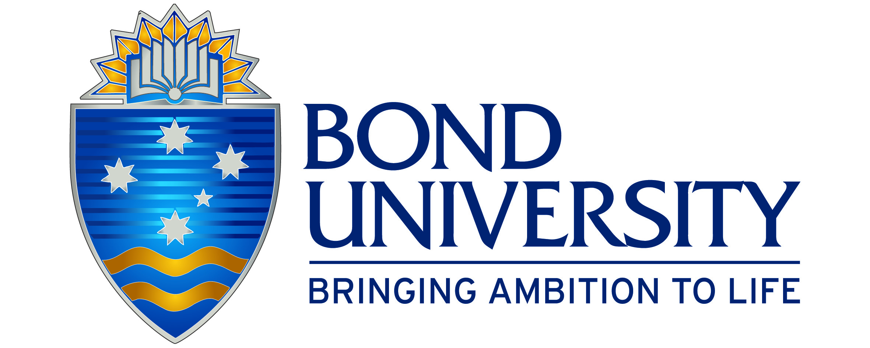Exercise and Sports Science Course Change
The Bachelor of Exercise and Sports Science will be replaced by the Bachelor of Clinical Exercise Physiology from January 2027.

The new program provides a stronger clinical focus, preparing students to work with people living with chronic and complex medical conditions, while still covering exercise science, athletic performance and rehabilitation.

Key differences between the current and new program:

- Duration extended from 2 years to 2 years 4 months
- Increased practical placement from 140 hours to 500 hours
- Designed to align with dual ESSA accreditation pathways as both an Accredited Exercise Scientist (AES) and Accredited Exercise Physiologist (AEP)
- Stronger clinical training in exercise prescription, pathophysiology, behaviour change and digital health
- Expanded career outcomes across hospitals, rehabilitation, allied health clinics, community health and sports settings

Entry requirements: ATAR 70.00, and subject pre-requisites: English, General Mathematics, and one of Biology, Physics or Physical Education.

 Richmond Institute of Sports Leadership
Students interested in a career in sport are invited to join us live at the Richmond Football Club to learn more about the Richmond Institute of Sports Leadership which is delivered in partnership with Swinburne University of Technology.

The Diploma of Sport/Diploma of Leadership and Management is delivered through Richmond Football Club’s partnership with Swinburne University of Technology. This unique program is aimed at developing the next generation of leaders within the sports industry.

This dual diploma combines theory, practical and hands-on learning with a focus on real world skills and knowledge. Students will learn how to enhance athlete performance, manage people and teams, and become a leader.
Upcoming Student Information Sessions:
Date: Monday 17 August 2026
Time: 6.00pm @ Punt Road Oval
OR
Date: Tuesday 18 August 2026
Time: 5.30pm Online

Register at https://cloud.e.richmondfc.com.au/swinburne-course
Media, Communication & Journalism Degrees in Victoria in 2026
Many universities in Victoria offer advertising, media, media & communication, and/or journalism degrees, and many of these are listed below. These areas of interest are often also offered as majors/minors in Bachelor of Arts degrees. This is the case for the University of Melbourne: Bachelor of Arts, ATAR 85.00.
Note: An English is usually the only prerequisite subject for entry.
For a comprehensive list of all courses (including double-degree options) visit VTAC.
INSTITUTION | COURSE NAME | MAJOR STUDIES IN 2026 | ATAR 2026
DEAKIN  G – Waurn Ponds  M – Melbourne | Communication | Advertising, Creative advertising (minor only), Digital and social media, Digital media (minor only), Indigenous studies (minor only), Journalism, Photojournalism (minor only), Public Relations Strategy (minor only), Public relations, Social media (minor only), Strategic advertising (minor only). | 61.50 (G)  60.05 (M)
DEAKIN  G – Waurn Ponds  M – Melbourne | Communication  (Advertising) | Advertising. | 70.35 (M)
DEAKIN  G – Waurn Ponds  M – Melbourne | Communication  (Digital and Social Media) | Digital and social media. | 65.20 (M)
DEAKIN  G – Waurn Ponds  M – Melbourne | Communication  (Journalism) | Journalism. | 66.16 (G)  61.45 (M)
DEAKIN  G – Waurn Ponds  M – Melbourne | Communication  (Public Relations) | Public relations. | L/N (G)  66.30 (M)
LA TROBE  M – Melbourne | Media & Communication | Creative and professional writing, Journalism, Marketing, Sports media. | 60.20 (M)
LA TROBE  M – Melbourne | Creative & Prof. Writing | Creative and professional writing. | L/N (M)
LA TROBE  M – Melbourne | Journalism | Journalism. | 62.70 (M)
LA TROBE  M – Melbourne | Marketing | Marketing. | 60.20 (M)
LA TROBE  M – Melbourne | Sports Media | Sports Media. | 60.10 (M)
MONASH  C – Caulfield | Media Communication | Journalism, Media, Public relations, Screen. | 72.80 (Ca)
RMIT  C – City | Communication  (Journalism) | Communication, Fact checking, Journalism, Media, News, News practice, Podcasting, Radio, Television (TV), Visual and audio journalism. | 64.15 (C)
RMIT  C – City | Communication  (Media) | Asian studies, Cinema, Communication, Film, Literature, Media, Politics, Popular Culture, Production, Radio, Social media, Television (TV), Video. | 63.30 (C)
RMIT  C – City | Professional Communication  (majoring in Advertising, Digital Communication and Public Relations) | Advertising Strategy, Asian studies, Business and Technology, Cinema studies, Client Management, Communication, Creative Advertising, Digital Communication, Digital content development, Entrepreneurship, Gender studies, Journalism, Law and Emerging Technology, Literary Studies, Marketing, Media, Photography, Politics and communication, Popular Culture, Professional communication, Public Relations, Social media, Strategic Communication. | 63.35 (C)
SWINBURNE  H – Hawthorn  * Professional Degree  An excellent pathway course into the B Media & Communication is the Diploma of Screen and Media - Sports Media. | Media & Communication | Advertising, Cinema and screen studies, Creative writing and publishing, Immersive media, Journalism, Public relations, Social media. | 55.50 (H)  75.85 (H) *
 Snapshot of The University of Otago (NZ) in 2026
- Founded in 1869, the University of Otago is the oldest university in New Zealand.
- Students join a diverse population of well over 20,000 students from around New Zealand and more than 100 nations around the world.
- The University of Otago is ranked in the top 200 universities in the world and consistently has the high rating of 5 Stars Plus in the QS global university performance ratings - Why Otago? | University of Otago.
- The University of Otago has campuses in five main centres throughout New Zealand, with its main campus situated in Dunedin. Dunedin is a coastal city situated in the southern part of the South Island - Campuses.
- The University of Otago has four Academic Divisions and students have the option to study courses in any of these departments:
Health Sciences
Humanities
Business
Sciences
- The Health Sciences First Year (HSFY) is is the essential first step into Otago’s health professional programmes, and also an excellent way to begin a degree in biological or biomedical sciences. This foundation year leads into five professional programmes: dentistry, medical laboratory science, medicine, pharmacy, and physiotherapy. It is also an excellent way to begin a degree in biomedical science or any of the broad range of biological sciences at Otago - Health Sciences First Year (HSFY).
- The University has 14 well-appointed and friendly residential colleges - Residential Colleges.
- Australian citizens and permanent residents pay the same fees as New Zealand citizens if they are studying in New Zealand. If they are studying distance learning papers from outside of New Zealand, they will need to pay international fees. They are also not eligible to apply for the New Zealand Student Loan or Allowance unless they have been living in New Zealand for at least three years and are normally living in New Zealand. For further information about the fees of various courses, visit Australian Student Study Fees and New Zealand Study Loan for more information about study loans.
- Minimum ATAR of 69.60 or above is required for consideration for university entrance from an Australian school.
To find out more about studying at the University of Otago, visit University of Otago.

