STC South Camberwell Cricket Club



Season 2024/25

**GIRLS WANTED!**

**STC are again fielding girls cricket teams for season 24/25**

**All ages & abilities welcome from 9–16 years: Stages 1 & 2 teams**

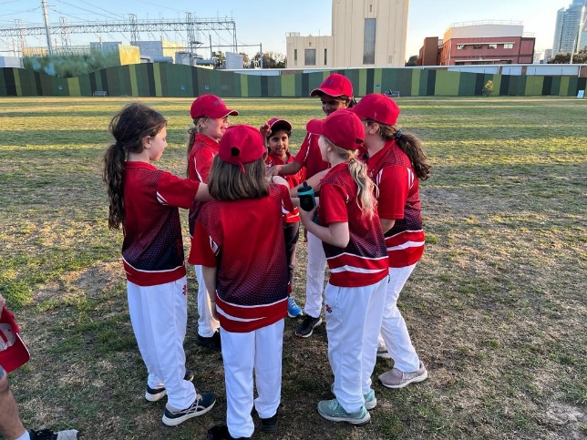

Registrations are now open! Only $**115** for the season to play

[https://www.playhq.com/cricket-australia/register/628952](https://stccricket.us13.list-manage.com/track/click?u=bdf18770996076a240770a07c&id=a1f5dcde21&e=1e6f648c3e)

***Why play at STC?***

We are a supportive, family friendly club with number of teams for all levels of ability. We have strong ties to the local community

And a proud history of inclusion and participation

***All girls of any skill or age level are welcome!***

Training will begin in October and games will be played on Wednesday evenings from 5:00pm from Oct-Dec and then Feb-March

For further information contact the club at info@stccricket.com.au or Chanika Dias- [chanika.dias@gmail.com](mailto:chanika.dias@gmail.com)or

Nick Adams- [adamsnickj4@gmail.com](mailto:adamsnickj4@gmail.com)

Nettleton Park – Gardiner Parade, Glen Iris 3146

[www.stccricket.com.au](http://www.stccricket.com.au)