**Expert advises how to handle stress of VCE exams**

Ashley Argoon, Sunday Herald Sun

October 8, 2017 3:36pm

Subscriber only

SECRETS to success for this year’s VCE exams have been revealed as 85,000 students prepare for the biggest tests of their lives.

Ahead of Monday’s start of exams with language and performance, an expert has broken down the tricks and tips for memory recall and pushing past the dreaded mind blank.

Melbourne University educational neuroscientist Dr Jared Cooney Horvath said students crippled by a mind blank in the middle of an exam needed to “calm down”.

“Your brain interprets the situation as a threat — even for a split second — and in that moment it wipes your working memory clear,” Dr Cooney Horvath explained.

“If you have a mind blank, it’s just your threat response, it doesn’t mean you forgot everything.”

His tip for VCE students who suffered a mind blank in an exam — just put the pen down.

“When it happens, 60 seconds of pen down and let go is the most important 60 seconds you’ve got,” Dr Cooney Horvath said.

“It’s the one thing you don’t want to do, but it’s the one thing that will bring you back online.”

Dr Cooney Horvath said students should put their pen down, close their eyes and take a deep breath.

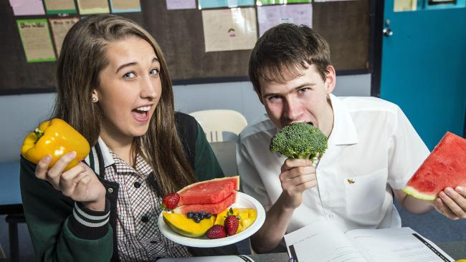Avoiding processed foods can help students. Pictured are Melba College VCE year 12 students Rebekah Wynne, 18, and Matt Pike, 18, trying some healthy alternatives. Picture: Sarah Matray

Once they calmed down, then they could find a way back into the exam.

“Flip back within the test, or to something you already know, or if you can’t find an easy entry point, spend 60 seconds just thinking like you would at home,” he said.

VCE students could also get themselves ready for exam pressure by studying under test conditions, at a desk in a quiet room and to the allotted time given.

“Don’t study sitting on your bed or with music on or the dog running around,” Dr Cooney Horvath said. “Start mimicking that exam right now.”

Stress also had a huge impact because “it eats away at your memory and ability to recall things”.

“The less you can stress now, the better it will be going in to the exam,” he said.

Dr Cooney Horvath offered students a confidence booster: “Just let them know that I believe in all of them and they can all do it.”

Language oral exams and performance exams including dance, drama and theatre studies begin from Monday.

Written exams start with English on November 1, followed that same week by psychology, economics, biology and further mathematics.

**DR COONEY HORVATH’S VCE STUDY TIPS FOR ...**

**STUDENTS**

**1 — GET IT OUT**   
- Focus on getting information out rather than getting it in.  
- Memory works in three stages — encoding, storage and retrieval.  
- And while getting the information in is important, getting it out is what’s vital in tests.  
- Don’t repeatedly reread, review or relatch.  
- Instead, draw it out by summarising information in a three-minute pitch to your parents, do a practise test or quiz yourself with flash cards.

**2 — SPACE IT OUT**   
- Don’t cram your study in, spread it out.  
- Three hours of study today is less beneficial than if you spaced it out to an hour today, an hour in two days and an hour in a week.  
- It gives the information time to consolidate and will help with memory recall.

**3 — MIX AND MATCH**   
- Jump between studying for different subjects.  
- When you alternate your study, you subconsciously create connections between ideas.  
- Spend about 20 or 25 minutes strongly focusing on one subject, have a five-minute break, then repeat with a different subject.

**PARENTS**

**1 — GET INVOLVED**- A lot of parents avoid this but being a part of your child’s study stops them from cramming.  
- And if parents interject, it forces kids to do their work.  
- Ask them to summarise information, quiz them and hold them to time.

**2 — EMBRACE ERROR**   
- The more mistakes we make, the better — it’s literally how we learn.  
- If kids mess up they will recall that mistake and be less likely to repeat it.  
- And the more mistakes they make in practice, the less they will make during tests.

**3 — SCHEDULE**   
- Come up with a study schedule with your child and hold them to it.  
- It’s easier to hold them to account if it’s locked into a timetable.

**HEAVY HITTERS BACK ROUTINE ... AND THE REST**

PAST students who smashed last year’s VCE exams have offered advice to the class of 2017 as exam season looms.

The three high performers all shared similar advice — balance is key.

“During the exam period, still do normal things,” said former Montmorency Secondary College student Tom Jeffs, who got an ATAR of 96. “I worked a couple of nights, I went to the gym. I didn’t just study all day every day, you’d drive yourself insane.”

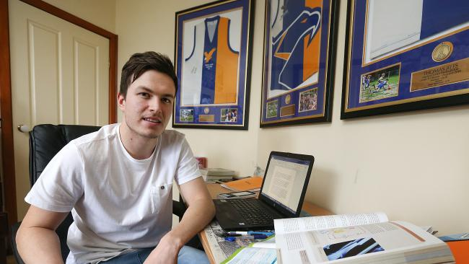Tom Jeffs mentors year 12. Picture: Ian Currie

Year 12 was a difficult time for Mr Jeffs, now studying physiotherapy at La Trobe University. “My mum was sick during the year, I didn’t know the depths of it; she passed away a month after my last exam,” the 18-year-old said.

He now mentors year 12 students at his old high school, telling them to “try to keep a normal routine, otherwise it will drag you down”.

“My English teacher told me, ‘It’s only a short period of time, it’s not a big part of your life’,” he said.

Mr Jeffs’ school mates Luke Pollock, who was dux of the school with an ATAR of 99, and Jamisyn Gleeson, who got 93.35, also made sure they took time out for themselves during exam study.

“I made sure I took care of my physical and mental health, I exercised, kept active, went running,” said Mr Pollock, now studying aerospace engineering at RMIT.

“It takes your mind off VCE and you need an outlet.

“People who had an outlet seemed to be more stable.”

Ms Gleeson faced a tough year in VCE, moving out to a friend’s house during exams after family troubles.

“I didn’t have a good home life so it was quite stressful at times,” the Monash arts student said.

“But I had to ignore all that and realise it’s not going to last forever.

“I had the mentality, ‘Try your very best because it’s the best you can do, and everything will be fine’.”

And for those who planned on doing last-minute cramming the night before exams, both Mr Pollock and Ms Gleeson urged students to get a good night’s rest instead.

“Take it easy, don’t stress yourself and don’t stay up all night,” Ms Gleeson said.

Mr Pollock added: “You might know everything but if you’re half asleep, you’re not going to do as well.”

[ashley.argoon@news.com.au](mailto:ashley.argoon@news.com.au)

[@ashargoon](https://twitter.com/AshArgoon)

**EAT SMARTER TO CLEAR BRAIN FOG**

**Kieran Rooney**

FISH may be the best brain food going around, but high school students need more than fish fingers to get them through exams.

Dietitian Melanie McGrice said a meal plan full of nutrients from fruit, vegetables, nuts and lean protein foods were the best way to give children an advantage in their VCE results.

“There is a decent amount of evidence suggesting the Omega 3 in fish can influence concentration and learning ability, but that’s not something you want to only do at the last minute while cramming,” she said.

“In the weeks leading up to the exams one of the most important tricks is eating small regular meals rather than going hours and hours without.

“They will provide continual food for your brain and should include small portions of red meat, fish, legumes and a serve of low-GI whole grains.”

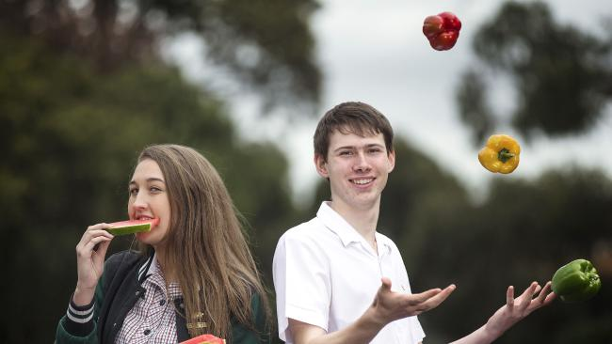Melba College VCE year 12 students Rebekah Wynne, 18, and Matt Pike, 18, tuck into healthy foods. Picture: Sarah Matray

Ms McGrice said it was important to avoid processed foods that provided quick sugar hits.

“Fruit makes a great snack, so having that with yoghurt or a fruit smoothie is a much better alternative,” Ms McGrice said. “Choose foods which are nutrient-dense to keep your brain fuelled through a slow release of energy.

“If you delay a meal, you end up with brain fog.”

Melba College principal Terry Bennett said students were instructed on diet and healthy habits at the start of the year.

“We set aside a day early when we get clinical psychologists like Andrew Fuller to talk about eating correctly and being well rested,” he said.

“If you can stomach it, I always say sardines are the best way to get the day started.”