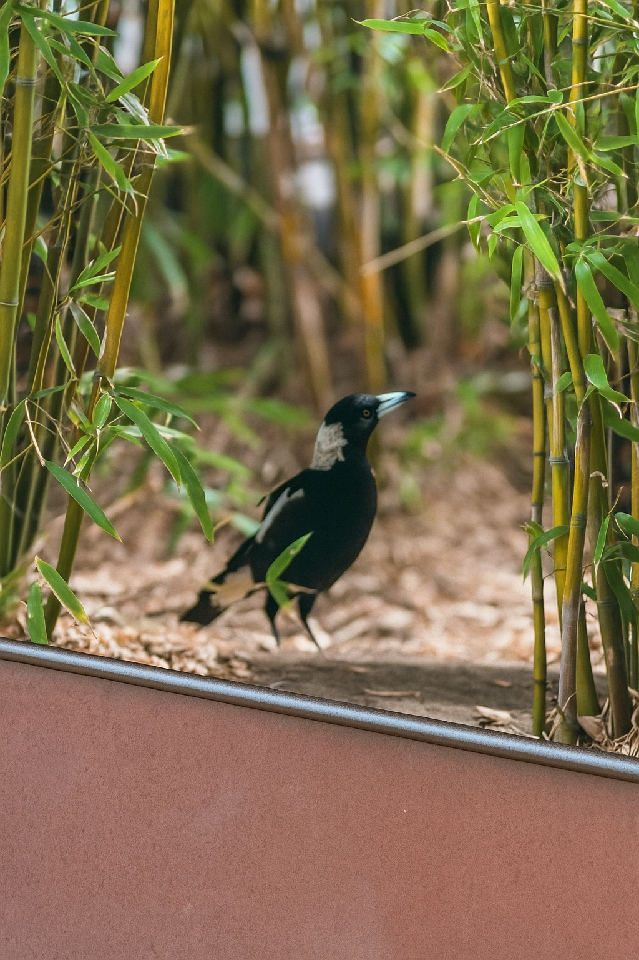
Image taken at BVSPS
By Henil Patel

This is image consists of a magpie sitting amongst a plot a of bamboo. Its been taken in the morning while the sun is out, it is sitting in a clearing. The sun hits the bird as a shadow appears in front of it. The image gives a sense of calmness, becuase of the nature around it, along with the colour contrast of green to black.

