SEA NEWS

Open Night
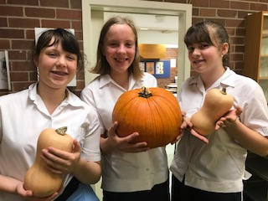
Tuesday 26 February, 3 year 9 students Mae Mitsak, Ella Davis and Sophia Carlson presented to the visiting families and the future year 7 for 2020 or 2021, the purpose of the Environmental Ambassador group. Using the produce from the garden, the interactive board and a small speech, we discussed various projects that we have worked on in the past and some initiatives we will be working on for this year. The experience was enjoyable and a learning curve for presenting in front of various groups of people.

Year 9 Representative
Ella and Mae

Clean up Australia day

Thank you to the year 7’s and years 8’s that participated in the ‘Clean-Up Australia day during DEAR on the 14th of March. It was an amazing success, many students helped to make the school cleaner and it showed. We all had a lot of fun helping to educate you all on the importance of picking up your rubbish and I hope that you enjoyed your Zooper Doopers!
Year 10 Representative
Kiara Green

Climate strike: Towards a Better Future

On Friday on the 15th of March 150,000 student’s country wide went on strike to call for climate action along with another 1.5 million students worldwide. Inspired by the original action of Greta Thunberg of Sweden. It was an incredible turnout with a venue that had a supposed capacity of 10,000 but managed to squeeze in 30,000 students. All students showed great enthusiasm for the cause and the energy levels were through the roof. The young generation is hopeful to change the attitudes towards climate change and secure a sustainable future for our planet.
Year 10 Representative
Ada Kelly

