

REMINDERS:

Non notified absences will incur a $20 fee. Please be sure to notify the service via phone or via the parent portal app.
Term 4 is flying by, Halloween is over and Christmas is approaching. Term 4 is always filled with so many exciting things, and fun are excited to let everyone know that again this year we will be working with Have a Little Hope and running a Christmas Toy Drive, more info to follow.
We have been busy making spooky crafts and talking about costumes, we always enjoy joining in on the fun during the spooky season.
Every term this year we have had a focus point on improvements to the service; this term we are hoping to increase our family outreach and make Oshclub a completely inclusive space for everyone. We would love for families to reach out and help us improve our service from meals, activities to clubs.
As this is now term 4 we do wish to remind parents and families that all children playing outside will require a hat and sunscreen.

What’s been happening…
BUNYIP
OSHCLUB

Policy Corner

Child Safe Standard
Sun Protection
Child Safe Standard 3
Here at OSHClub, we follow the Child Safe Standards which is a list of 11 standards tha t we need to implement to keep children safe. Child Safety Standard 3 is: Children and young people are empowered about their rights, participate in decisions affecting them and are taken seriously. We embed this standard by promoting children's voice/ideas and implementing it within our program through activity/menu evaluations, child's meetings, and planning child-led activities, as well as implementing leadership roles where children can feel empowered in participating in decision makings and planning. If you have any further suggestions on how we can embed this standard, please let us know!

As we enjoy the warm weather, it's important to remember the significance of sun protection for our children. With the extreme heat, children are more vulnerable to heat-related issues like dehydration and heat stroke. Our Educators are ensuring that sun safety is integrated into our program planning. A sunscreen station is set up in the service and children are reminded to reapply sunscreen every 2 hours and 20 minutes before outdoor play. Supervision is crucial in ensuring children are protected from the sun. Educators model good sun safety practices, especially during outdoor activities. Educators understand the UV Index is important, and any ratings over level 3 require sun protection measures. Sun safety resources, including posters are available around the service, and they are use as discussion starters in children’s meetings. Let's work together to keep our children safe and healthy under the sun!

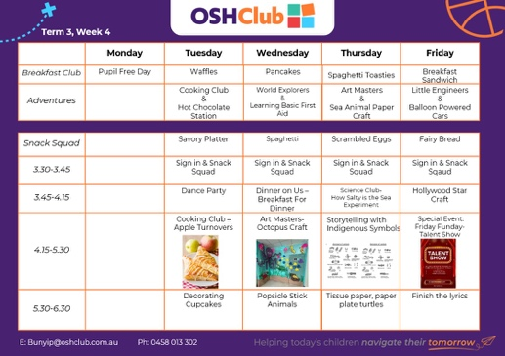
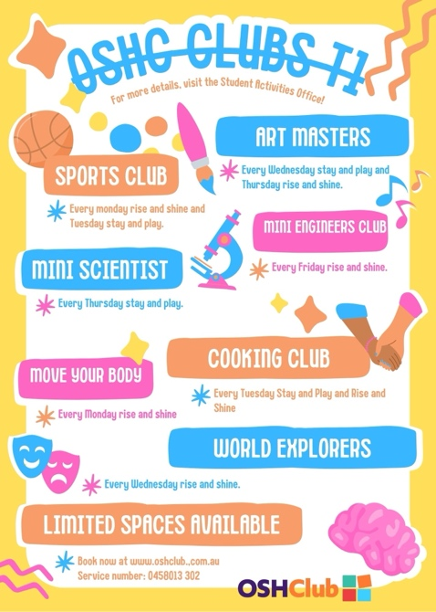
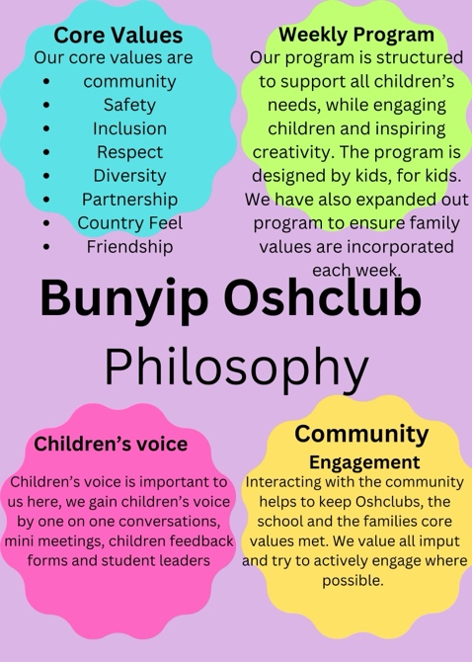

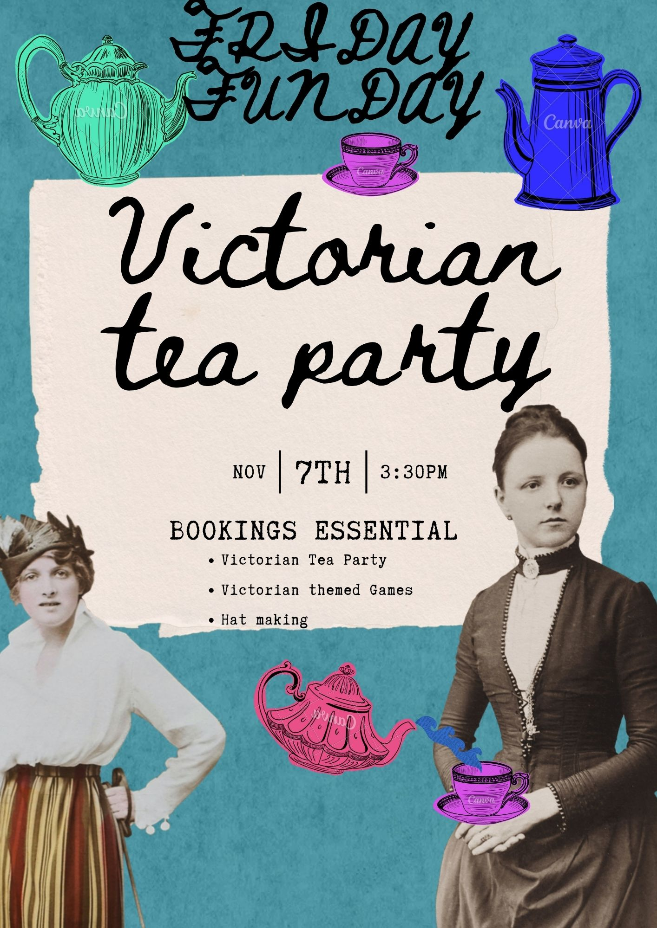
Upcoming Events

PHOTO GALLERY
