St Josephs School - P T & F Committee
Hi Everyone
Welcome to 2021! After a mixed up 2020, the P,T&F Committee is once again hoping for a successful year of fundraising and promotion of our School.
Fundraising
Our first fundraising event will be the annual Easter Raffle. Traditionally each year, the PT&F ask families to donate eggs or Easter themed non-perishable items, (for those who do not eat chocolate) for this raffle. We then put together a sizable 1st Prize basket and many runner up prizes. It is fantastic to see the kids head home in the afternoon with a prize or 2. 😊
Please drop your donations into the front office during office hours and the lovely ladies there will look after them until the drawing date. Tickets are sold for $1each and the raffle will be drawn on the 31st March 2021. Tickets will be handed to the children today, so please have a look for these in their school bags.😊 Additional books can be requested from the front office if you require more.
At our next meeting 2021 fundraising ideas will be discussed and agreed upon, so if you have any suggestions for creative fundraising opportunities, come along to the meeting and share your ideas. After this meeting a calendar of events will be sent out in the newsletter, offering families the opportunity to help out wherever you can. This is not only great for the school, it’s great for you too. It allows parents to socialise outside of a school environment, whilst promoting our school in the local community. So please keep an eye out for this and come join in the fun!
Annual General Meeting
A quick reminder and notice to all parents, teachers and friends of St Joey’s that the Annual General Meeting for this committee will take place at 6:00pm on Wednesday 3rd March 2021, in the school Library. This committee is open to all interested parents, caregivers, teachers and friends. All are welcome to attend, participate and have their contribution heard.
Mrs Long and a number of staff are regularly present at these meetings and welcome all suggestions in helping our School become bigger and better.
The PT&F Committee is a terrific environment that not only helps the school with the purchase of items not readily available through mainstream funding, it is also a place where you can get to know other parents outside of the school pickup area. Please take the time to come along and see just how we can help our school improve and our children benefit from our efforts.
Facebook Pages
A quick introduction, and reminder, to parents about the Facebook pages available for St Joey’s.
The first being the official St Joseph's School FB Page where you can find information in relation to the School.
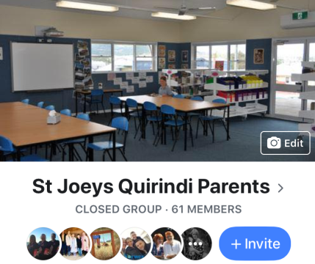
The second Facebook page is for St Joey’s Quirindi Parents. This page is mostly to do with everyday items, such as lost items, uniforms for sale, swap, fundraising, working bees etc. This page is a “Closed Group” and is only visible to those approved members. Any parent of St Josephs’ is able to be a member upon request.

Please take the time to “Like”, “Follow” and “Request” both of these pages for updates about our school.

Thank you for your support of our wonderful school!

