Bucket Hat Fundraiser – cost $30 each

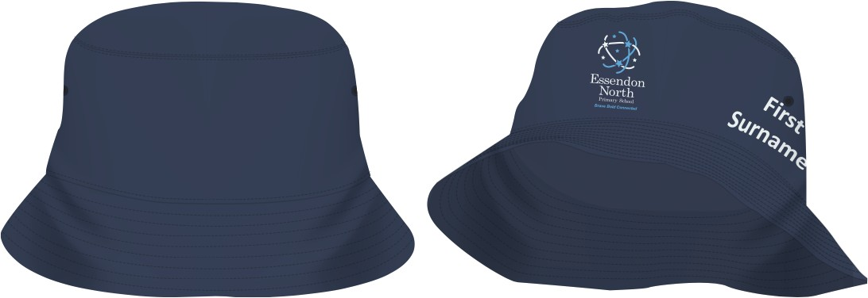

Dear Parents and Carers,

As part of our ENPS Sun Smart Policy, all students must now wear a sun protective hat each day.
If you would like to purchase a personalised Bucket Hat as a part of our fundraising program, please see the form below. All hats are personalised with your child’s FIRST and SURNAME printed on the side of the hat. (See attached digital image) We ask that no nicknames are used, however shortened first names can be used as appropriate.

Complete the following [please print clearly] and return with payment to Teresa.
Please visit the office for sample sizes.

First Child’s First Name and Surname (no nicknames):
Hat size (circumference): S/S (54cm) S/M (56cm) M/L (58cm) Cost: $30

Second Child’s First Name and Surname (no nicknames):
Hat size (circumference): S/S (54cm) S/M (56cm) M/L (58cm) Cost: $30 Total: $60

Third Child’s First Name and Surname (no nicknames):
Hat size (circumference): S/S (54cm) S/M (56cm) M/L (58cm) Cost: $30 Total: $90

NO orders will be taken after Friday 17th October 2025
Payment options:
Cash (please provide in a sealed, clearly marked envelope or bag to Teresa)
Credit card Please enter your card details below:

Cardholders Name:
Visa Mastercard
Card number:

Expiry Date: / CVV:

Cardholder’s signature:__________________________________ Amount: $___________

