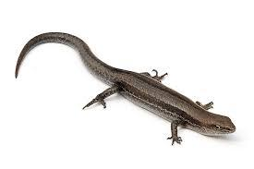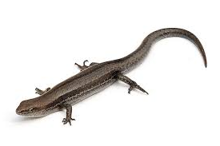

**Atticus and Hunters skink**

**Catching**

**‘ATTI’**

**A couple weeks ago Hunter was catching skinks and I wanted to join in, the next day I brought my bug catcher and it definitely helped a week or so after there was a baby skink and I forgot my bug catcher *but* I didn’t need it! The skink happily crawled onto my finger, under my watch, up my arm.**

**‘HUNTER’**

**Atticus and I have been catching skinks for the past couple weeks there are certain spots where we find them such as behind the bins near the Cowfé or behind the sport shed *or* in the bike shed. We’ve seen lots of different skinks, some small some big some fast some slow.** 