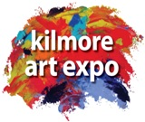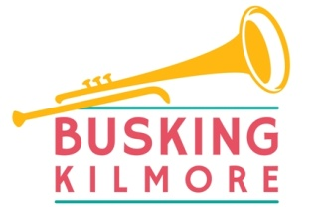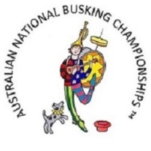
KILMORE REGIONAL BUSKING CHAMPIONSHIPS Kilmore VIC 3764
Saturday 18th April 2026

ENTRY FORM
Closing date for entries Sunday 12th April 2026

NAME OF APPLICANT:____________________________________________

Consent of Parent or Guardian required for children under the age of 16: Use Group Members List when more than one child performing.

I consent to have my child perform in the 2026 Kilmore Regional Busking Championships.

I also consent to allow images and or film footage of my child taken during this event to be lawfully used in promotional material and/or displayed on our official website and/or Facebook page. I also understand any children under the age of 16 years must be accompanied by their parent or guardian during this event.

Signed ________________ Print parent/guardian name____________________________

Postal Address:____________________________________________________

Mobile:___________________ Email:_______________________

Which category will you e performing in? Primary
(Please circle category) Secondary
Open
Will you be performing solo? Y/N Or in a group? (2+ people) Number:______

What name do you want your act/group to be advertised as?________________________________________________________________________

How would you best describe your performance?__________________________________
___________________________________________________________________________

Are any of your performances online? Y/N
Please provide details - ________________________________________________________

Will you be using amplification? If yes, details.____________________________________
Do you require power? Y/N We encourage you to provide your own power supply.

Can you perform more than once? We recommend you perform 3-4 times at different Busking Spots to maximise your exposure. Y/N

TERMS & CONDITIONS:
- All performers must be registered with buskingkilmore and have their registration lanyard clearly displayed while performing
- Entry is open to any age group and street performance type, subject to organiser’s decision.
- As this event is family friendly the organisers reserve the right to exclude any performances that may be deemed offensive or unsuitable for a general audience.
- Volume levels must conform to any direction given by the event organisers or officials. Repeat offenders may be disqualified from the competition.
- Any images or film taken during this event may be used by the event organisers for future promotions.
- Judges decisions are final.
- Buskers are totally responsible for all claims made against them for personal injury or property damage. Buskers are not covered under the Rotary Club of Southern Mitchell’s Public Liability insurance policy. You are encouraged to take out Public Liability Insurance. If you do not hold Public Liability Insurance you must complete and sign the Rotary Release and Indemnity form and return with your entry form. School groups may be covered by their school policy.
I agree to these terms & conditions and I will comply with any lawful direction given by the organisers and/or officials during this event.

Signed: Date:

ENTRY FEE: $25 for solo participant, $40 /duo, $60 /group.
(Please submit payment details with your entry form.
Please pay all entry fees by Direct Deposit to:
The Rotary Club of Southern Mitchell
Bendigo Community Bank
BSB 633 000 A/C 182 688 689
Ref: Your performance name/BE

We require your banking details should you win a prize!

A/C Name:__________________ BSB __________ A/C No._________________

Where did you hear about the Kilmore busking Competition? (Please circle)

Facebook Website Print media Radio Word of Mouth Other______________

Please return this form to buskingkilmore@gmail.com

Please attach a copy of your Public Liability Insurance if applicable or complete and sign the Rotary Release and Indemnity form supplied with your entry form.

The Kilmore Regional Busking Championships is a regional final of the Australian National Busking Championships (TM).
The Australian National Busking Championships (TM) is a Registered Trade mark (TM#1658214). It can only be used with permission of the IP owner, Allan Spencer, Cooma, NSW.

