Out of School Hours Care
Information Booklet

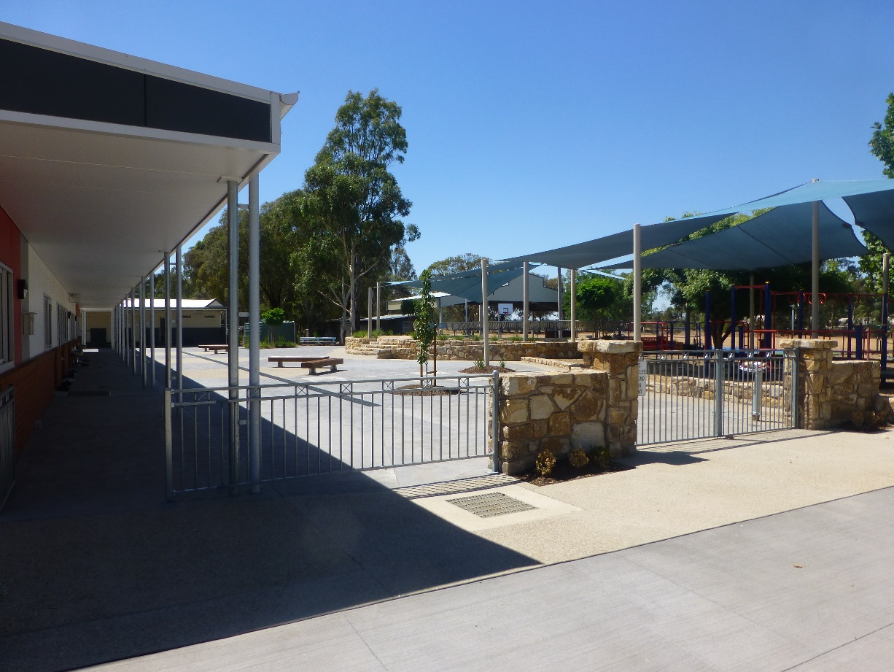

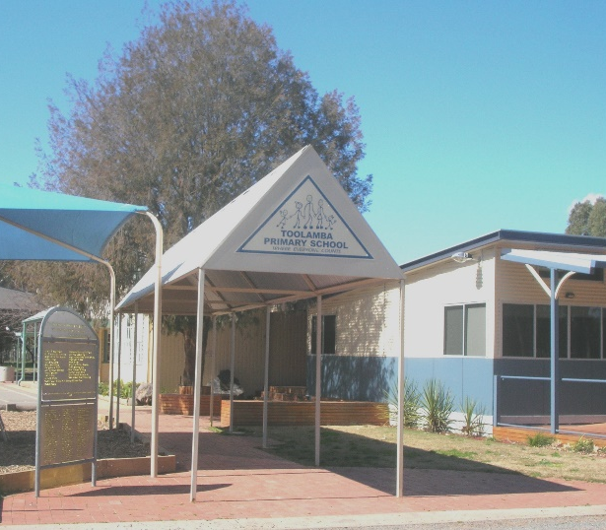

Where Everyone Counts

Toolamba PS Out of School Hours Care

Welcome to the Toolamba PS Out of School Hours Care (OSHC). We hope that you and your child will be very happy during your association with us.
The OSHC Service operates on a not-for-profit basis. We aim to provide a welcoming and safe environment that is child-focused and fun and to provide opportunities for children to develop social, emotional, physical and creative skills through play.

This handbook has been designed to be a guide for you, in helping you and your child settle into our service and for you to have an understanding of our policies. Our OSHC program is guided by the National Quality Framework and OSHC My Time, My Place Curriculum.
This handbook summarises many of the Service’s policies that are outlined in more detail in the OSHC Policy and Procedure Manual, which is available electronically by email and a hardcopy can be viewed or borrowed from the OSHC Office.
PHILOSOPHY
At Toolamba, our community believes that children have the right to:
“Learn, grow, contribute and have fun.”
Toolamba PS OSHC service provides a safe, supervised and fun place for children. Our programs provide a wide range of supervised creative, recreational and play activities that assist in the social, emotional, creative and physical development of children.
At Toolamba we respect diversity within our school community and promote the values of fairness and equity.
We place an emphasis on reinforcing and fostering positive student behaviour.
Every child has the right to fully participate in an educational environment that is safe, supportive and inclusive.
We believe that everyone deserves to be treated with respect and dignity.
Your child will be offered a balance of structured and unstructured activities providing stimulating, enjoyable and safe play opportunities.
We aim to create opportunities for children to develop their communication skills.
We respect the needs and interests of each child and their families and incorporate this into our programs with activities, experiences that further develop life skills.
We respect and acknowledge children’s feelings and self-expression and aim to guide them in a positive manner.
We aim to provide an environment where each child feels safe whilst enabling them to explore and express themselves.
We acknowledge that we are a part of a diverse community and aim to build strong community links to help support our children and families.
Goals
The program aims to:
- Provide a safe, warm and caring atmosphere for children
- Provide a wide variety of stimulating and interesting activities that cater for the needs of individual children
- Promote warm and friendly relationships, with staff children and parents
- Encourage child, Educators, staff, parent and community involvement in the development of the program
- Conduct a school age child care program consistent with the policy and guidelines contained in the National Standards for OSHC and OSHC Quality Assurance Principles

- Management of the Program

The OSHC program is run by the School Council. (Approved Provider)
The School Council has delegated the authority for the day-to-day running and decision making of the program to an OSHC Educator who is the person in Day to Day Charge and who is also known as the Responsible Person.
The number of Educators employed at the service
The OSHC Program is staffed as a Single Educator model. On occasions, more than one Educator shall be employed at a time if numbers or conditions warrant this e.g. if numbers exceed 10 children. There shall be a maximum of 27 children present at any one time.
Parent Involvement.
The role of the family in the OSHC Service is paramount to the success of the Service, its programs and outcomes for children. Your input is greatly valued and always welcomed.
Parents can help Educators increase their understanding of the children and support them in their caring. This support can be fostered through day to day contact and communication between parents and staff. You are welcome to discuss any aspect of your child’s participation with program Educator in Day to Day Charge, (Responsible Person) or the Nominated Supervisor. Confidentiality will be ensured. For more formal or in depth discussions, an appointment with the Nominated Supervisor can be arranged on request.
Please also feel free to give us your feedback (both positive and negative). We will ensure that parents are provided with regular OSHC information through the newsletter, the OSHC notice board and your regular face to face contact.

Outside School Hours Care National Quality Framework
The OSHC program operates under the National Quality Framework for Early Childhood Education and Care. This framework includes:
- a national legislative framework that consists of the Education and Care Services National Law and Education and Care Services National Regulations
- a National Quality Standard
- an assessment and rating system
- a regulatory authority in each state and territory who will have primary responsibility for the approval, monitoring and quality assessment of services in their jurisdiction in accordance with the national legislative framework and in relation to the National Quality Standard
- ACECQA
The National Quality Standard is linked to national learning frameworks that recognise children learn from birth and outline practices to support and promote children’s learning. For OSHC Services our learning framework is the Early Years Learning Framework, Belonging, and Being & Becoming.
It addresses five outcomes.
Outcome 1: Children have a strong sense of identity.
Outcome 2: Children are connected with and contribute to the world.
Outcome 3: Children have a strong sense of wellbeing.
Outcome 4: Children are confident and involved learners.
Outcome 5: Children are effective communicators.

Hours of Operation
Before School Care
The Before School Care Service operates from 7:30am to 9am each weekday during school terms.
After School Care
The After School Care Service operates from 3:15pm to 6:00pm sharp each weekday during school terms.
Both the After School Care and Before School Care Services are approved child care services and are funded by the Commonwealth Government to provide the new Child Care Subsidy (CCS) to eligible families.
Holiday Program
The holiday program will operate for up to 5 days a week during the school holiday programs. Opening will be based on demand and staff availability. Hours of care will be from 8:30am to 5pm. Daily rates will be $78.

Educators
Our Educators are all required to have a current Working with Children Check, and the relevant qualifications required for their position. Educators are trained in anaphylaxis management, and have current first aid training. There will be at least one Educator on duty at all times who has current First Aid Level 2 training, asthma management and anaphylaxis management training. We encourage staff to participate in professional development and training.
The Approved Provider will ensure that the workplace operates on the principles of fairness, equality, merit and team work in all aspects of employment. New educators will be provided with comprehensive induction.

Nutrition
Afternoon sessions provide children with a healthy snack of fruit, dry biscuits and cheese. Children are encouraged to bring along a drink bottle.

Bookings
Any bookings for either, Before School Care or After School Care can be made through Xplor or by calling on 0490 812 401. There will now be only one phone number to call to make a booking.

Fees.
Fees are set at a flat rate of $18 per session for morning sessions and $22 for afternoon sessions. Accounts are sent out on a fortnightly basis.

Subsidy (CCS)
Both Before School Care and After School Care are approved child care services and are funded by the Commonwealth Government to provide the new Child Care Subsidy to eligible families.
To ascertain eligibility you must register with myGov.au before your child starts using the program, to notify them that your child will be attending an out of school hours service, and ensure you have been assessed for CCS. You must also supply your Centrelink Reference Number (CRN) and date of birth, and your child’s CRN and date of birth to the Service. These steps must be done. Until these steps are done, full fees must be paid to the service.
If you have a Prep child starting, you must also notify the myGov.au that they are now a school aged child.

What do I do on arrival and departure?
It is necessary by law, and a safety requirement, to sign your child in and out each day. An iPad is located inside the front door of the Multi-purpose room. The Educator Staff sign the children in for Out of Hours School Care. When you collect your child at the end of the session please sign them out.
Apart from the child’s parent /guardian only people specified as authorised persons on the child’s enrolment form are allowed to collect the children, unless otherwise organised with the Educator. Authorised persons must be 18 years or over, and may be asked to provide proof of identification when collecting the child, if unknown to staff.

Policies
These policies provide a basis for how our OSHC Service operates. For more in-depth information, please refer to the OSHC Policy and Procedure Manual.

Protective Care of Children
The OSHC Service is committed to the protection and safety of all children attending the service. The OSHC Service will act on behalf of children to protect their rights to safety and security in accordance with Children, Youth and Families Act 2005. OSHC educators have a duty of care to keep children safe from harm. This is done by ensuring the venue is safe, ensuring children are appropriately supervised at all times, protecting children from strangers and intruders while at the service, and documenting and reporting any concerns regarding suspected child abuse or neglect, as required by current State Government regulations. All information regarding these matters is held confidentially.

Child Protection
Statement of Commitment
Toolamba OSHC support the rights of children and young people and are committed to ensure the safety, welfare and wellbeing of students. Toolamba OSHC is therefore committed to responding to allegations of student harm resulting from the conduct or actions of any person including that of employees.
This commitment includes the provision of a safe and supportive living and learning environment for all students and requires all employees, volunteers and visitors to model and encourage behaviour that upholds dignity and protection of students from harm.
Privacy and Confidentiality
The OSHC Service is legally required to keep up to date records about Educators, staff, parents/guardians and children for the purposes of running a safe, reliable and high quality service, and to provide access to any eligible funding. The OSHC Service will comply with the Privacy Act 1988, and the Privacy Amendment (Enhancing Privacy Protection) Act 2012, which governs the handling of personal information. Information collected and provided will only be used for the primary purpose of collection for the OSHC Service, and will not be disclosed to other families within the service or external persons, unless exemptions apply (eg law enforcement or in the interests of public health and safety).
All personal information collected is accurate and kept up to date, and is filed safely and securely, with access restricted to use only as required. Families are informed about the type of information collected regarding themselves and their children and the purpose of this, and their rights in accessing this information.

SunSmart Policy
As the OSHC Service we are obliged to follow the Cancer Council Guidelines in relation to sun protection, which are as follows:
Between 1st September to 30th April (when the average UV levels reach 3 and above in Victoria), all children must wear a suitable hat (legionnaires or broad brimmed) and apply sunscreen when playing outdoors, when the actual UV levels are 3 or above. This applies to both before and after school care. If a child does not have a hat and sunscreen, they will be required to stay indoors or undercover. Children should also wear a suitable t-shirt that covers their shoulders.
If your child has any sensitivities or allergies to sunscreen, you may be required to provide your own, to leave at the service.
The educators will also act as role models by wearing hats and sunscreen and seeking shade whenever possible. Families and visitors are also encouraged to follow these guidelines when participating in or attending service activities.

Toys from Home
Children are encouraged to leave any toys, games and equipment brought from home in their bags. OSHC Educators cannot take responsibility for any lost, damaged or stolen items and children are responsible for their own belongings.

Positive Guidance of Children
The OSHC Service is committed to developing a safe, secure, caring and stimulating environment, which enhances children’s self -esteem and encourages them to interact positively and to respect and co-operate with others.
Educators encourage positive behaviour and give clear, consistent guidelines to children regarding the service’s expectations and code of conduct. Children are involved in developing behavioural guidelines and consequences for inappropriate behaviour for the service. Children and families are involved in the development of behaviour plans when behaviour consistently conflicts with the services behavioural guidelines. A child may be excluded from the service if all attempts to modify inappropriate behaviour fail or if their actions affect or endanger other children. In these circumstances the service will ensure that alternative care is discussed with the family.

Health and Safety
Your child’s welfare is our primary concern, and we take the management of accidents and illness very seriously. Should your child become ill during their time at the OSHC program, our staff will contact the parents or nominated emergency as soon as possible. We will comfort and continue to monitor your child until your arrival. In the event of an accident, staff will undertake the appropriate action required such as the administration of first aid, and/or calling an ambulance, and contact the parents immediately thereafter.
Parents are required at enrolment to provide relevant details of their child’s medical information to the service staff, so that the child can be cared for appropriately while attending the Service. Medical information should include any special needs of needs of the child’s allergies, asthma and other relevant medical conditions. Individual health management plans must be provided for children with serious medical conditions. Long term health needs, and must be reviewed on an annual basis, or earlier if there is a change in condition.
To help ensure the safety of children, preventative measures and strategies are actively implemented to reduce the risks of accidents and remove hazards, but in the event of an emergency or major incident, emergency management and evacuation plans and procedures are in place. Emergency drills will be held at least once a term to ensure children and educators are familiar with evacuation procedures.

Grievances and Complaints Procedures
A suggestion box is provided for children and/or families to make comments or suggestions or bring up any ideas they have about the service. All suggestions will be addressed and responded to.
If at any time you have a complaint, issue or are unhappy with any aspect of the program, please feel free to initially discuss any concerns directly with the OSHC staff or the Coordinator. This can be done either in person or by phone, or an appointment can be made to discuss any issues more formally with the Coordinator. Grievances and complaints can also be made in writing or on a Grievance and Complaint Form and forwarded to the Educator. The Educator is the assigned contact person within the Service to handle any complaints, and all complaints and concerns will be acknowledged and addressed both promptly and respectfully. If you provide your name and contact details, the Coordinator will endeavour to respond to you within 48 hours (verbally or via e-mail) and/or in writing within 5 working days. Complaints will be referred to management and also to the Department (DET) if required.
If the complaint is regarding the Educator, the complaint should be forwarded directly to the Principal.
All complaints will be registered, logged and tracked, and the complainant will be advised on the progress of its outcome and final resolution. Complaints made in writing will be responded to in writing.

Infectious Diseases Reference.
The OSHC Educators reserves the right to exclude a child who is obviously too unwell and cannot be adequately cared for in the OSHC Environment. Condition | Exclusion of Cases | Exclusion of Contact
Diarrhea | Exclude until diarrhea has cease for 24 hours. | Contacts not excluded.
Chicken Pox | Exclude until fully recovered or for at least five days after the eruption first appears and all blisters have dried. Note that some remaining scabs are not a reason for continued exclusion. | Any child with an immune deficiency or receiving chemotherapy should be excluded.
Conjunctivitis (Sticky Eye) | Exclusion until discharge from eyes has ceased. | Contacts not excluded.
Haemophilus type b (Hib) | Exclude until medical certificate is received. | Contacts not excluded.
Hand, Foot and mouth disease (cocksackie B) | Exclude from care whilst there is fluid in the blisters. NB The virus remains active in the faeces for several weeks, therefore excellent hand washing techniques and cleaning procedures are essential. | Contacts not excluded.
Hepatitis A | Exclude until a medical certificate of recovery is received, but not before seven days after the onset of jaundice or illness. | Contacts not excluded.
Impetigo | Exclude until appropriate treatment has commenced. Sores on exposed surfaces must be covered with a watertight dressing. | Contacts not excluded.
Measles | Exclude for at least four days after appearance of rash. If un-immunised contacts are vaccinated within 72 hours of their first contact with the first case, they may return to care. | Un-immunised contacts should be excluded until 14 days after the first day of appearance of rash in the last case.
Meningitis (bacterial) | Exclude until well. | Contacts not excluded.
Meningococcal Infection | Exclude until adequate carrier eradication therapy has been completed. | Contacts not excluded if receiving rifampicin.
Mumps | Exclude for nine days or until swelling goes down | Contacts not excluded.
Rashes | Exclude until medical certificate provided indicates the rash is non-infectious. | Contacts not excluded.
Ringworm, scabies, pediculosis (lice), trachoma | Re-admit the day after appropriate treatment has commenced. Dead eggs may still be present when the child is no longer infested and dead nits need not be removed. | Contacts not excluded  Unless infested.
Rubella (German measles) | Exclude until fully recovered or for at least four days after the onset of rash. | Contacts not excluded.
Streptococcal infection  (Including scarlet fever) | Exclude until the child has received Antibiotic treatment for at least 24 hours and the child feels well. | Contacts not excluded.
Temperatures of unknown origin | If a child has a temperature the parent is to be contacted, the approved medication administered, and the child is to be tepid sponged. | Contacts not excluded.
Thrush and mouth ulcers | Do not exclude, hygienic practice must be a priority. | Contacts not excluded.
Whooping cough | Where a known outbreak has occurred, children presenting with symptoms such as cough and fever should be excluded and tested immediately as a precautionary measure. If diagnosed, exclude until they have taken five days of antibiotics or twenty-one days from onset of coughing. | Exclude un-immunized household contact aged less than 7 years for 14 days after the last exposure to infection or until they have taken five days of a 10-day course of antibiotics.

