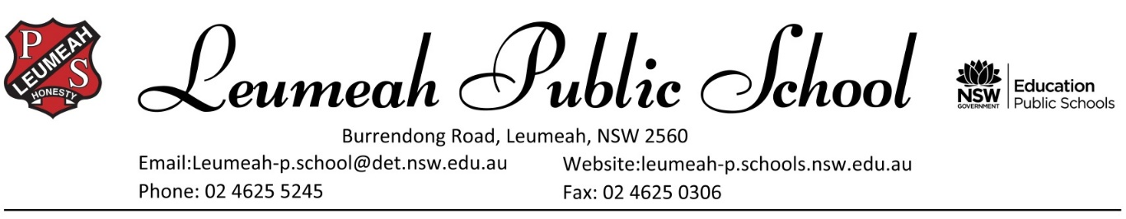
`

Thursday 24 September 2020

INTENTION TO APPLY FOR YEAR 7 PLACEMENT IN A SELECTIVE HIGH SCHOOL IN 2022
Dear Parent/Carer,
Selective high schools cater for academically gifted students with high potential who may otherwise be without sufficient classmates at their own academic standard. Selective high schools help these students to learn by grouping them with students of similar ability, and by using specialised teaching methods.

Applications for selective high school placement are considered mainly on the basis of the Selective High School Placement Test results and school assessment scores. The Selective High School Placement Test will be held on Thursday 11 March 2021.

If you would like to have your child considered for Year 7 selective high school entry in 2022, you need to apply on the internet using a valid email address (not the student’s email address).

Detailed instructions on how to apply online will be available in late September 2020 at https://education.nsw.gov.au/public-schools/selective-high-schools-and-opportunity-classes/year-7.

The application website opens at that link on 6 October 2020 and closes on 9 November 2020. You must apply before the closing date.

There are no paper application forms. If you do not have internet access, you could apply at a public library. If you have a disability that prevents you from using a computer, you can contact the Team for assistance after 6 October 2020.

You must submit only ONE application for each student.
The tear-off slip below is not an application and the school cannot apply on your behalf.

Yours sincerely,

Mrs Kristy Hill
Relieving Principal

Please return the completed slip below to school by FRIDAY 25 SEPTEMBER, 2020.

THIS IS NOT AN APPLICATION FOR ENTRY TO A SELECTIVE HIGH SCHOOL.
This is a notice to your primary school only that you intend to apply.
TO APPLY YOU WILL NEED TO REGISTER AND THEN APPLY THROUGH THE HIGH PERFORMING STUDENTS WEBSITE: https://education.nsw.gov.au/public-schools/selective-high-schools-and-opportunity-classes
-------------------------------------------- Cut here and return the note below to the school ----------------------------------------------

Intention to apply for Year 7 placement in a selective high school in 2022
Student’s Name: __________________________________________________ Class: _______________________
I intend to apply for selective high school entry in Year 7 in 2022 through the High Performing Students website between 6 October 2020 and 9 November 2020.
Signature of Parent/Carer: ___________________________________________
THIS IS NOT AN APPLICATION FOR ENTRY TO A SELECTIVE HIGH SCHOOL.
This is a notice to your primary school only that you intend to apply.
TO APPLY YOU WILL NEED TO REGISTER AND THEN APPLY THROUGH THE HIGH PERFORMING STUDENTS WEBSITE:
https://education.nsw.gov.au/public-schools/selective-high-schools-and-opportunity-classes

