The Trinity Times 8th October 2020 Issue 001 of Term 4
Welcome to our first SRC school Newsletter for 2020 Term 4.
Instead of the usual newsletter this week we will be going over the term that we went through last term.
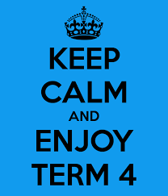
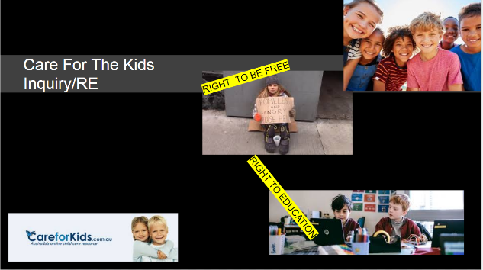
As we did lots of testing towards the end of the Term.
In Inquiry we worked on our care for the kids workflow
HAPPY BIRTHDAY
Natalie 2/3UR will be 8
An 5/6FA will be 11
Leo 5/6JC will be 12
Casey P/1AP will be 6
Leah 5/6JC will be 12

