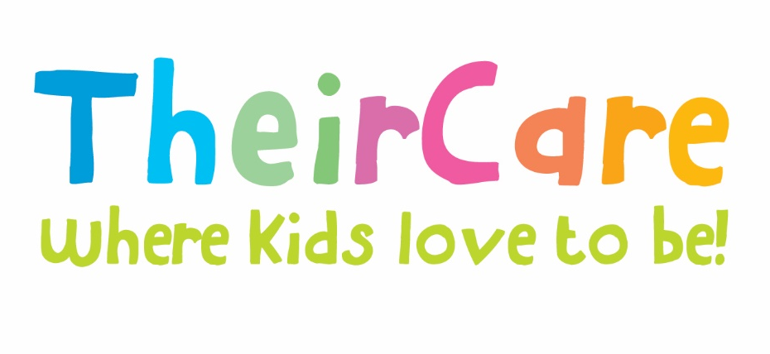

Newsletter Term 2 Week 1 2022

St Marys Primary School St Kilda

Photo Gallery

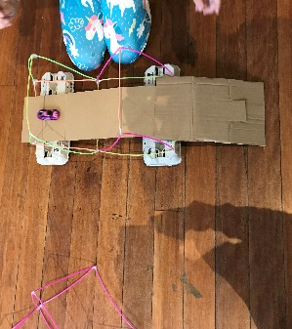
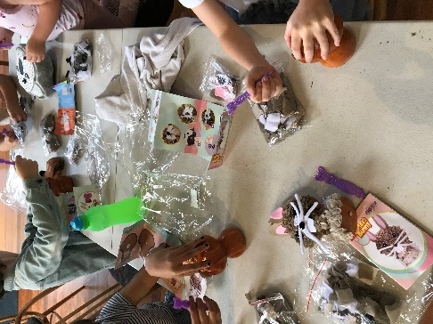
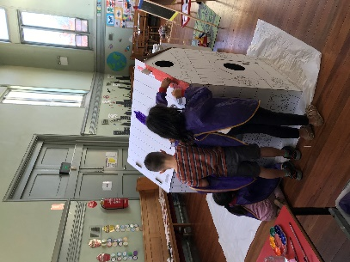
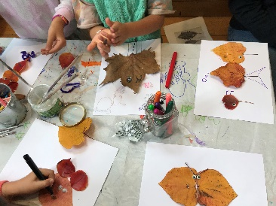
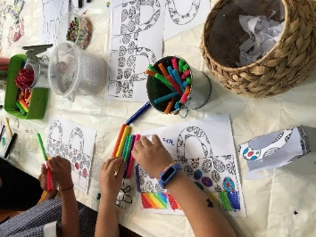
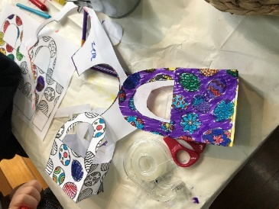
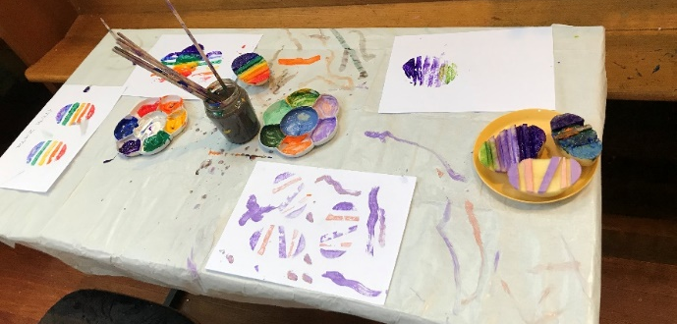
Easter Celebration – Week 10 Term 1
AS part of the festivity, we were celebrating Easter during week 10 with Easter activities, making bunny mask, bunny crafts, Easter baskets, eggs painting with several techniques and eggs scavenger hunt. Our children shown during this week the initiative to be active practicing several sports being soccer the most popular one, followed by hand ball, tennis, group games such as tag and lava monster.

Autumn Holiday Program – When I Grow Up!
Autumn Holiday Program was full of amazing ‘in house’ activities, exciting excursions, and active incursions.
We had fun making Pillows and Toys design, clocks, paper tye dye, pots and leave plates painting, making our own scratch art; doing Nature Art and building challenge making towers and bridges; decorating cookies, and making hot chocolate for this cold weather. Also, we had sensory experiences making playdough.
We were active with the incursion activities playing Footy Tag, making cars, and playing with them in a race in the hall, with obstacle courses and sporting challenges.
As excursion, we went to the cinema to watch ‘The Bag Guys’ and learned about life in the farm at Chesterfield Farm with the opportunity to feed farm animals such as Emus, Kangaroos, Birds, Pigs, Deeres, Goats, Sheep and chickens.
Contact Service | Contact Head Office | Times
Phone: 0475 577 404 | Phone: 1300 072 410 | Before School: 7:00am – 8:45am
Email: stmarysstkilda@theircare.com.au | Email: info@theircare.com.au | After School: 3:30pm – 6:00pm

