Transitions
Transitioning back to school can be an exciting time for many kids, and also an anxious one.
Preparation is key to dealing with situations where there are lots of unknowns. The more things feel familiar and controlled, the more your child or young person can relax and feel confident about what’s happening.
Here are some strategies and tips to make the transition back to school a positive experience.
- Get back into the school-day routine at least a week early – waking up, eating and going to bed at regular times.
- Get your child involved in planning out their lunches and snacks for the first week back.
- For anxious kids, plenty of detail can be calming. Talk through the steps of getting to their classroom: "And then we hang up our bag on our hook; we say hi to our friends; we find our seat...etc"
- Stick to familiar routines as much as possible. Try to have a calm evening and allow more time to settle before bedtime if your child is feeling excited or nervous about school.
- Help your child pack their bag the night before. A visual checklist can help them remember what they need to take. Lay out their clothes so everything’s ready for the morning.
- Allow some extra time to get ready so you’re not rushing.
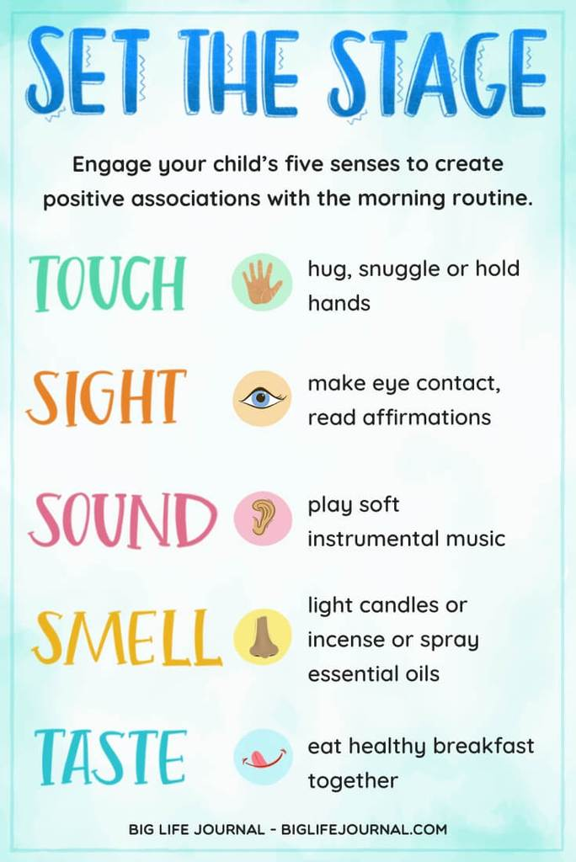
- Invent a fun routine to make saying goodbye a bit easier – try a high-five, bear hug or secret handshake.
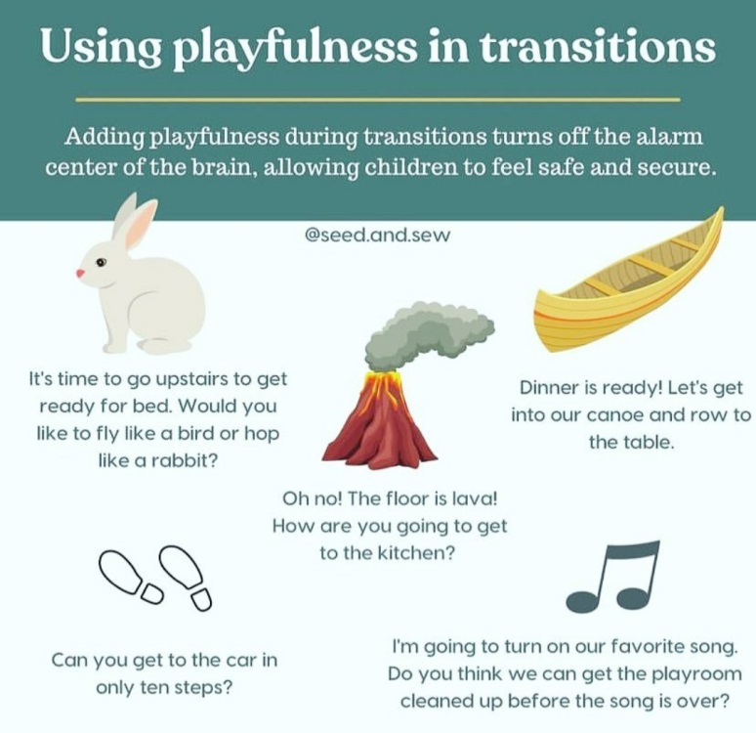
- Talk positively about the day ahead on the way to school and remind your child where you’ll be at pick-up time.
- Drawn-out goodbyes can be upsetting, especially if other kids are getting emotional.
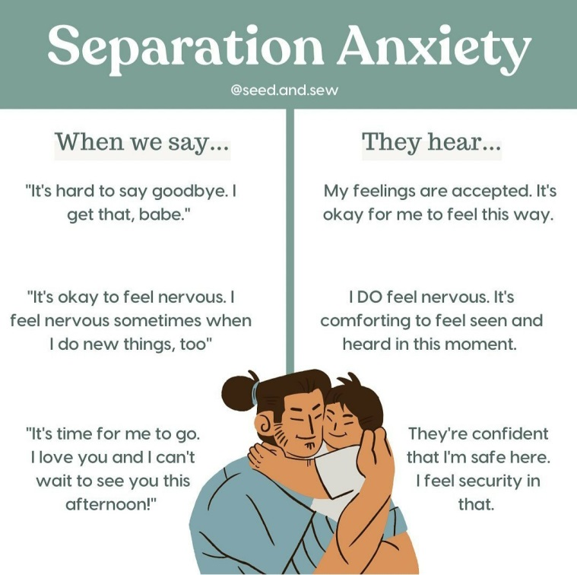
- Try to limit other activities during the first few weeks – the transition to school can be tiring and kids need down time.
- Check in and connect at the end of the day.
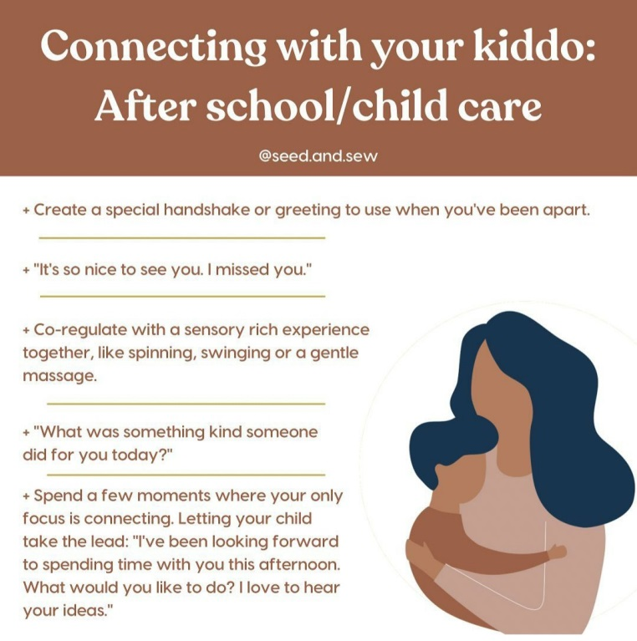
- Schedule a family celebration or a video call from grandparents on the weekend to mark the milestone.
Should I be worried?
It can take a few weeks for kids to adjust, it is best to expect things to be a bit unsettled in that time. If you notice changes in your child's behaviour lasting beyond the first couple of weeks, speak to school staff about your concerns.

And finally, check your own behaviour
The return to school can be a nervous and uncertain time for parents and staff as much as kids, we are all adjusting back, but it’s important to try and keep our own anxiety levels under control. The more we can stay calm and present school as a fun, positive experience – the better.
(Sources from Healthy Families, www.beyondblue.org.au, Visuals from big life journal and seed.and.sew)

Warm regards,
Georgina Watney
(School Counsellor)

