

**04/08/2023**

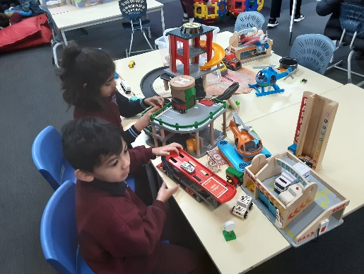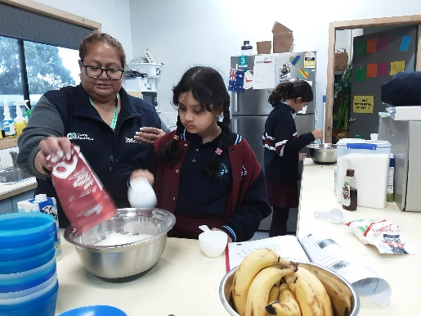](https://pp.campaustralia.com.au/)

**A message from your Coordinator**

What coming up at Out of School Hours Care. Over Science Week we will be trying many experiments oil, water, with colours. Kinetic sand creating. Making fake snow, Baking Soda Experiments, and many more come and see.

* Ozbolt
* Milk experiments
* Baking soda

**Activities coming up**

Join in the fun of Outside School Hours Care activities and experiences with Your OSHC and Rocketeers.

**Make a booking**

Book now

**Oatlands Primary School OSHC**