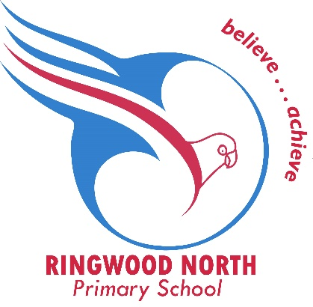
Ringwood North Primary School
PO Box 2312
Ringwood North
VIC 3134

6 September 2022

Dear Families,

We are writing to inform you that School Council has recently approved a fee increase for the Before and After School Care programs.

The new rates will be effective from Monday 3 October 2022.

Our new fee details are set out below:

Before School Care – $18.00
After School Care – $25.00
Curriculum day - $50.00

CCS benefits will continue to be applied to eligible families.

Thank you for your continued support of our program.

Sincerely
Judy Miles Ricarda Lillis
OSHC Coordinator Business Manager

