Now is the time to start some planning for the upcoming University and College Open Days!
- Most are held on weekends, either Saturday or Sundays over late July and August. Some are earlier in the year – check the dates carefully.
- It is a very worthwhile experience to go on campus to various universities and colleges and to find out about the relevant courses and careers that you are interested in, particularly for those of you in Year 10 and 11. Then you can make some researched choices about subjects and future pathway options for your final years of secondary school.
- It is a great idea to get a group of friends together to attend an Open Day event. Families are also strongly encouraged to attend as well. In addition to in-person Open Days, some institutions are offering a Virtual Open Day experience, which may be more convenient.
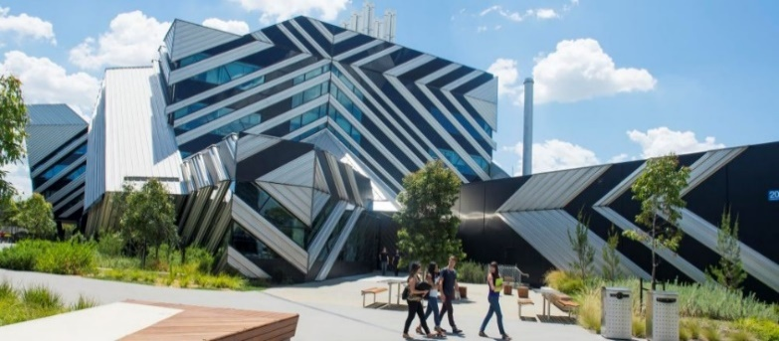

Attending an Open Day will provide you with the following essential information:
- What breadth of courses and areas of study does the university or college offer?
- What may be the VCE subject prerequisites for your chosen area of study?
- Are there other pathways into courses, if you don't get the required ATAR or don't get an ATAR?
- An opportunity to speak to the people/lecturers who teach the courses.
- An opportunity to speak to current students who are studying the courses.
- Seeing the campus in person and visiting facilities and taking a guided tour.
- Looking at on-campus and off-campus residential options, so you can start planning if this is something you will need to consider down the track.
- Looking at the public transport and parking options.
- Investigating relevant scholarships and getting information so you can apply in advance, if necessary, in a timely fashion.
- See if the university offers VCE subjects that you can complete in your final year of school to add to your ATAR and provide you with credit towards a degree. For example - Deakin University Accelerate Course, Federation University Advance to Uni Course.
- Great food, free pens, giveaways, fun and free entertainment!
Below is a list of Open Day dates which gives you the dates and a link for each institution.
Institution | Date | Event type
Academy of Interactive Entertainment | Saturday 25th May 2024 | On Campus
Australian Catholic University (Ballarat) | Sunday 25th August 2024 | On Campus
Australian Catholic University (Melbourne) | Sunday 11th August 2024 | On Campus
Australian Institute of Music | Thursday 18th January 2024 | On Campus
Box Hill Institute (Box Hill) | Tuesday 19th March 2024 | On Campus
Charles Sturt University - Albury-Wodonga Campus | Sunday 11th August 2024 | On Campus
Chisholm Institute | See online for events | On Campus
Collarts - Australian College of the Arts | Saturday 11th May 2024. | On Campus
Deakin University (Burwood) | Sunday 25th August 2024 | On Campus
Deakin University (Geelong) | Sunday 18th August 2024 | On Campus
Deakin University (Warrnambool) | Sunday 4th^{h} August 2023 | On Campus
Endeavour College of Natural Health | Sunday 15th June 2024 | On Campus
Federation University Berwick | Sunday 18th August 2024 | On Campus
Federation University Gippsland | Sunday 11th August 2024 | On Campus
Federation University Ballarat | Sunday 25th August 2024 | On Campus
Holmesglen | Thursday 18th April 2024 | On Campus
JMC Academy | Saturday 11 May 2024 | On Campus
La Trobe University (Albury-Wodonga) | Sunday 11th August 2024 | On Campus
La Trobe University (Bendigo) | Sunday 25th August 2024 | On Campus
La Trobe University (Melbourne) | Sunday 4th August 2024 | On Campus
Monash University (Caulfield) | Saturday 3rd August 2024 | On Campus
Monash University (Clayton) | Sunday 4th August 2024 | On Campus
Monash University (Parkville) | Sunday 18th August 2024 | On Campus
Monash University (Peninsula) | Saturday 3rd August 2024 | On Campus
Photography Studies College | Check website for dates | On Campus
RMIT (City & Brunswick) | Date to be confirmed | On Campus
RMIT (Bundoora) | Date to be confirmed | On Campus
RMIT (Bendigo) | Date to be confirmed | On Campus
SAE Creative Media Institute | Saturday 12th August 2024 | On Campus
Swinburne University of Technology | Sunday 28th July 2024 | On Campus
Torrens University | August 2024 – Date to be confirmed | On Campus
University of Melbourne | Sunday 18th August 2024 | On Campus
Victoria University City Campus | Sunday 18th August 2024 | On Campus
Victoria University Footscray Park and Sunshine | Sunday 25th August 2024 | On Campus
William Angliss Institute | Date to be confirmed | On Campus

