Signing into the Parent Access Module (PAM) via the web
- Open your preferred browser
- Enter URL: https://pam.insertschooldomain.catholic.edu.au
  - For example: https://pam.spballarat.catholic.edu.au
- All PAM accounts have been reset, and users will need to create a new password to gain access to PAM
  - Select “Forgot Password?” to receive a password reset link:
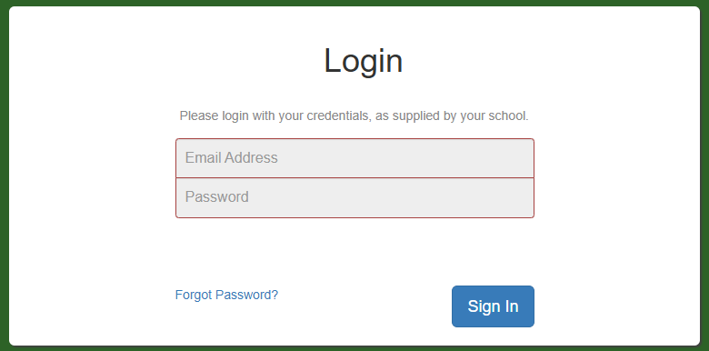

- Enter the email address associated with your PAM account in the “Email Address” field and click “Send Link”
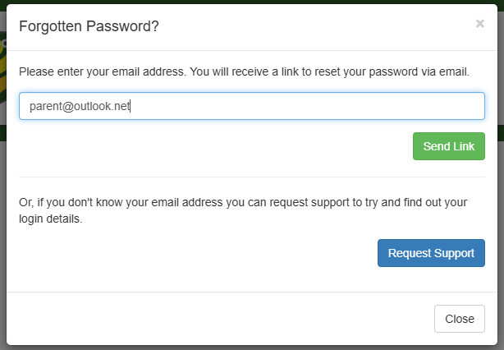

- A confirmation screen will appear. Select “Close”
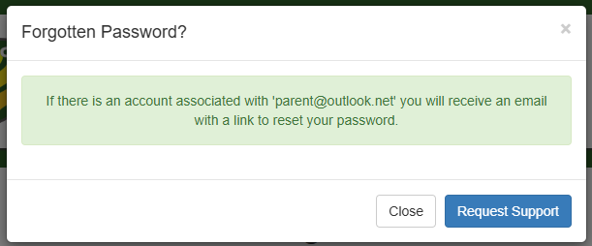
- You will be sent an email; it may take a few minutes to arrive. The email will be titled “Password Reset” (also check your trash or junk folders if it does not arrive in your inbox).
  - Open this email and click on the link to open the password reset webpage.
  - Enter your new, unique password into the “New Password” field. The password complexity and requirements are as follows:
    - Minimum of 12 characters
    - Must contain at least 1 number
    - Must contain at least 1 upper case and 1 lower case letter
    - Must contain at least 1 special character: !@#$%^&*()_+=[]{};:<>|./?,-
    - Moving forward, you will not be able to use either of your last two passwords
  - Re-type your new password into the “Confirm New Password” field
  - Click on “Set New Password”
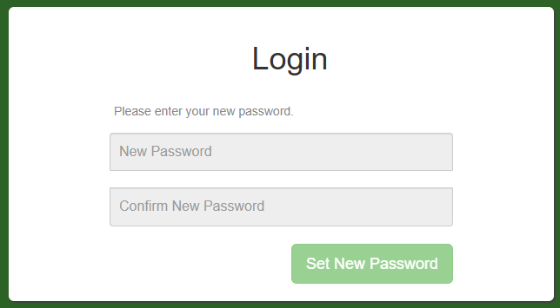

- You will now be taken to the PAM login screen where you will be asked to enter your email address and newly created password. Click on “Sign In”
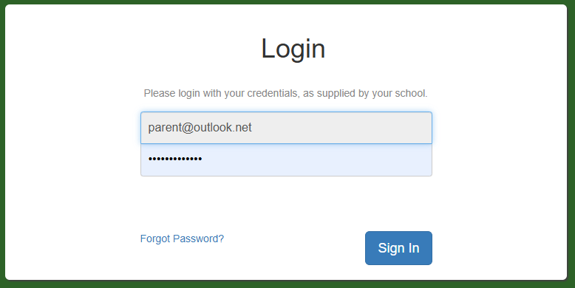

NOTE: For extra security, you may at times be asked to complete a Captcha verification
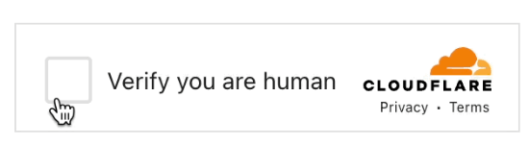
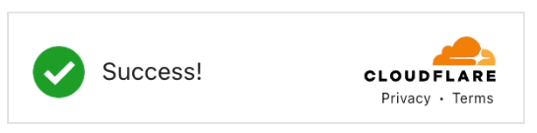

- Finally, you will be asked to enter a six-digit authentication code which will be sent to the email address associated with your account. Once you have received and entered the six-digit code, select “Continue”.
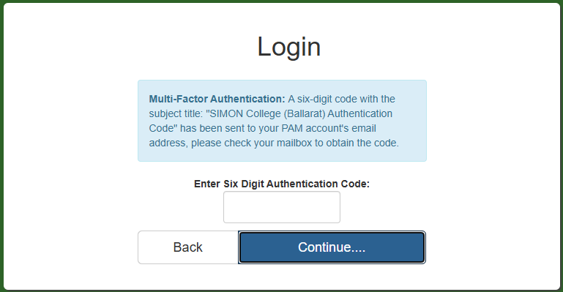

- You have now successfully logged into PAM.

Changing your PAM password
Please note: the account used is for demonstration purposes only and is not a real person’s name or image. The image is AI-generated and no real information has been included in this guidance.
- Once you have successfully logged into PAM, you can change your password at any time.
- Click on the three line, “hamburger” icon at the top right of the page.
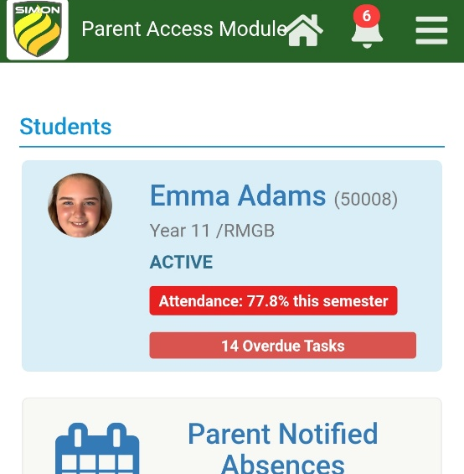

- Select “My Settings”
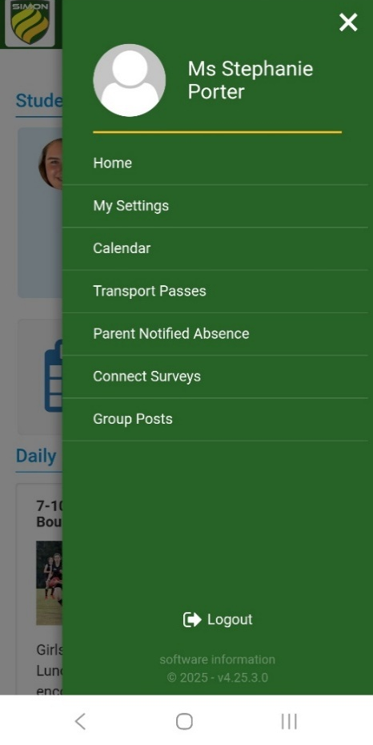
- Find the “Change Password” option and follow prompts to change password
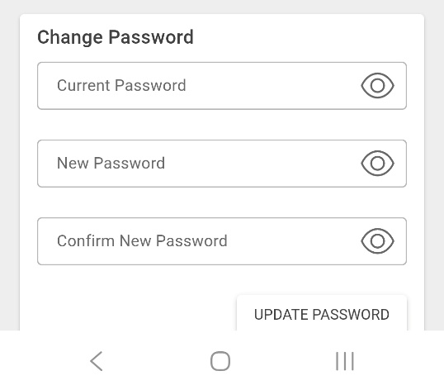
- Click on “Update Password”

Saving PAM to the home screen – ANDROID device
- Log into your PAM account on a browser on your mobile device and click on the three dots at the top right of the screen.
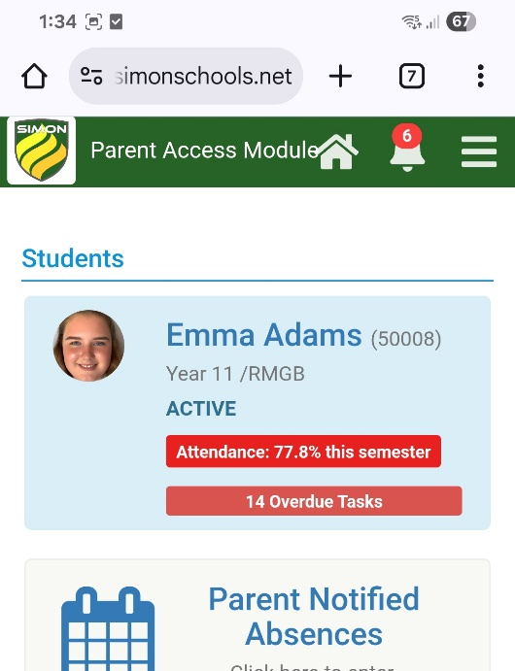
- Select “Add to Home Screen”.
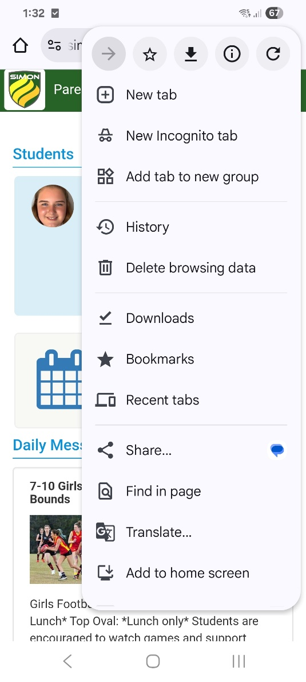
- A confirmation screen will pop up asking you to “Install App”. Click on “Install”
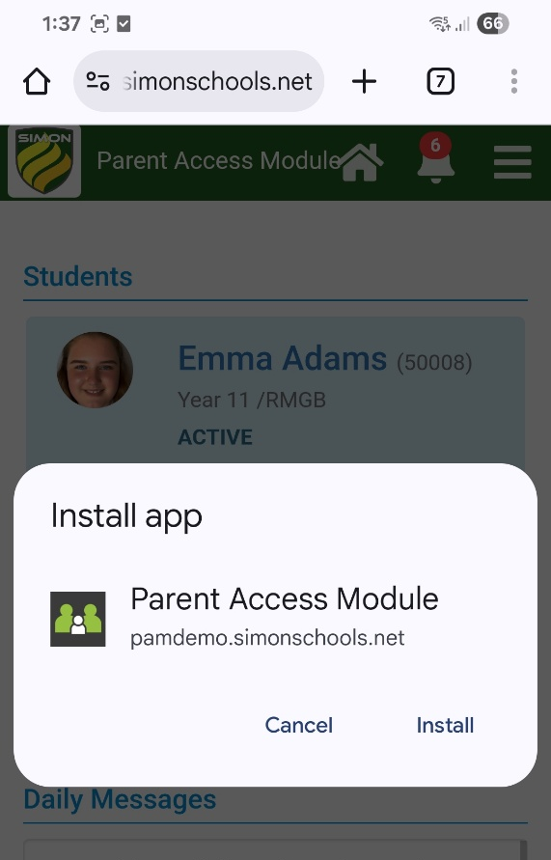
- PAM will now be available on your phone as an “App”
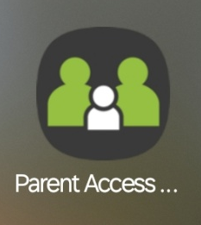

Saving PAM to the home screen – iPhone
- Log into your PAM account on a browser on your mobile device and click on the middle icon (which looks like a square with an upward arrow in it) at the bottom of the page
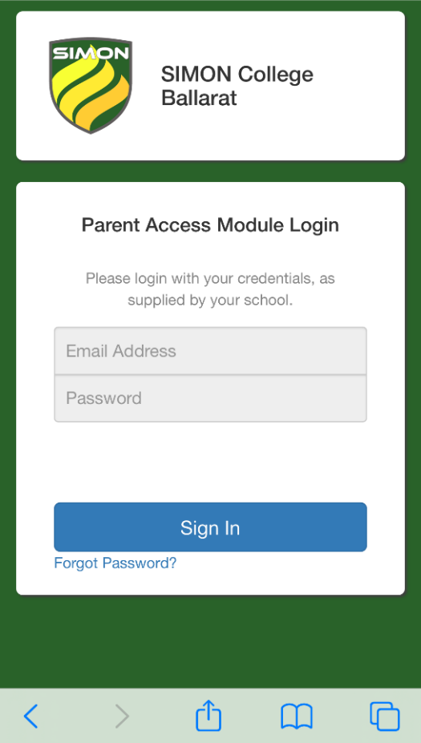

- Scroll down and select “Add to Home Screen”.
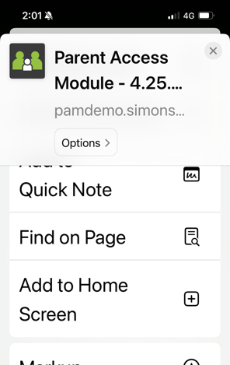
- A confirmation screen will pop up asking you to confirm this action. Click on “Add”
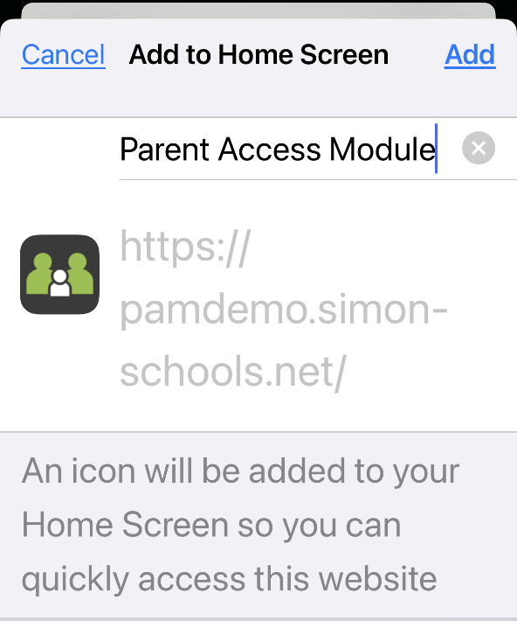

- PAM will now be available on your phone as an “App”

