Wow, what a term!
3E did fantastic work all term. Each Monday, we had so much fun sharing our weekend news. We practised listening carefully while others were speaking and asking questions about their weekends. We also focused on writing sentences and explored lots of different phonic groups to help with our reading.
In Maths, we explored time, fractions, multiplication and division. We learned how to share things out evenly and how to count in 2s, 5s and 10s. When learning about fractions, we looked at halves and quarters. In time, we practised reading o’clock and half-past.
Our integrated unit this term was Wonderful Weather. We investigated all the different types of weather and how they appear in each season. We also carried out a Science experiment each week, all focused on weather.
In cooking, we made muesli balls, fruit skewers, cheese toasties and blueberry muffins. Each week in PE we worked on our athletics skills, and we got to be creative in Performing Arts lessons. Our favourite part of the term was swimming — we had so much fun splashing in the pool and did really well at transitioning each day. We’ve also been getting our hands busy at the Cafe each week. We’ve been preparing staff and student lunches and learning so much about safety and hygiene!
Well done, everyone, on working so hard in Term 3. We are looking forward to our final term!
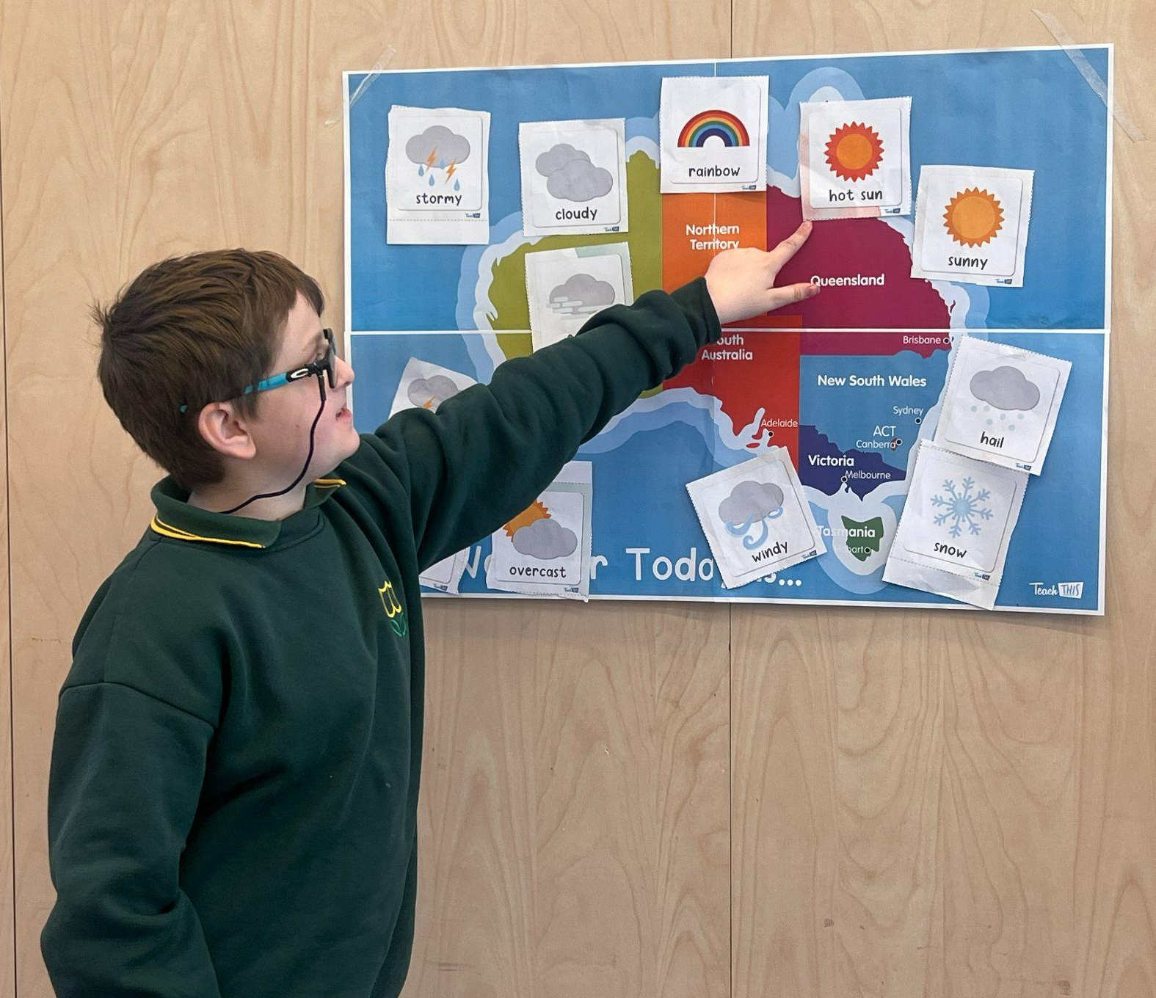
Aoise & Chloe

