2021 Profile
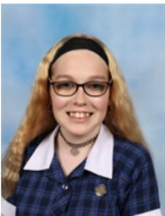
Student Voice, Student Leadership and Extra Curricular Teams
Student
Name | Kayla Parker
Homegroup | 10R1
Contact details | Par0027@kdc.vic.edu.au
Student Team/s involved with | Instagram, Wellbeing, Events, Facilities & General Team
Reasons I chose to be part of KDC Student Voice/ Student Leadership/ Extra Curricular Team/s | It’s vital that we as the next generation of young people, take a stand and ensure our voices are heard in both the school environment and the general public, which is exactly why I applied to be apart of the KDC Student Voice Team. As a result of applying your giving the opportunity to assist in building the bridge that connects the students to the staff, and ensure that all of the viewpoints and concerns from the students are heard by the faculty and relevant action is taken. Not only that, your also able to build strong bonds and relationships with your peers and teachers, in a safe and productive environment.
What I hope to help achieve in these teams during 2021 | 2020 was nothing short of unexpected, in many moments we were left in the dark as there was so much uncertainty surrounding the future. Nonetheless it took its toll on everyone, there was a significant decrease in online engagement and our general wellbeing. I hope that this year as a group we are able to facilitate and create initiatives aside from our general educational activities, to further promote positivity and assist in creating a better school environment on all fronts. As a group we have accomplished many things over the years, from the revamping of our school bathrooms to the frequent event planning! However, there are still so many areas within our school that need improvement, and so many voices that are still unheard which is what I hope to help improve.

