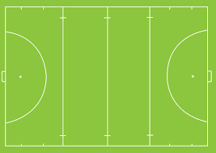Where 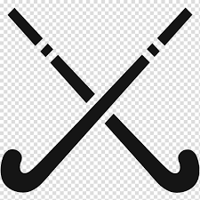

Ice or field

Ice hockey is more popular than field hockey. Even though field hockey was invented first

NHL stands for national hockey league it started in 1917 and still we can watch it online

NHL

* Hockey is dated back to the earliest civilisations.
* Before hockey sticks were invented, they used simple sticks.

history

Field hockey is played most in the Netherlands. Where there are a lot of fields.

Best country

Types of dribbles

Best team

The best team in the NHL is Montreal Canadians

Inventor

The inventor of field hockey was Constance M.K

* Strait dribble
* Loose dribble
* Indian dribble
* Dribbling pulls back.
* One handed right hand.
* One hand reverse stick

Hockey is the second most played sport after soccer.

The first hockey balls were made from cow dung.

Fun Fact

Fun Fact

Hockey is one of the oldest team sports.

Fun Fact

Gear

Normal players:

* Shin guards
* Mouth guards

Goal Keepers:

* Helmet/mask
* Gloves
* Goalkeeper girdle
* leg guards
* kickers

Hockey was made in England. In the year 1875

Where was hockey invented?

The rules

. No kicking the ball

. Only use the flat side of the stick

. You are not allowed to obstruct the player

HOCKEY