October 2025
An open letter to all parents and guardians of Merbein P10 College

Dear Parents/Guardians,
This letter is to inform you about the Mildura Schools Lands Trust (often referred to as College Lease) and how it works for our school and our children.
- Each year our school receives money from this trust.
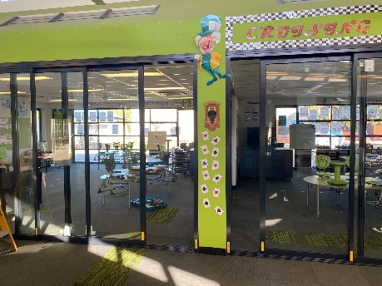
- Last year we received $89,000 and our School Council used this money, along with funds from this year to install commercial doors in our Primary School building, creating more flexible teaching spaces, purchased new computers to enhance the music program, as well as refurbished several teaching spaces to improve the facilities for our students and staff.

The money we receive from this trust is additional to the funding we receive from the government and voluntary contributions from families. Every Victorian primary and secondary school in Sunraysia and therefore, every student, benefits from the money raised by this trust. The amount of money that each school receives is allocated evenly, based on the number of students who attend each school.
Information & History
Our trust was formed in 1916 and it is the most unique, community education trust in Australia. Mildura Schools Lands is a trust that owns 183 parcels of land spread throughout the city of Mildura and the original irrigation district. Each land title is leased for 50 years. Leases can be bought and sold and developed by the lessee, with approval from council. Commercial rental from each lease raises the money for schools. The Chaffey brothers first allocated these lands and it was then legislated for in 1916.
The Mildura Schools Lands-Beneficiaries Committee works to protect and improve the trust. This committee works with the trust’s manager (State Trustees), the community and the Department of Education to ensure the security of the trust for the benefit of all Sunraysia students.
If you would like further information, please contact the school.

Kind Regards,
Chris Grimmmer
Principal
Merbein P10 College

