Dear Families,
Melton Specialist School is now in its third year of the Disability Inclusion program. This is a normal and expected process for all students at Melton Specialist School as part of ongoing planning and review.
If your child is due for a funding review, you will receive a pack sent home next week. This pack will include important forms that need to be completed, signed, and returned to the school.
About the funding review cycle
The funding review process may include:
- An updated cognitive assessment completed at Melton Specialist School
- Confirmation of continued eligibility (a Full-Scale IQ under 70 and a diagnosis of Intellectual Developmental Disorder)
This information helps inform your child’s Disability Inclusion Profile.
About the Disability Inclusion Profile
The Disability Inclusion program has replaced the previous PSD process and continues funding and resources to support inclusive practices in schools. This ensures students are supported to participate, learn, and engage fully in school life.
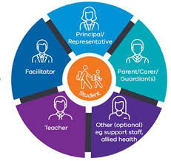
A Disability Inclusion Profile is a written description of your child’s strengths and needs. It helps guide planning for adjustments and determines what additional resources or funding may be required.
The profile meeting:
- Is supported by an independent facilitator
- Involves families and school staff who know your child well
- Runs for approximately 90 minutes
During the meeting, we will discuss:
- Your child’s strengths, needs, and goals
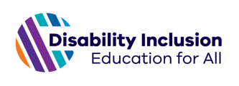
- Adjustments required to support participation and learning
- The level of adjustment needed across different school activities
- Sharing perspectives and building a shared understanding
After the meeting:
- You and the school will receive a written report of the profile
- The profile can be discussed further at a Student Support Group (SSG) meeting
- The SSG will determine when a new profile is required (for example, if your child’s needs change or they transition to a new school)
- Adjustments will be regularly reviewed to ensure they are working effectively for your child
The results of the funding review will not affect the level of support that is currently offered to your child.
If you have any questions, would prefer to complete the forms electronically, or would like to meet in person, please contact:
Sarah Dawson
📞 9743 4966
✉️ sarah.dawson@education.vic.gov.au
For more information about Disability Inclusion, please visit:
Disability Inclusion: a new approach for students with disability | vic.gov.au

