

**06/10/2023**

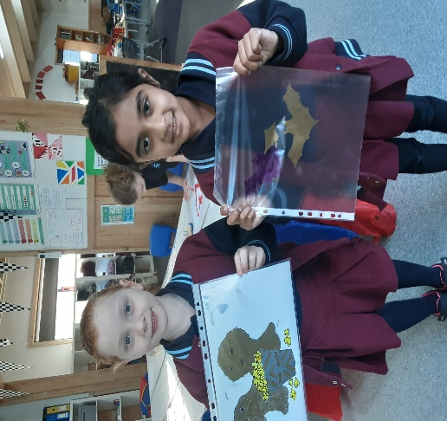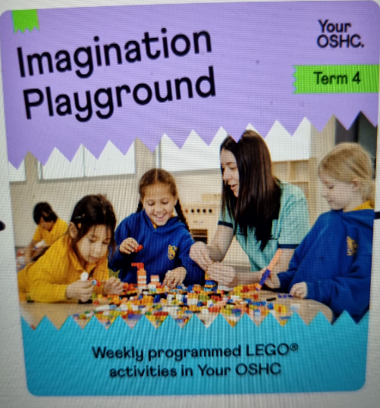](https://pp.campaustralia.com.au/)[](https://apps.apple.com/app/apple-store/id1529575453?pt=120333103&ct=edmbookings&mt=8)[](https://play.google.com/store/apps/details?id=au.com.campaustralia.parent)

**LEGO WEEK 12th OCTOBER 2023**

Figure 

**A message from your Coordinator: Debbie**

**We have a World Play Lego Day, Thursday 12-10-2023, children can create and challenge their skills, see our amazing creations to share and explore our talent at Oatlands. Then we have Sustainability Superhero on the 13- 17th November 2023 celebrate National Recycling Robots Week.**

Figure

**Oatlands Primary School OSHC**

Join in the fun of Outside School Hours Care activities and experiences with Your OSHC and Rocketeers.

**Make a booking**

Book now

* Tallest Lego Creation
* Biggest Building with Lego
* What can we Create in Two Hours Challenge

**Activities coming up**