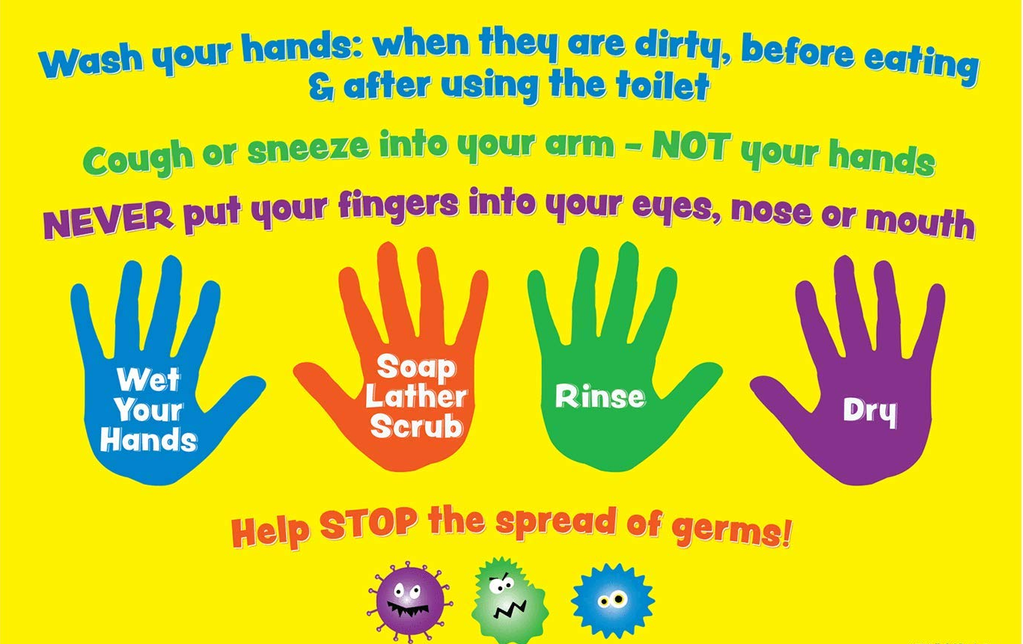
Make sure you wash your hands frequently for at least 20 seconds
- When you come to school
- Before and after eating
- Before and after playing outside
- After going to the toilet
- After coughing, sneezing or using a tissue (cough into your elbow)
- After sharing school equipment
- When your hands are dirty
Use hand sanitiser if you cannot wash your hands

