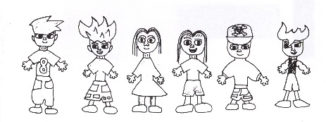
TERM 3 CURRICULUM DAY BOOKING FORM
CRAZY DAY
WHEELERS HILL PRIMARY SCHOOL
OUTSIDE SCHOOL HOURS CARE
FRIDAY 13th September 2024
7am – 6pm

Friday 13th September – Cost $75 per child

Crazy day
Dress up with your Crazy Hair and your clothes crazy for a fun filled Crazy Day
Lots of crazy Crafts and Drawing, Crazy Outdoor games and our very own Crazy Disco afternoon

No Food provided today. Please provide Breakfast, Lunch and morning and afternoon snacks.

BOOKING PERIOD INFORMATION
Families with a Permanent Friday BSC/ASC booking | Community Families
Monday 20th August 2024 | Thursday 23rd August 2024

Numbers are limited due to staffing capacity please book early to ensure your place.

Children must be enrolled with OSHC before making a Curriculum Day booking.

TERM 3 CURRICULUM DAY NOTICE

Child’s Name | Friday 13th September 2024  $75 per child | Total Cost

Contact Phone Numbers on the Day

Name: ______________________________________ Phone: ___________________

Name: ______________________________________ Phone: ___________________

Signature of Parent: _________________________________ Date: __________________

