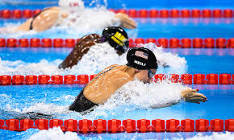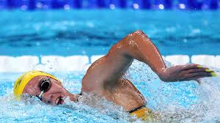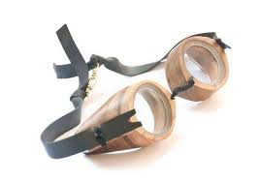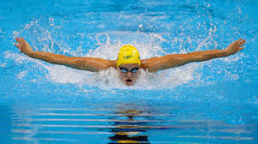

Breaststroke

Breaststroke is [by many people] considered the slowest stroke. While swimming Breaststroke you burn up to 700 calories per hour.

FUN FACT!!

Some people consider swimming meditation because the rhythm stroking through the water can sometimes help with your problem.

Backstroke

Backstroke is the only stroke where you swim on your back. This is the reason for its name. If you swim backstroke for one hour you burn around 400 calories.

FUN FACT!!

The first goggles ever made for swimming were made out of tortoise shells!

Swimming

Freestyle

Freestyle is the fastest and most common in races of these four strokes, another name for it is Front Crawl. You burn roughly 600 calories if swimming freestyle for one hour.

An IM

IM is a swimming term that stands for Individual Medley. In an IM you swim all four strokes in this order: Butterfly, Backstroke, Breaststroke then Freestyle.

Butterfly

Butterfly, in many people’s opinion is the hardest of the four strokes. It requires a lot of strength and you burn about 820 calories per hour.