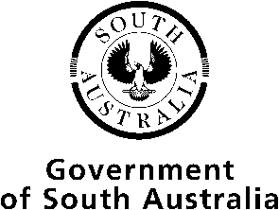
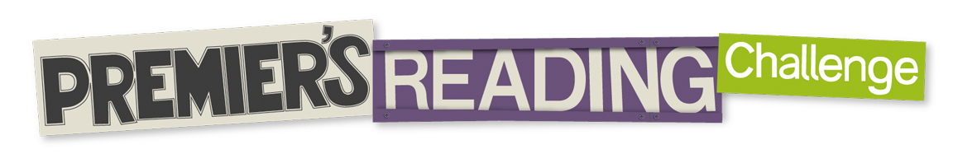

www.prc.sa.edu.au

School Student Reading Record 2023 Reception – Year 6 students

Reading for the Challenge finishes on 8 September 2023

Name |  |  | Male  Female  Unspecified |  | Teacher |  |  | Room Number
School |  | Year  Level |  |  | Date of Birth (needed for matching records) |  | / / DD MM YYYY
Please enter the year you last completed the Challenge in.
If you were at a different school last time you completed the Challenge, print the name of the school here.
The award I am reading for this year is (tick one):
Certificate Bronze Silver Gold Champion Legend Hall of Fame

Reader for Life: 8 9 10 11 12 13 14

Hall of Fame honour roll consent:
This student has permission for their first and last name only to be printed on the Challenge website in the Hall of Fame Honour Roll when they achieve that award. | Yes No | _____________  Parent/Guardian Signature
Ask a teacher, parent, carer or librarian to initial each of the 12 books you have read in the right hand column to indicate that the books are at an appropriate level for you and that the authors and titles are correct.

Please list the eight books you have read from the Challenge Booklist.
 | Title | Author | Adult Initials
1
2
3
4
5
6
7
8

Please list the other four books you have read. (These books can be your own choice or from the Challenge Booklist.)
9
10
11
12

When completed, please give this form to your Premier’s Reading Challenge school contact person before 8 September 2023 so that your record can be entered.
You will receive your award in Term 4.

Premier's Reading Challenge Guidelines

- What is the Premier's Reading Challenge?
  - The Challenge is a literacy engagement strategy that requires students to read 12 age-appropriate books in a year. Students who complete the challenge receive an annual award.
- Who can participate:
All students: the Premier’s Reading Challenge is open to all students from Reception to Year 12 in South Australian government and non-government schools as well as home education students.
- What must students do:
  - 12 books: students are challenged to read 12 books from the start of the school year until the end of week 7, term 3.
  - Recording: students will record the titles and authors of the books they read on the appropriate Student Reading Record on the Challenge website.
  - Endorsement: a teacher, teacher librarian, public librarian or parent/carer must sign each entry on the Student Reading Record. This indicates that the student has read (or shared in the reading of) a book at an appropriate literacy level and that the book title and author are accurate.
- Number of free choice books:
  - Reception - Year 6 students will read 8 of the 12 books from the Premier’s Reading Challenge booklist at an appropriate literacy level. They may read 4 books of their own choice at a similar standard to books on the list. At the teacher's discretion, students may read more than 4 books not on the booklist.
  - Year 7, 8 and 9 students will read 4 of the 12 books from the Premier's Reading Challenge booklist at the appropriate literacy level. They may read 8 books of their own choice at a similar standard to books on the list. At the teacher's discretion, students may read more than 8 books not on the booklist.
  - Year 10, 11 or 12 students read 12 books of their own choice at an appropriate literacy level for each student and may include prescribed texts.
- Literacy and ability appropriate books:
  - Literacy level: students should read to their level of language proficiency to achieve the Premier’s Reading Challenge. This may mean reading books from a different year level group as deemed appropriate by the student’s parents, carers and teachers. Guidance may be required for students in their choice of titles from booklists for older students.
  - Students with disabilities can read books that are at an appropriate literacy level for them and/or use texts that have been adapted to meet their individual learning and literacy needs. This includes Braille texts, talking books, e-books, and books on tape, DVD or CD.
  - Languages: students may choose to read books in other languages, especially those from culturally and linguistically diverse backgrounds who are learning English as a second language and those involved in First Language Maintenance and Development Programs (e.g., students with special needs, ESL students).
- Book categories:
  - Mature age books are most appropriate for students from year 9 - 12.
  - Book series: if at least one book from a series is included on the Premier’s Reading Challenge booklist, then any book from that series can also be included as a book chosen from the booklist.
- Awards:
  - Annual awards: Students cannot receive more than one award per year; i.e. reading 24 books in one year will not result in two awards. Schools may consider extra merit awards for those students who go above and beyond the required reading for the Challenge.
  - Award catch up: If there are extenuating circumstances, it is possible to negotiate for individuals to catch up a medal. To discuss, please contact the Premier’s Reading Challenge office.
  - Award order: first year - certificate signed by the Premier, second year - bronze medal, third year - silver medal, fourth year - gold medal, fifth year - champion medal, sixth year - legend medal, seventh year - hall of fame medal, eighth year onwards– hall of fame reader for life certificate reflecting the number of years participated.
- School coordination and celebration:
  - Contacts: schools will nominate 2 school contact people. Along with the school’s administration contact, they will receive all communication in order to manage participation in the Challenge. Students and classes do not register separately.
  - Award presentations: awards will be sent to schools in November and it is suggested that presentations are made at a special assembly involving your local Member of Parliament, a local identity, an author or a Premier’s Reading Challenge ambassador.
- Recording completions:
  - Government schools: will record completions via EDSAS (or EMS as it is rolled out).
  - Non-government schools: will record completions via a portal to EDSAS (guidelines are provided on registration).
  - Home education students or those participating individually do not need to register. Simply download the Student Reading Record from the website and submit the completed form by the end of September directly to the Premier's Reading Challenge office.
  - Students who have completed a Reading Challenge in another Australian state or territory or overseas, can have their previous records acknowledged:
    - Please verify students’ prior completion of a similar Challenge,
    - Advise the Premier’s Reading Challenge office of the years completed for South Australian records to be updated.
- Premier’s Reception:
55 schools: with outstanding Premier’s Reading Challenge completion records are invited to the Premier’s Reception each year and awarded a certificate and books for their school libraries. In fairness to all schools, it is unlikely that schools will be invited to the Reception more than once. Schools with continuing outstanding achievement in the Challenge will receive a certificate signed by the Premier.

