YMCA St Joseph’s Cobram
Weekly Program - Term 2 Week 1
Service Name | Date
St Joseph’s Cobram | 15th – 19th April 2024
The weather looks perfect for outdoor play this week so let’s make the most of it
 | Monday | Tuesday | Wednesday | Thursday | Friday
Planned Activities  (all activities are planned based on children’s interests and are available throughout the week) | Nature Painting Outside  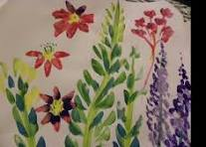  Let’s use nature as out inspiration painting pictures of, with and on flowers, leaves and seed pods | Potion Making  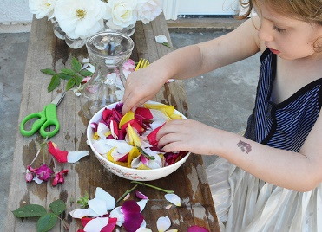  Flowers, food colour and glitter mix it all up and make your extra special potion | Cubbies and Kitchen Outside  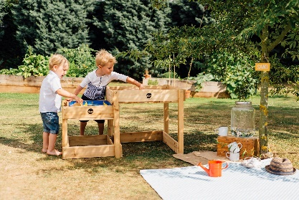  We will cook up a feast in the sandpit and build our cubby homes near-by. | Relay Obstacle Course    Let’s get moving, up and over around and through. Can your work together to win? | Ice Art in the Sun  - 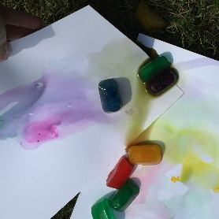  - It’s perfect weather for melting ice to make beautiful art.
Yarning Circle Discussion Topics | Acknowledgement to country  Looking at different versions of Acknowledgement of country, what they have in common and exploring the idea of writing our own.

Interest Areas
These areas and resources are available always for the children to extend on their interests and curiousness.
Crafty Creations | Dramatic Play |  | Super Sports
This area is always available for children to be creative and explore and extend on their imagination. Using textas, coloured paper, beads, glitter, recycled materials and more!  Outdoor Colouring and Drawing  LO:4 (ALL), LO5.1, LO2.4, LO5.3 | This area is always available for children to imitate and connect to their home life. This includes kitchen, food, babies, dress-ups and jewellery.  Taking our Dolls Outside  MTOP: LO1.1, LO1.2, LO, 2.2, LO5.2 |  | Children are encouraged to be participate in active play. This supports the development of their fine and gross motor skills, coordination and social skills  Down Ball  MTOP: LO1.4, LO3.1, LO3.2, LO2.3, LO5.1
Construction Capital |  | Games Galore
Children utilising our construction and imaginary play space, think and create independently, working collaboratively, problem solve and enhance their fine motor skills. Resources include, Lego, Cars and Trucks, Trains, Connector Blocks, Dolls, play food and more!  Outdoor Cubbies  MTOP: LO4 (all), LO5.1, LO3.1 |  | In our Games Galore area, we have a variety of engaging and interactive board games, where children continue to develop their thinking, problem solving and language skills. They also have the opportunity to learn how to work in teams or individually and understanding the importance of fairness.  Block Pictionary  MTOP:4.1, LO5.1, LO3.1

Give Lara a call on 0477336657, if you need help enrolling your child.

