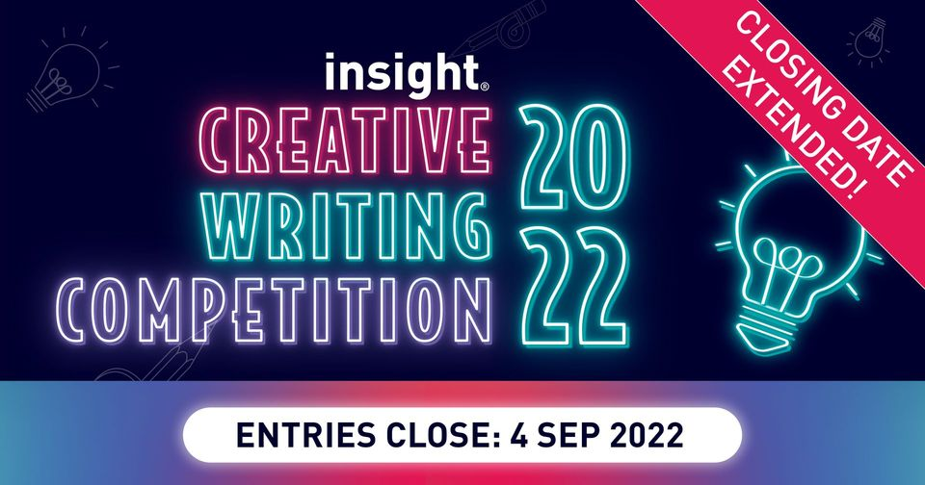

If you enjoy creative writing, consider entering this competition which is run annually by a Melbourne-based educational publisher: Insight Publications.

Note that the closing date for entries has now been extended until 4 September 2022.

Further information, including conditions of entry: http://www.insightpublications.com.au/writingcompetition

Prizes will be awarded as follows:
Year 7 First Prize: $200 Second Prize: $125 Third Prize: $50
Year 8 First Prize: $200 Second Prize: $125 Third Prize: $50
Year 9 First Prize: $250 Second Prize: $175 Third Prize: $100
Year 10 First Prize: $250 Second Prize: $175 Third Prize: $100
Year 11 First Prize: $300 Second Prize: $225 Third Prize: $150
Year 12 First Prize: $300 Second Prize: $225 Third Prize: $150

Linda Duncan
Resource Centre Manager

