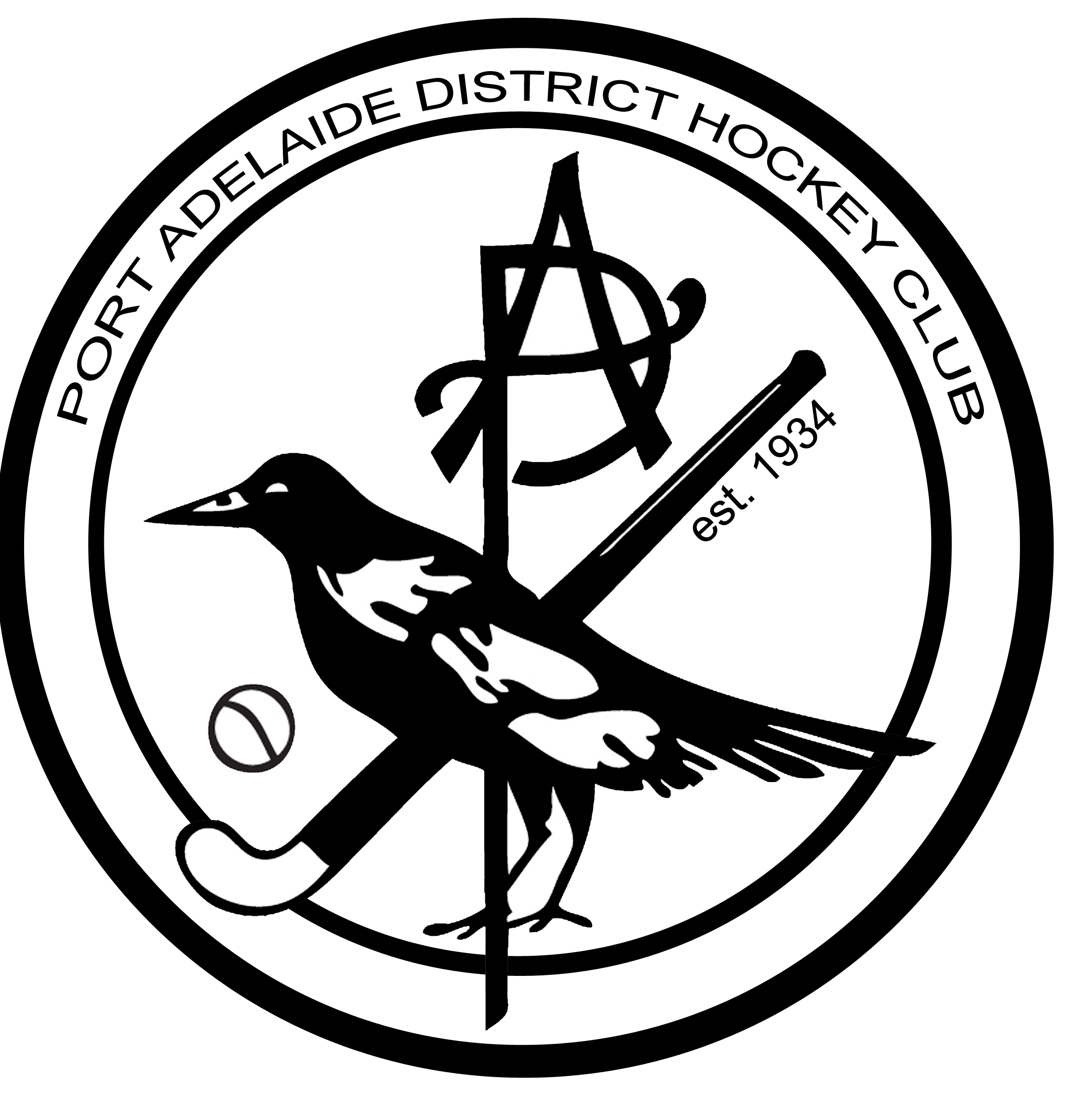
2017 PADHC Primary School Hockey Program

Plan:

To increase the participation rate of Junior Hockey in the Western Suburbs of Adelaide by creating an Interschool Junior Hockey Program each Friday afternoon in Terms 2 and 3 in 2017

The PADHC will be hosting a Primary School Hockey Program using modified rules for local Primary Schools in Terms 2 & 3 2017. This program is based on the highly successful NSW Stick2Hockey Program for U9’s (grade 3& 4) and U11’s (grade 5 & 6) Please see the attached document for program details, coaching suggestions and field dimensions.
Local schools will be able to enter teams into the round robin style tournament that will link well with existing school PE programs.
Existing PADHC juniors involved in our Umpire Development program will umpire the games under the supervision of their mentors and other members will be active in supporting roles.
Competition Details:

All games are played on Fridays, from 4pm to 5.30pm at Port Adelaide District Hockey Club: John Hart Reserve, Swan Terrace. Semaphore, SA, 5019.

Up to 12 teams can be accommodated in 2 game times each using either ¼ or ½ of the field (depending on age group) with modified goals. (Note: Depending on the number of team entries we may need to source a second venue such as Adelaide University Hockey Field at West Beach. If this occurs teams will be able to select their preferred venue.)

A Canteen will be open for coffee, tea and snacks.

First game scheduled for Friday May 12 Week 2, Term 2, playing through to September 22

Teams
Each team may have seven (7) to ten (10) players. There are seven (7) field players in U9 ¼ field or eight (8) players in U11 ½ field, permitted on the pitch at any one time. Goal keepers are optional in the U11 program. Kicking backs are not allowed. The remaining players are interchange substitutes, all players must have equal time. Teams can be a mixture of each gender.
Duration
Games will be played with two halves of fourteen (14) minutes each with an interval (half-time) of no more than five (5) minutes.
Rules Synopsis
- All rules are to be the same as the 2013 FIH Rules of Hockey
- The ball cannot be raised above shin pad height in play.
- The Ball must be stopped before being hit.
- No reverse side hits known as "tomahawks".
- There will be NO penalty corners at U9s. If the ball hits a defending foot in the circle it will be a side line ball or free hit outside of the circle.
- The ball must be passed first before entering the circle.
Cost:

Cost - $150 + GST per team

School Name
Contact Name
Contact Phone Number
Contact Email
Email address for invoice
Team Registrations: | No. of Teams | Uniform Colours Skirt/Shorts T/Shirt Sox
U9 ¼ field
¼ field for Grade 3 & 4 Grade 3s Cost - $150 + GST per team
U11 1/2 Field
For Grade 5 & 6 Cost - $150 + GST per team

