MEDIA RELEASE
Tuesday 4th March 2026
FOR IMMEDIATE RELEASE

New young Crew members join Wellington Shire’s Live4Life program

Live4Life Wellington is pleased to announce that last week 30 young people were inducted into Wellington Shire’s Live4Life Crew. This is the first step for these committed and caring young people in becoming local community leaders and Mental Health Ambassadors.

Live4Life is an award-winning program protecting young lives in rural communities through mental health education to help reduce suicide. Crews made up of Year 9 and 10 volunteers are a leading component of the program.
“I think today went very swell. Everyone was able to connect and get to know each other. It looks like it is going to be a lot of fun getting to do this year of Live4Life.” Archie - Live4Life Wellington Crew 2026
“It was really neat to meet the other crew members and take our first steps towards helping everyone to have positive mental health” Rustan - Live4Life Wellington Crew 2026
The Royal Commission into Victoria’s mental health system revealed that 63% of young people are unable to access mental health services when they need to. In rural and regional areas, access to services is even harder, there can be more stigma around seeking help, and young people can feel more isolated. Live4Life is the only mental health education and youth suicide prevention model designed specifically for rural and regional communities.
Live4Life Crews fulfill a critical role in their communities. Young people from Years 9 and 10 take the opportunity to become leaders in their local area, and advocate for mental health support and education. Wellington Shire Crew will devise a theme for 2026, help to organise Live4Life events, and promote key mental health messages in their local school/s and community.
Friday’s Crew Induction was held at Nakunbalook Environmental and Cultural Education Centre and included Councillor Wells welcoming the new crew and congratulating them on having the courage to step up and be leaders. Crew also learnt about Wellington Shire’s Municipal Public Health and Wellbeing Plan - Live Well in Wellington, and their part in it as positive mental health ambassadors.
“Live4Life Wellington Induction Day was a valuable and engaging experience for our school’s Crew. It provided a meaningful opportunity to deepen their understanding of youth mental health while working collaboratively with students from other schools to share ideas and learn from one another.” Tracey Grubb – Learning Specialist, Gippsland Grammar
Young people are at the centre of the Live4Life program. In 2025, across all Live4Life communities, over 8,960 young people received evidence-based mental health education — improving their mental health literacy and ability to offer and seek help, while reducing stigma through the annual program of events and activities.

The total number of young people living in rural and regional communities who have received evidence-based mental health education since the Live4Life program began in 2010 is now 38,887. In 2024, 297 young people joined the Live4Life Crew and were trained and mentored to support their peers as Mental Health Ambassadors. In total, 1800 young people have joined Live4Life Crew.

Live4Life Wellington led by Wellington Shire Council partners with Catholic College Sale, Gippsland Grammar, Maffra Secondary School, Sale College. Sale & District Specialist School; Headspace Sale, Central Gippsland Health, Victoria Police, Quantum Support Services, Latrobe Regional Health, PHN Gippsland and Walk & Talk for Mental Health to deliver this life-changing program in Wellington Shire.

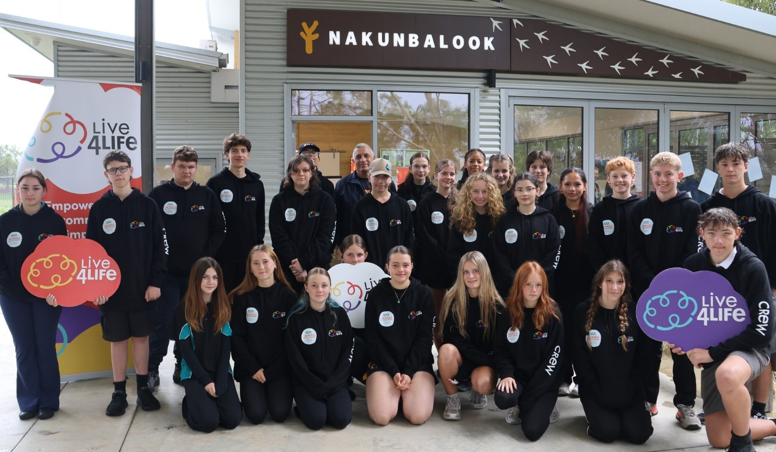

Cr Wells with 2026 Live4Life Wellington Crew

Live4Life Wellington is generously supported by The John Leslie Foundation and Community Bank Maffra & District.

***ENDS***

For comment, contact:
Wellington Shire Council Communications and Media Unit by calling 1300 366 244.

Additional information:

Visit the Live4Life website.

Media Contacts
Jeremy Wiggins is available for Interview.
CEO, Youth Live4Life
0484 299 885
ceo@live4life.org.au

Josephine Wright
Communications & Fundraising Manager, Youth Live4Life
0402 086 341
media@live4life.org.au

Live4Life Model
Find out more about the Live4Life model.

Media Backgrounder
Read the Live4Life media backgrounder.

Link to Media Images
High resolution images of Live4Life’s programs and CEO can be downloaded here.

Live4Life Awards
Winner, VicHealth Award for Improving Mental Wellbeing, 2018. Winner, YACVic Rural Youth Award for Most Innovative Youth Project or Program in Rural or Regional Victoria, 2018. Highly Commended, LG Pro Awards, 2020. Finalist, 7NEWS Young Achiever Awards in the Community Group Category, 2023. Live4Life Southern Grampians Crew awarded Young Citizens of the Year, Australia Day Awards, 2023. Live4Live Benalla Crew awarded Community Group of the Year, Australia Day Awards, 2023. Finalist, Victorian Community Achievement Awards in the Mental Health and Wellbeing Award Category, 2023. Winner, Suicide Prevention Australia’s National LiFE Award for Communities in Action, 2024.

Read more
Live4Life Annual Reports can be viewed here.

Live4Life Media Releases carefully adhere to Mindframe media guidelines for reporting, portraying or communicating about suicide or mental ill-health. We respectfully ask that all publications use the images Live4Life has provided to accompany our media release.

