My Life in Isolation
My life in isolation has been a fairly good time. I’ve liked using technology to connect with teachers and friends from school, though I still want to go to normal school. I believe that it is better to connect and socialize face to face instead on facetime. it is also easier to get help from teachers if we are all there in the same place and time. If we use technology and we are in a totally different place from on another, then it takes time to get a response from someone.
At normal school we don’t spend a huge amount of time on technology because there is a teacher there teaching us directly. Whereas in the state we are in right now we are using technology for almost 5-6 hours a day, and some of us aren’t getting the physical activity a day (like what we do at school we have recess and lunch). Personally, I prefer going to normal school rather than learning online.
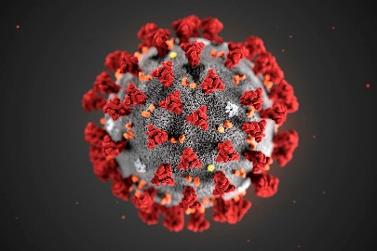
One of my biggest challenges have been trying to get work done from all different types of subjects. One subject may have a big project or task you must complete, and then another subject will have the same amount of work to complete and then another and it could get quite overwhelming. So sometimes I don’t get all the work done in time and it becomes overdue. I find that sometimes challenging.
Positives from the Pandemic
- One of the positives we can take away from this pandemic is that we must stay hygienic and wash our hands regularly.
- Another thing is that we can still have fun if we’re stuck with our family even though you can’t go outside.
- The pandemic has made people come up with many creative things to do while in isolation and lockdown.
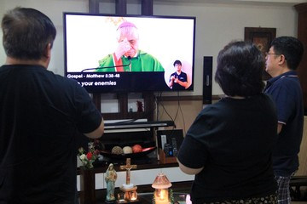
- Pollution has gone down due to the lack of activity going on in the worlds (like much less cars driving around on the streets).
What have the Religious Leaders Done?
Many religious leaders like Pope Francis and many other priests around the world have made online masses and religious services so people can continue following their faith. This has given people hope and assurance to keep going through this pandemic.
What am I Looking Forward to after the Pandemic?
There are many things I am looking forward to after the pandemic. Most of all I want to see my friends face to face. I don’t want to worry about catching the virus and staying 6 feet apart. I also want to go to public places like cinemas, shopping centres and restaurants. I would also like to have parties and gatherings with family. There are many things I would like to get to after the pandemic, but what I want most of all is everything to get back to normal and no one has anything to worry about.

