[](https://www.campaustralia.com.au/blog)[](https://zoom.us/webinar/register/WN_STlYKZaISC-DDGn04jkpAg)[](https://zoom.us/webinar/register/WN_Nu8QIDmRQTyVPy79MmwvLg)[](https://apps.apple.com/app/apple-store/id1529575453?pt=120333103&ct=edmbookings&mt=8)[](https://play.google.com/store/apps/details?id=au.com.campaustralia.parent)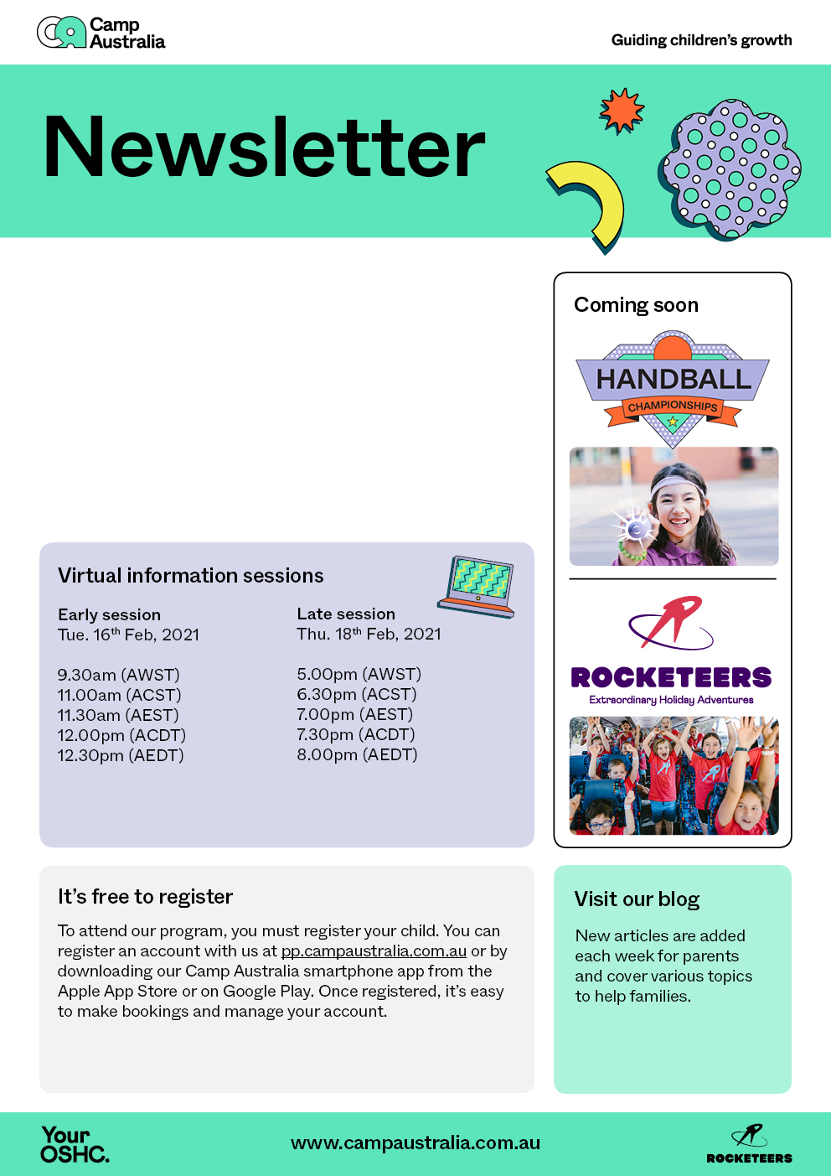

A very warm welcome to all our new parents and guardians at Camp Australia. We are so proud to be part of Guiding Your Child’s Growth this Year.

Despite current conditions in Victoria, we are definitely looking forward to the coming year. We have so many fun activities and incursions planned this term, and we can’t wait to get started!

Remember to book your child in so they don’t miss out!