**TRINITY VOLLEYBALL CLUB**



EAT PASTA

Trinity Volleyball Club are holding a **‘Golden Ravioli Pasta Fundraiser’** to raise funds that support our boys to represent the college at volleyball events, competitions and tours.

[Golden Ravioli are](mailto:heidiian@yahoo.com.au) Western Australia’s leading Pasta manufacturers. They make authentic fresh handmade pasta every day, here in Perth!

# HOW TO ORDER

**Step 1:** Complete the order form overleaf and return via email to: [heidiian@yahoo.com.au](mailto:heidiian@yahoo.com.au)

**Step 2:** Pay via the Trinity Online Store

Use Reference: ‘Sons full name and year’

https://store.trinity.wa.edu.au/product/volleyball-golden-ravioli-fundraiser/

**ORDER DEADLINE: Sunday 30th March 2025**

If you have any queries, please contact Heidi on 0402 967 818

**HOW TO COLLECT ORDERS**

Orders will need to be picked up from the school canteen

**Wednesday 9th April 2025 between 3.15pm – 5:30pm**

All Pasta products come frozen so please BYO freezer bags.

**PLEASE NOTE: The Club is unable to hold items overnight.**

The Club will ensure all items are kept frozen until pickup.

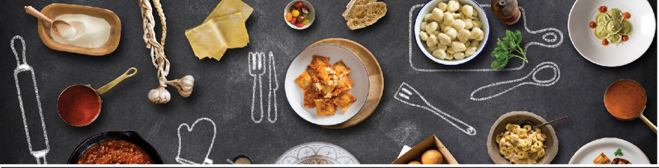

|  |  |
| --- | --- |
| Contact name |  |
| Phone |  |
| Email |  |

# PASTA AL FORNO

|  |  |  |  |
| --- | --- | --- | --- |
| Product | Price | Quantity | Total |
| Traditional Lasagna – 1.3kg | $ 19 |  | $ |
| Traditional Lasagna – 2kg | $ 28 |  | $ |
| Vegetarian Lasagna – 1.3kg | $ 19 |  | $ |
| Spinach & Ricotta Cannelloni – 1.3kg | $ 19 |  | $ |
| Spinach & Ricotta Cannelloni – 2kg | $ 28 |  | $ |
| Tortellini Alla Panna – 1.3kg | $ 21 |  | $ |
| Tortellini Alla Panna – 2kg | $ 30 |  | $ |

**PASTA FRESCA**

|  |  |  |  |
| --- | --- | --- | --- |
| Product | Price | Quantity | Total |
|  |  |  |  |
| Classic Roasted Meat Ravioli – 1kg | $ 15 |  | $ |
| Spinach & Ricotta Ravioli – 1kg | $ 15 |  | $ |
| Roasted Pumpkin Ravioli – 1kg | $15 |  | $ |
| Beetroot and fetta Agnolottti 1 kg | $ 15 |  | $ |
| Traditional Gnocchi – 1kg | $ 15 |  | $ |
| Classic Roasted Meat Tortellini – 1kg | $ 15 |  | $ |
| Fettuccine – 1kg | $ 10 |  | $ |
| Linguine – 1 kg | $ 10 |  | $ |
| Traditional Arancini - dozen | $ 25 |  | $ |
| Vegetarian Arancini - dozen | $ 25 |  | $ |
|  |  | **TOTAL** | **$** |

Please BYO Freezer Bag. All products come frozen.

Please fill out form and return via email to Heidi on [heidiian@yahoo.com.au](mailto:heidiian@yahoo.com.au)

Payment can be made via the Trinity online store using **Reference: "Sons full name and year"**

https://store.trinity.wa.edu.au/product/volleyball-golden-ravioli-fundraiser/